## **1.0 Introduction to Cloud Migration**

* Learning about cloud computing characteristics, the difference between running your workloads on-premises vs running them in the cloud, reasons to move the cloud, and the common migration strategies to the Cloud.
* [Introduction to VM Migration](https://youtu.be/EGftIjN5qas) 1 minute
* [Cost of ownership](https://youtu.be/PzkHHjGpFxg) 1 minute
  + 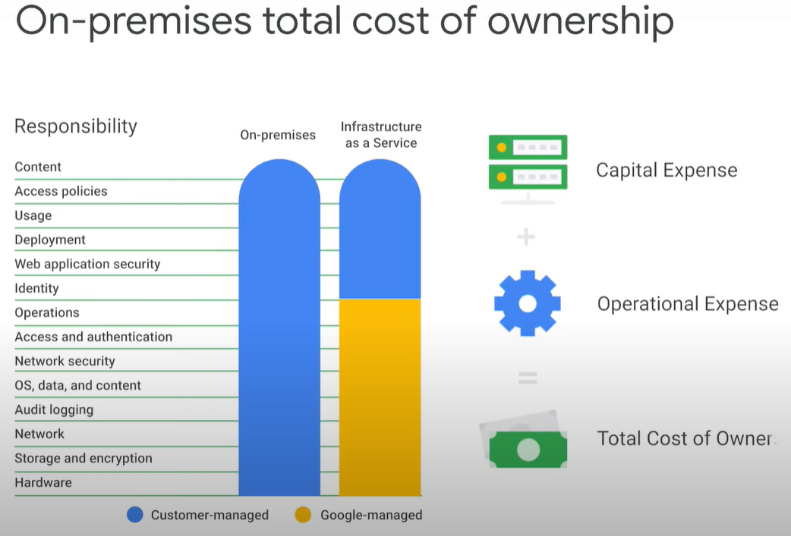
* [Reasons to move to the cloud](https://youtu.be/SAKn7QmiUf4) 1 minute
* [Migration types](https://youtu.be/UPcjDxZiY3A) 2 minutes
  + 4 common strategies to migrate your VMs to the cloud
    - lift and shift
    - improve and move - to take advantage of cloud native capabilities
    - rebuild in some edge cases - decommission an existing app and completely redesign and rewrite it as a cloud native application
    - workloads might need to remain on premise due to technical limitations – like mainframe machines incompatible licensing with the cloud environment, data locality in a specific country that doesn't have a cloud data center , unsupported os like windows desktop images servers and virtual appliances

|  |  |
| --- | --- |
|  |  |

* [The migration process](https://youtu.be/d4O8X8BMHvg) 2 minutes
  + 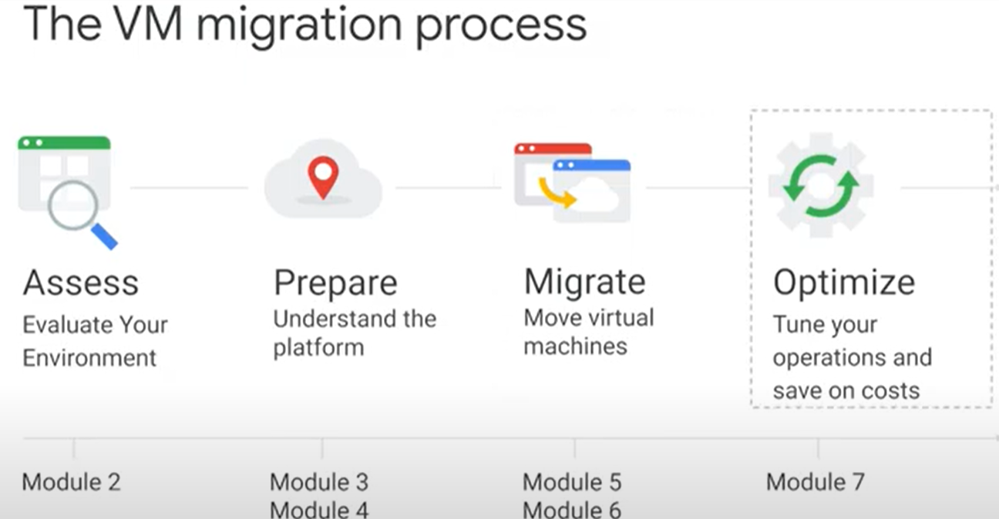
  + 4 main stages
    - Assess - which helps discover your source environment like list of servers, storage usage, applications, os and licenses
    - prepare phase - learn the foundational knowledge to architect and implement an infrastructure environment on GCP
    - migration phase - configure the migration process like test the solution and start the migration to the cloud while trying to minimize disruption to your service
    - optimize phase – after the vms are running successfully in the cloud you can focus on how to make the billing performance and process optimized
* [Migration to Google Cloud: Choosing your migration path](https://www.cloudskillsboost.google/course_sessions/743467/documents/108490)
  + <https://cloud.google.com/architecture/migration-to-gcp-choosing-your-path>
* Review 1 minute
* Module Quiz
  + What’s the purpose of the Optimize stage of the migration process? Tune your operations and save on costs.
  + Select a common incentive to move to the cloud The cloud allows individual customers to enjoy economies of scale.
    - The Cloud allows companies to enjoy economies of scale and provides competitive pricing and a higher level of security and automation.
  + Select the main stages of the migration process in the correct order Assess, Prepare, Migrate, Optimize

## **2.0 Assessing the Source Environment**

* Learning how to discover and analyze your source environment via an **assessment automation tool**.
* The tool will assist you in identifying VMs to migrate to the cloud, predict the total cost of running VMs in the Cloud, as well as optimize Cloud bill by providing VM recommendations based on their actual utilization.
* Module Overview 1 minute
* [The assessment phase 1](https://youtu.be/kLoZfKLpecA) minute

|  |  |
| --- | --- |
|  |  |

* + the assess phase which includes discovering and assessing which VMs to lift and shift
  + this process will help uncover existing workloads and determine a group of VMs for the first wave of migration
  + work with other members of your organization like security and application teams
  + Early in the process can help you identify and remediate or bypass issues that might otherwise occur mid-migration
  + there are many automation tools on the market that can help list your vm inventory, predict total cost of ownership, post migration and spot migration challenges and obstacles
  + google partners with cloud physics, stratazone and cloudimize to provide you with free automated discovery tools to help you assess your env.
  + each tool has distinct advantages and disadvantages
* [StratoZone assessment tool](https://youtu.be/s-bxoXgva-k) 2 minutes

|  |  |
| --- | --- |
|  |  |
|  |  |

* [Choosing virtual machines to migrate](https://youtu.be/cK65SBW7wa4) 1 minute
* 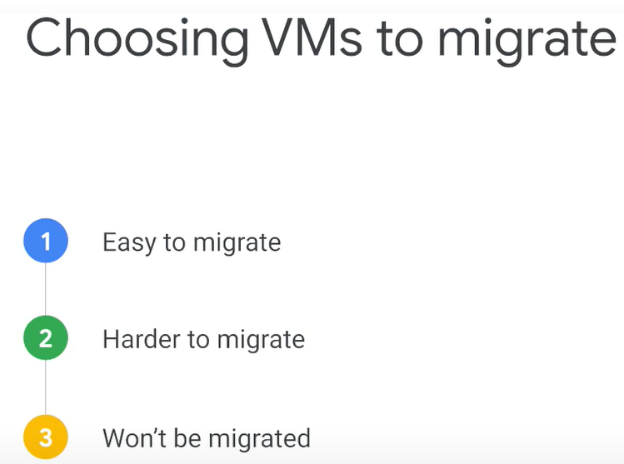
* [Lab Intro: VM Migration Journey: Introduction to StratoZone Assessments](https://www.cloudskillsboost.google/course_sessions/743467/video/108497) 1 minute
* [VM Migration Journey: Introduction to StratoZone Assessments](https://www.cloudskillsboost.google/course_sessions/743467/labs/108498) 1 hour 31 minutes
* Lab Solution: VM Migration Journey: Introduction to StratoZone Assessments 20 minutes
  + [StratoProbeGuide - Google Slides](https://docs.google.com/presentation/d/1iNS2BXelxUgBbtmIQyOa3WhS79Eh17CWOMU_UzTrkdA/present?slide=id.gb48bf533c4_0_1275)
  + **Overview**
    - learn how to assess a customer's current environment with StratoZone's scalable discovery. You will also learn to generate inventory, cloud fit score, and financial reports including TCO and ROI analysis.
    - The **StratoZone® SaaS platform** provides customers with a data-driven cloud decision framework. The StratoProbe® Data Collector application delivers the ability to easily deploy and scale the discovery of a customer's IT environment for private, public, or hybrid-cloud planning.
    - To ease and accelerate the VM migration journey, Google Cloud offers assistance and guidance in making the right decisions when deciding to go to cloud.

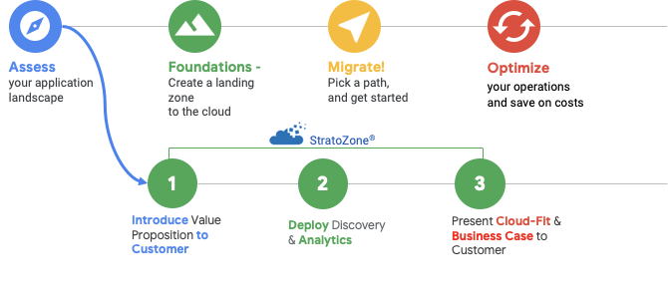

* + **Objectives**
    - In this lab, you will learn how to perform the following tasks:
    - Create a new assessment. Deploy a collector and start a scan of the deployed environment
    - Group assets based on defined criteria
    - Review collected data and run reports
    - Note: RDP client installed locally on your computer.
  + Task 1: Prepare your environment
    - Connect to a simulated customer env running in a Windows VM that has been created for you in Google Cloud.
    - the **Navigation** menu, select **Compute Engine** > **VM instances**. If prompted, select the Google Cloud project assigned to your lab.
    - Click the **RDP** button next to the **windows-vm** instance -> Open the RDP -> Change more choices to enter the user

|  |  |
| --- | --- |
| **User name** | stratozone |
| **Password** | $tr@t0z0n3 |

* + Task 2: Log in to the StratoZone portal and navigate to the Analyze module.
    - From the windows-vm desktop, click on the **Google Chrome** icon, then open <https://labs.stratozone.com/>.
    - Use the lab credentials provided to log in to the StratoZone lab session.
    - Agree -> click **Next**. Once logged in you will be able to access the assessments and review collected data.
  + Task 3: Start new assessment (automatic)
    - Collect live data from a set of machines running in the GC environment. This automatically collected data is how 99% of assessments are conducted in real-world customer environments. The main benefit of this approach is that you will receive unbiased information directly from the systems scanned. This natively collected data provides machine inventory, specs, utilization, execution processes, services, software versions installed, and network connectivity.
    - This data enables all of the advanced StratoZone features, such as:
      * Cloud fit scores
      * Optimization of underutilized workloads
      * Network dependency mapping
      * Financial business case (TCO/ROI)
      * Automated summary reporting and proposal
    - To begin the discovery and start the assessment wizard, click the **Assessments** tab, then click the **Create New Assessment Group** button in the top menu. Specify the following values & Click **Save**:

|  |  |
| --- | --- |
| **Assessment Type** | Automatic Asset Discovery |
| **Assessment Group Name** | Lab-Assessment1 |
| **Customer Sponsor Name & Email** | Enter your name and a personal email address |
| **Customer Tech Contact Name & Email** | Enter your name and personal email address  **Note:** This email will receive an email with collector installation instructions |

* + - Once the assessment has been created, the system will automatically start the data collector configuration wizard.
    - On the **Details** tab, specify the following values:

|  |  |
| --- | --- |
| **Assessment / Data Center** | Lab Datacenter |
| **Expected Number of Assets to Collect** | 5 |

* + - * Leave the default values for the remainder of the options. Click **Save & Next.**
    - Under the **Run Schedule** tab, leave the default values and click **Save & Next.**
    - Under the **Data Security** tab, note the available options for removing data sent from the data collector to StratoZone. For this lab you use the default option Level 1. Click **Save & Next**.
    - Pre-configuration of the data collector has been completed and the install package can be downloaded.
      * **Click** the **download** icon  to obtain the installation package.

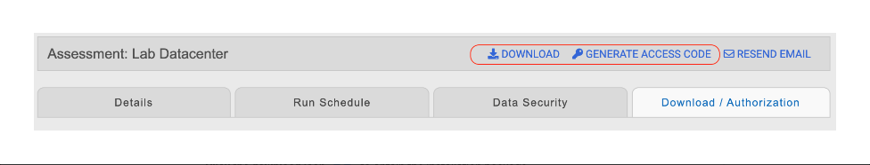

* + - * **Click** the **key** icon  to obtain the Temporary Access Code. Make a note of the Temporary Access Code, as you will need it in the next task.
  + Task 4. Deploy the StratoProbe data collector
    - In this task you will configure the StratoProbe data collector. Once the assessment has been created in the StratoZone portal, the customer installs the collector and begins the discovery process within their current datacenter (or cloud) infrastructure.
    - Click **setup.exe** file, click **Open** and select **Run**. Click **Yes ->** **OK ->** **Next -> Next ->** **Next -> Next** -> **Install**.
    - The installation will take a few minutes to complete. While you're waiting, check the email.
    - Once the installation is complete, click **Finish** -> select **Start** > **StratoProbe**.
    - When the StratoProbe Data Collector opens, click **Start Authorization** button.

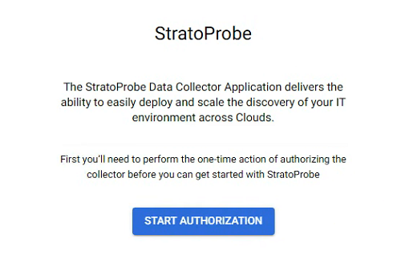

* + Click **Run Check** link to verify installation completed successfully.

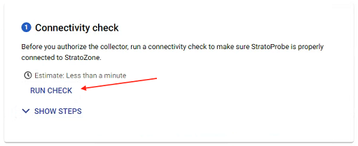

* + After verification completes and all checks pass, the collector can be activated.

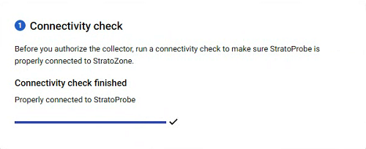

* + Enter the Temporary Access Code and click the **Authorize** button.
  + Once activation completes, the StratoProbe Data Collector will open.

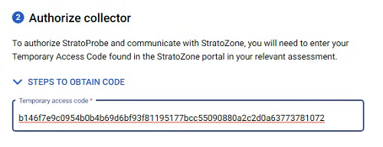

* + - * **HINT:** To find the Temporary Access Code again, follow the steps below...
      * (Click Assessments tab → Lab-Assessment1 → Edit Data Collector icon)

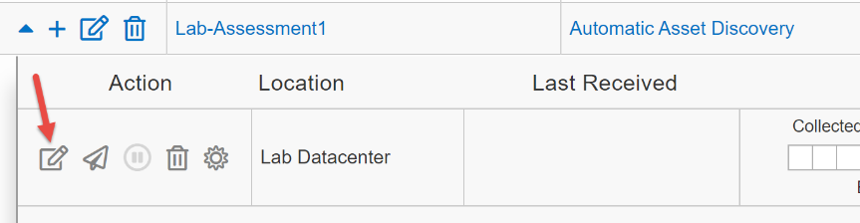

* + - * **Click** the **key icon**  to obtain the Temporary Access Code.

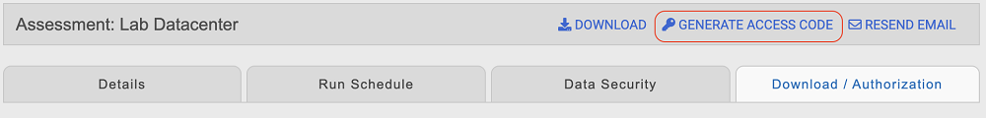

* + Once activation completes, the StratoProbe Data Collector will open.
  + **Create credential group**
    - Multiple credentials can be stored within StratoProbe to allow the collector to access systems belonging to different Active Directory domains, or having local accounts or SSH keys.
    - Click **Add Credentials** button in the upper left menu.
    - Choose OS as the scanning method and click **Configure**.
    - To set up a credential group, specify the following values:

|  |  |
| --- | --- |
| **Credential Name** | Lab |
| **Credential Type** | Username and Password |
| **Username** | stratozone |
| **Password** | $tr@t0z0n3 |
| **Group Scheduling** | Accept Defaults |

* + - Click **Add Credential** button.
    - On the **Add Resources** menu, click **Machine**, and then select **Scan IP address ranges**.
      * IP address range scan allows for discovery of assets across the network.

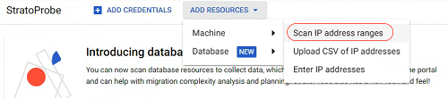

* + - Agree to the Terms & Conditions, and then click **Accept**.
    - **IMPORTANT:** Make a note of the Internal IP address configured for the lab VM Instances (e.g. 10.128.0.2). You will use the first three octets in the bulk scan.

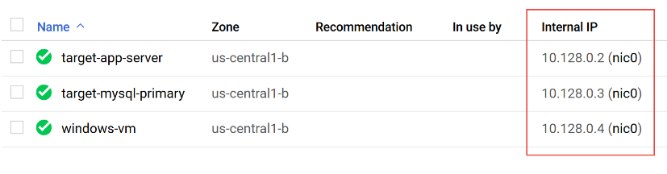

* + - On the **Add IP Address Ranges** menu, select **Enter ranges**.

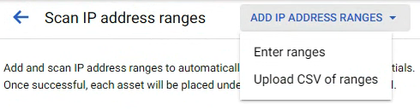

* + - For the beginning IP address, use the first three octets plus **.1** (10.128.0.1 in this example).
    - For the ending IP address, use the first three octets plus **.5** (10.128.0.5 in this example).
    - Click the **Add IP Ranges** button.
    - In the **Start to scan IP address range** dialog, click **Start Scan**.

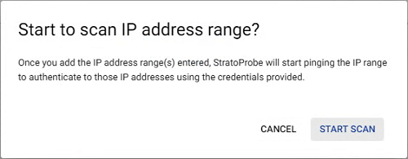

* + - Click on the arrow button to go back to the dashboard.

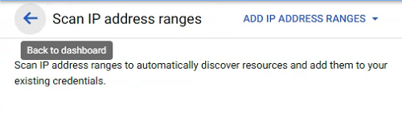

* + - **Note:** It may take up to 2 minutes for the scan to start and complete.
  + Task 5: Start new assessment (manual)
    - In this task you will conduct the assessment by ingesting external data directly into the StratoZone portal. This method is used when a customer does not want to scan their environment, but instead wants to provide a list of assets to achieve high-level pricing estimates.
    - The data can be sourced from a current CMDB, inventory list, vCenter exports, or any other internal system that provides the minimum required machine specs. This method offers a very quick turnaround for basic pricing, but will not offer the ability to optimize for utilization, understand running software components, or view network relationships.
    - To begin a manual-load assessment, **create a new assessment** as outlined for the automatic scan in Task 3.
    - Click on the **Assessments** tab, then click the **Create New Assessment Group** button in the top menu.

### **Establish a collector**

* + - * Specify the following values and click **Save** when done:

|  |  |
| --- | --- |
| **Assessment Type** | Manual Asset Entry |
| **Assessment Group Name** | Lab-Assessment2 |
|  |  |
| **Customer Sponsor Name & Email** | Enter your name and personal email address |

* + - * When prompted, specify the following values for manual inventory assessment:

|  |  |
| --- | --- |
| **Assessment Name** | Lab Datacenter Manual |
| **Upload Type** | Manual |

* + - * Click **Save & Next** button to go to the Upload tab.

### **Import manual assessment data**

* + - * Importing a CSV document is the fastest way to start a manual assessment. In this lab you will use a pre-existing Machine information CSV file. That is the only file required for manual import.
      * In the windows-vm, **Open Chrome**, then go to following URL:
        + http://storage.googleapis.com/cloud-training/OCBL226/machine\_info\_list.csv
        + Download the file. This is a list of servers that we want to manually import into StratoZone.
      * Click the **UPLOAD** button next to Machine Information.

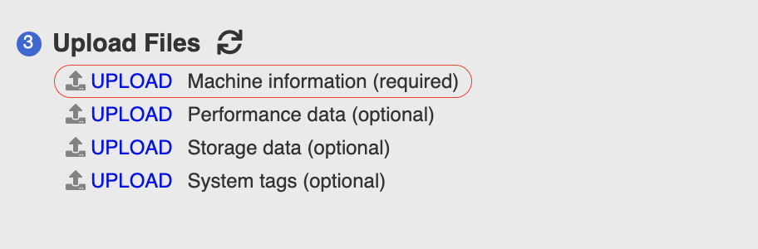

* + - * In the **Import Inventory from a File** dialog box, click **Choose File**, browse to Downloads, choose the **machine\_info\_list.csv** file, and then click **Open**.
      * Select **Use only provided IP addresses specified in import file**, then click the **Upload** button.

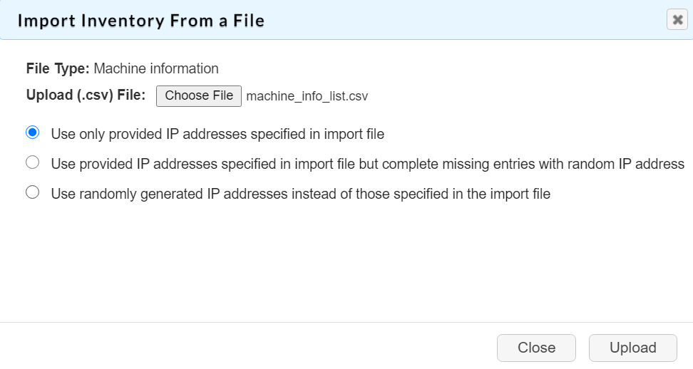

* + - * After 2 minutes, click the refresh button to see the status



* + - * Once the status changes to **Processed**, click **Save & Next** button to go to the next tab.
      * Servers should be imported successfully into the staging area for review. If the import was successful there will be a ✓ icon in the status column. If there are problems with a server from the import, there will be an X icon in the status column for the affected row.

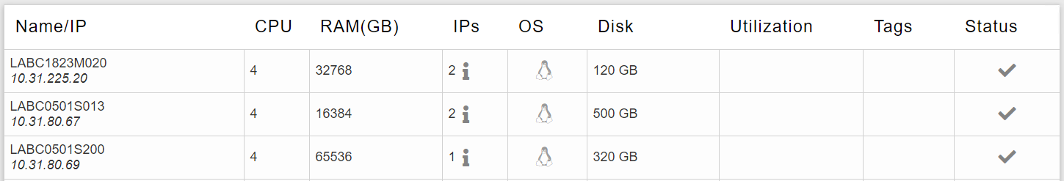

* + - * Click the **Add Inventory** button at the bottom of the page.
      * Once processing completes, the "Add Inventory" button will be disabled and notification will popup that import completed successfully.

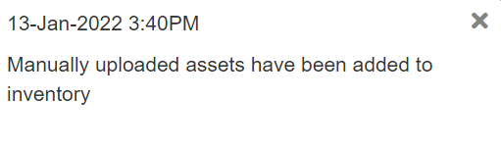

### **Verify assets were loaded (inventory check)**

* + - * Click the **Results** tab in the top menu, and then click on **Inventory** in the **Asset-level Data** menu.

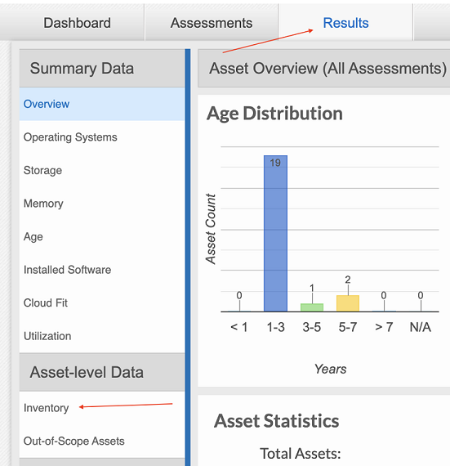

* + - * On the **Filters** menu expand **Assesment**, and then click **Lab Datacenter Manual**.

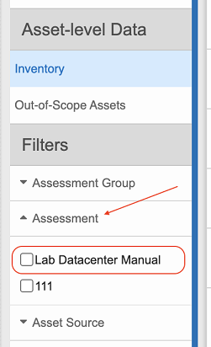

* + - * The system should display 19 records. Click **Check my progress** to verify the objective.
  + Task 6. Generate initial reports
    - work through a few critical reports that contain key results of an assessment. The findings can be delivered either interactively by presenting StratoZone portal screens to the customer, or by generating reports that can be used for presentation or offline delivery and transmission.

### **Summary report**

* + - The StratoZone platform continuously analyzes data based on the discovery of assets in this sample customer environment. The findings, analysis, and recommendations are made available to you within your StratoZone® portal and summarized in this report. This report is generated iteratively for customers during various assessment phases to capture various groupings and financial scenarios.
    - To generate the summary report:
      * Click the **Reports** tab.
      * On the **Assessment Summary and Proposal** tile, click **Generate Report**.
      * When prompted, specify the following settings:

|  |  |
| --- | --- |
| **Report Name** | Initial Summary Report |
| **Report Format** | Google Slides |
| **Select Filters** | Select All |
| **Baseline Vendor Catalog** | Private Data Center |
| **Comparison Vendor Catalog** | Google Cloud On-Demand |
| **Comparison Vendor Catalog** | Google Cloud 1 Year Commit |
| **Comparison Vendor Catalog** | Google Cloud 3 Year Commit |

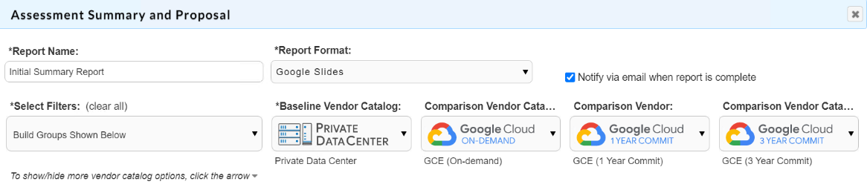

* + - * Click **Create Report**. The report will take a few minutes to build.
      * From the Report Queue, click the **Google Slides** icon to view the report 
      * To access generated reports, open the Analyze module and click on **Download Queue**.
      * Review the report for some of the key deliverables:
        + Automatically generated customer-ready narrative about the nature of the assessment
        + What locations were assessed
        + Technical findings (asset counts, CPU/RAM/Storage resource information, etc)
        + Cloud readiness (cloud fit score)
        + Financial analysis, comparison, and savings (including cost of current brick-and-mortar datacenter vs potential cloud options)

### **Inventory report**

* + - * To generate the inventory report: Click the **Reports** tab.
      * On the **Inventory** tile, click **Generate Report**.
      * Specify the following settings to create the report:

|  |  |
| --- | --- |
| **Report Name** | Initial Inventory Report |
| **Report Format** | Google Sheets |
| **Select Filter** | Select All |

* + - * Click **Create Report**. Click on the **Google Sheets** icon to view the report.
  + Task 7. Create and manage groups
    - In this task, you create and manage groups. Grouping allows you to present the information in a format that is familiar to the customer's environment. Groups can reflect business units, departments, dev/test/prod environments, applications, and so on. Groups can be created and managed directly in the platform.
    - Click on the **Grouping** tab. From the left menu, click on **Build Groups**.
    - In the top menu, click **Add New Group**.
    - In the **Create New Build Group** dialog box, specify a **Group Name** of Production, leave the rest of the settings as default, and then click **Save**. Click **Close** on the next screen.
    - From available group actions, click **Add Assets to: Production**.

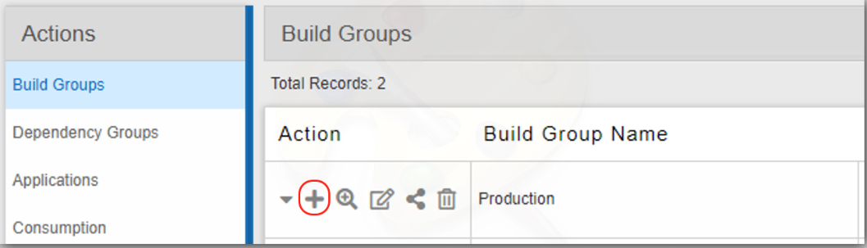

* + - In the search field, type **stz** to filter the server names.
    - Click the **Asset** box in the header row to select all filtered assets.
    - Click the **Add Selected Assets to Group** button.
    - Create a second group using the steps above and use the following configuration:

|  |  |
| --- | --- |
| **Group Name** | Development |

* + - When adding assets, type **dev** in the search criteria.
    - Select all dev assets and click the **Add Selected Assets to Group** button.
    - Create a third group using the steps above and use the following configuration:

|  |  |
| --- | --- |
| **Group Name** | Single CPU servers |

* + - To add assets, click the **Search** icon for the group.

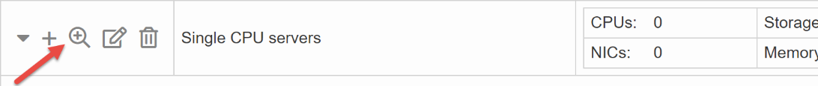

* + - From the pop-up, check the **Number of CPUs** option and select **1** from the list. Leave the rest of the default values.
    - Click the **Add Selected Assets To Group** button.
  + Task 8. Optimize assets
    - In this task you apply a pre-built optimization level to your assets. Optimizing underutilized resources may be the single most impactful action you can take to affect cloud spend projections and savings. Optimization can be applied globally to all assets, or applied by group.
    - Click on the **Sizing** tab.
    - From the left menu, select **Customize Assessments** and then click on **Customize For All Assets**.
    - Slide the value for **Optimization Mode** to **Aggressive**. Click **Save Sizing for All Assets**.
    - Click the **Close** button.
  + Task 9. Generate final reports
    - In this task you generate a final report based on the created groups. The report displays financials based on the applied optimization settings. Overall costs and savings will reflect these optimizations.
    - Click the **Reports** tab. On the Assessment Summary and Proposal tile, click **Generate Report**.
    - When prompted, specify the following settings:

|  |  |
| --- | --- |
| **Report Name** | Final Summary Report |
| **Report Format** | Google Slides |
| **Select Filters** | Select All |
| **Baseline Vendor Catalog** | Private Data Center |
| **Comparison Vendor Catalog** | Google Cloud On-Demand |
| **Comparison Vendor Catalog** | Google Cloud 1 Year Commit |
| **Comparison Vendor Catalog** | Google Cloud 3 Year Commit |

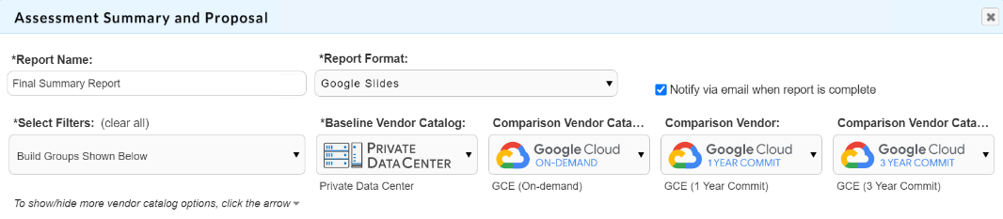

* + - Click **Create Report**. Click the **Google Slides** icon to view the report in Google Slides.
    - Compare the values to the initial summary report.
    - Financial comparisons that are visible in this report can also be generated live in the Plan module under the **StratoMatch** tab to evaluate any number of configurations or procurement scenarios.
    - Click the **Reports** tab. On the Detailed Pricing tile, click **Generate Report**.
    - The Pricing report provides a detailed breakdown of pricing that was applied to each individually evaluated workload. It gives additional visibility into the choices that are recommended. It also identifies specific VM and storage selections.
    - When prompted, specify the following settings:

|  |  |
| --- | --- |
| **Report Name** | StratoMatch Report |
| **Report Format** | Google Sheets |
| **Select Filters** | Select All |
| **Vendor Catalog 1** | Private Data Center |
| **Vendor Catalog 2** | Google Cloud On-Demand |
| **Vendor Catalog 3** | Google Cloud 1 Year Commit |
| **Vendor Catalog 4** | Google Cloud 3 Year Commit |

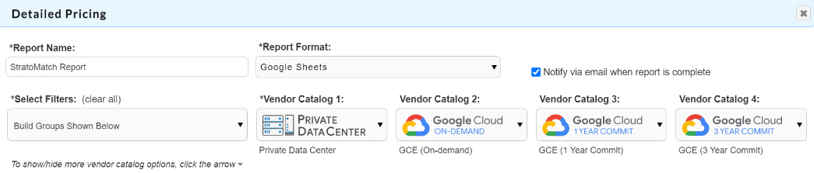

* + - Click the **Create Report** button. Click the **Google Sheets** icon to view the report
  + Task 10. Verify that data is being received
    - In this task you return to check on the progress of the automatic discovery. In a real situation, you would validate that the discovery has been correctly started by the customer in the first few hours or days of the assessment.
    - Select the **Results** tab in the top menu, and then click on **Inventory** link in the left menu.
    - On the Filters menu, expand **Assesment** and then click **Lab Datacenter**.
    - The assessment list should show Lab-Assessment1 and the number of assets collected.
* [Lab Solution: VM Migration Journey: Introduction to StratoZone Assessments transcript](https://www.cloudskillsboost.google/course_sessions/743467/video/108499)
* Review 1 minute
* Module Quiz
  + Choosing a machine rightsize recommendation based on the 99th percentile means..
    - The destination machine will have a CPU capacity equivalent to the peak CPU consumption across 99% of its sample time.
      * The algorithm will ignore 1% of CPU spikes, which tend to not reflect the real needs of the machine over time.
  + Which of the following tools can help list your VM inventory, predict total cost of ownership post-migration, and spot migration challenges and obstacles?
    - StratoZone, Cloudamize, CloudPhysics

## **3.0 Google Cloud Fundamentals**

* compare the terminology that you are familiar with on-premises or in AWS to the corresponding terminology on GC, explain how resource hierarchy works in GC’s environm, and discover ways to control permissions with Cloud IAM. Also learn how to limit consumption with quotas and budgets, predict cost and visualize spend over time.
* Module Overview 1 minute
* [Google Cloud terminology](https://www.cloudskillsboost.google/course_sessions/743467/video/108503) 2 minutes

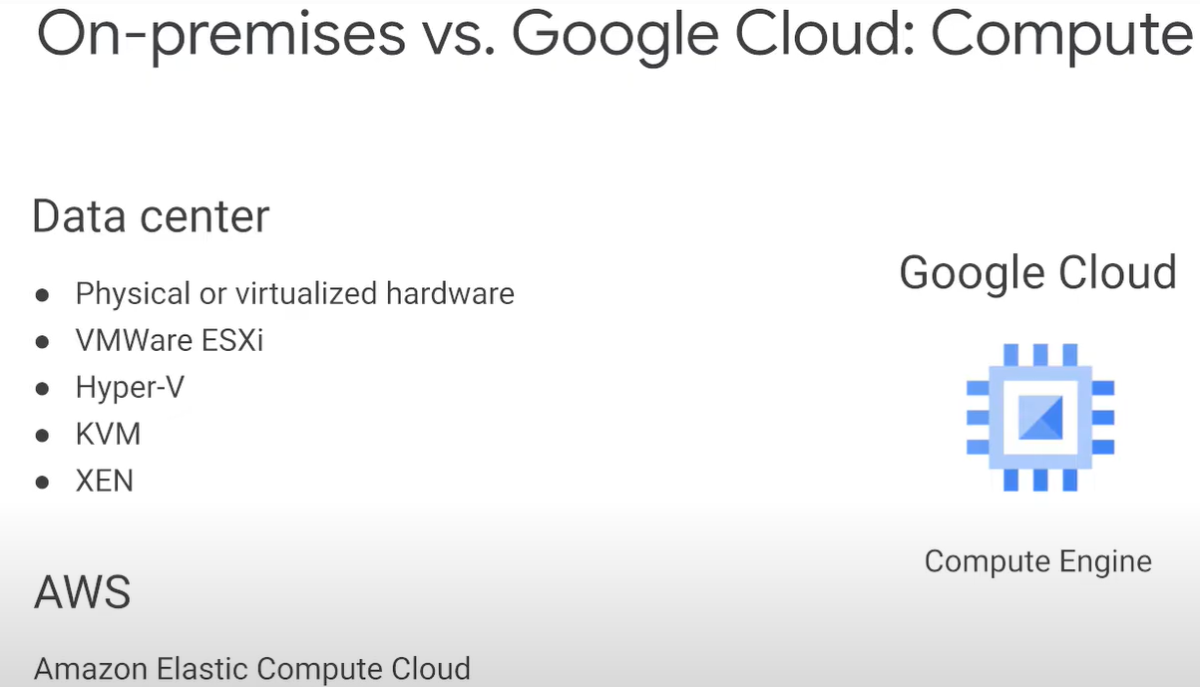

* + when running VMs on-premises you are responsible for the hypervisor that runs them whether vmware esxi, hyper-v, kvm.. or directly on bare metal hardware
  + also responsible for maintaining the underlying infrastructure such as networking, storage and hardware
  + google cloud VMs are called compute engine instances and they run on google's compute engine service
  + with compute engine you do not have to manage the underlying infrastructure or hypervisor
  + because google maintain these services

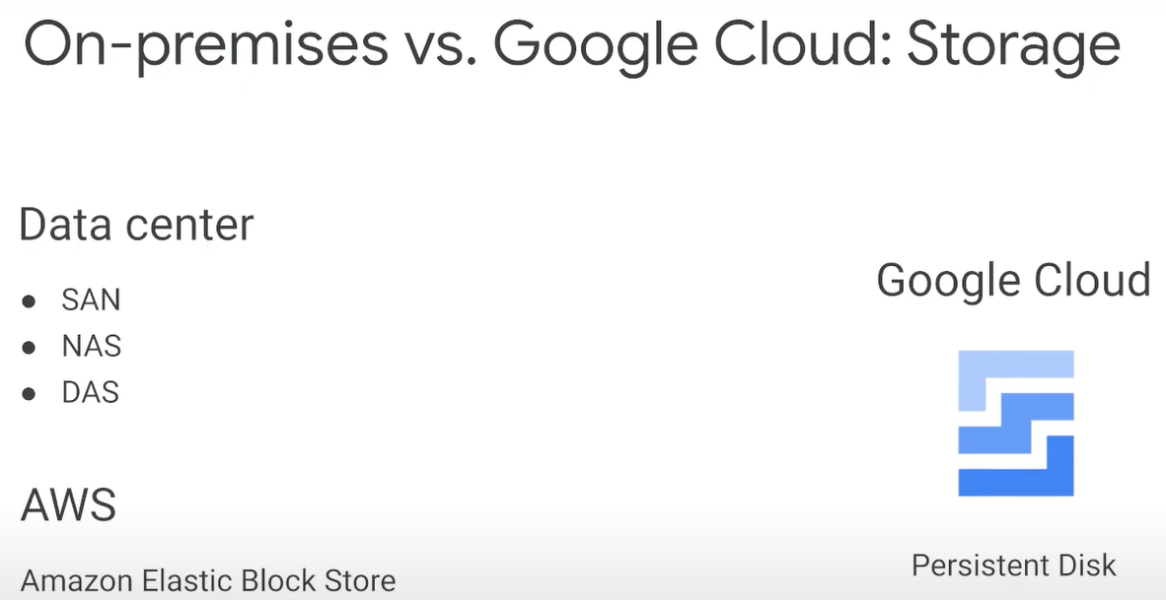

* + storage on premises - use directly (DAS), networked (NAS) attached storage or storage area network(SAN). benefits for minimizing latency with DAS, to providing ease of use with NAS, to providing ultra redundant scalable high performance storage with SAN
  + gcp has a complementary storage offering which maps to the storage technologies whether it's google's network attached persistent disk technology which supports standard spinning hard drives or ssds or high performance direct attached local ssds which supports scasi or nvme interfaces

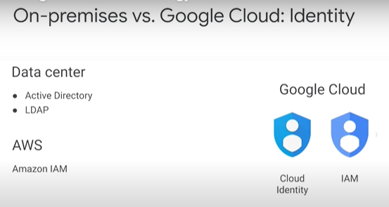

* + managing identity on-premise can be accomplished with active directory or ldap servers
  + gcb provides a cloud-based identity service which you can either extend your current directory services to the cloud via sync or create a new user directory for your cloud environment with GC's identity and access management (IAM)
  + you can also sync your on-premise active directory with cloud identity
* [Resource Hierarchy](https://youtu.be/OKJCjBmAch0) 1 minute

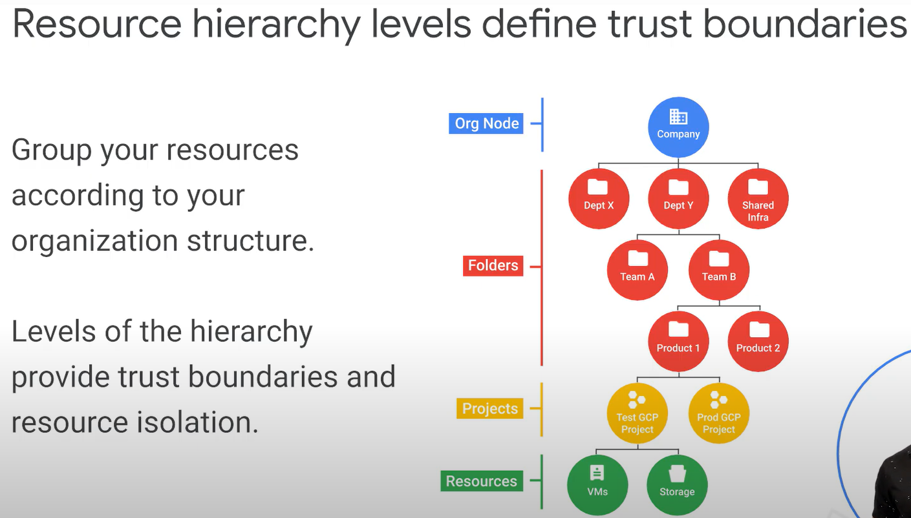

* [Resource Objects](https://youtu.be/U2m-7pOOpvE) 5 minutes

|  |  |
| --- | --- |
|  |  |
|  |  |
|  |  |

* [Demo: Resource Manager](https://www.cloudskillsboost.google/course_sessions/743467/video/108506) 2 minutes
* Quiz: Google Cloud Projects and Resources
  + True or False: All Google Cloud resources are associated with a project. True
    - All Google Cloud resources are associated with a project. Each project is associated with a billing account, which functions as the payment method for these resources.
* [Identity and access management](https://www.cloudskillsboost.google/course_sessions/743467/video/108508) 4 minutes

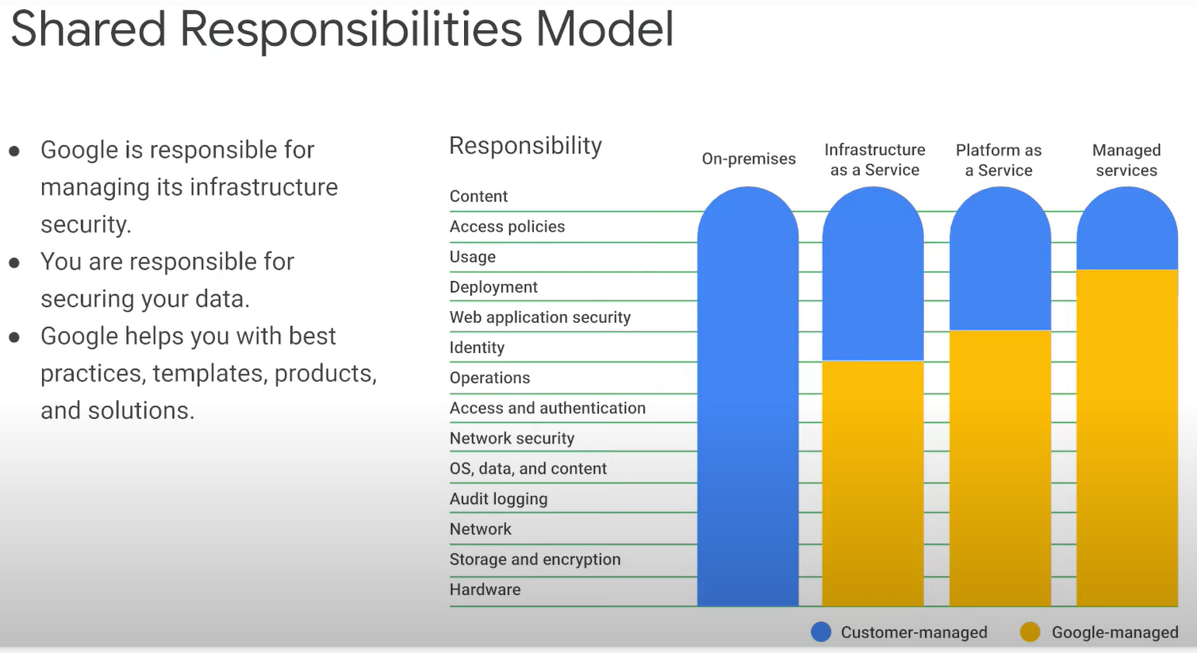

* + when you build an application on your on-premises infrastructure you're responsible for the entire stack when you move an application to gcp google handles many of the lower layers of security
  + this concept called the shared responsibility model and clearly defines which responsibilities are handled by the cloud provider google and which responsibilities are handled by the customer
  + google provides tools such as iam to help customers implement the policies they chose at these layers

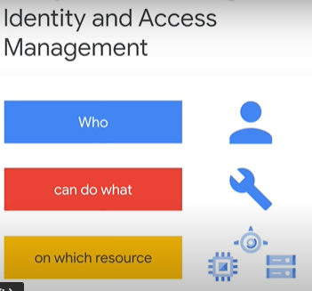

* + identity access management (iam) a way of identifying who (person, group, application) can do what (specific privilege or action) on which resource (any gcp service)

|  |  |
| --- | --- |
|  |  |

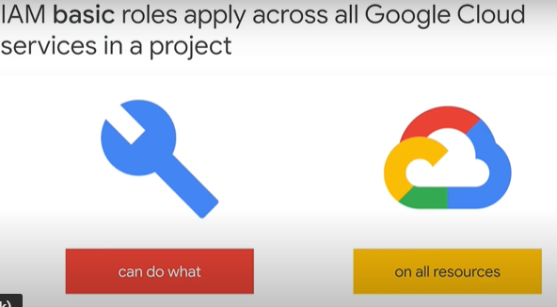

* + Apply the basic rules to a google cloud project and they affect all resources in that project from VMs to firewall rules, databases and logs

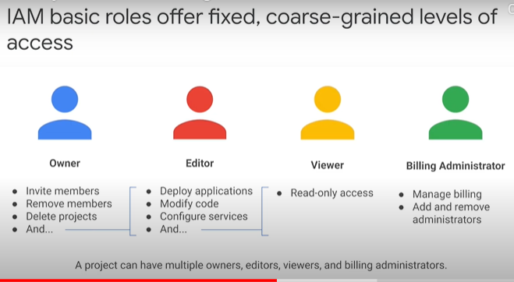

* + Billing Administrator - set up billing often companies, able to control the billing for a project without the change resources in the project

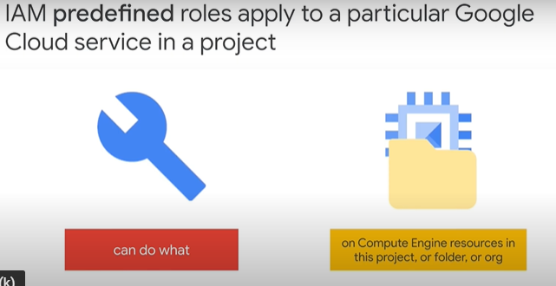

* + gcp services offer their own set of predefined roles and they're defined where these roles can be applied
  + FE compute engine(CE) which offers VMs as a service. CE offers a set of predefined roles and you can apply them to compute engine resources in a given project, a given folder or the entire organization
  + another example cloud bigtable which is a managed database service. CB offers roles that can apply across an entire organization to a particular project or even an individual bigtable database instance.
  + 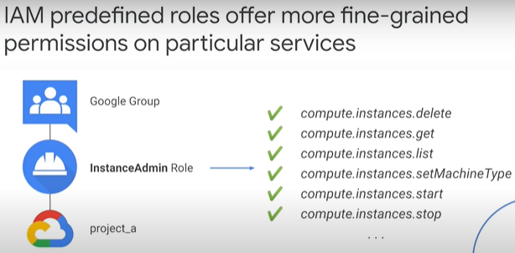
  + Compute engine's instance admin role perform a certain set of actions on a VM, what set of actions those listed here (listing, reading, changing their configuration, starting and stopping) and which VMs depends where the role is applied.
  + in this example all the users of a certain google group have the role and they have it on all the VMs in project a
* [Compute Engine IAM roles](https://www.cloudskillsboost.google/course_sessions/743467/video/108509) 2 minutes

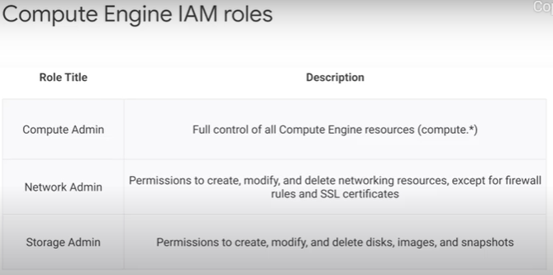

* + the compute admin role includes all permissions that starts with compute which means that every action for any type of compute engine resource is permitted
  + the network admin role allows read-only access to firewall rules, ssl certificates and instances to view their ephemeral ip addresses
  + for example if someone who manages projects images and you don't want them to have editor role on the project, grant their account this storage admin role on the project

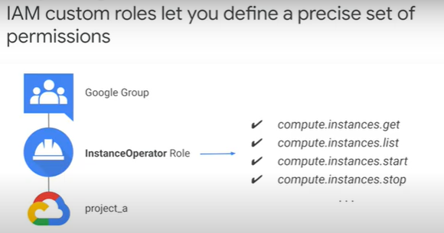

* + roles are meant to represent abstract functions and are customized to align with real jobs, but if one of these roles do not have enough permissions or you need something even finer grained that's what custom roles permit
  + for example, want to define an instance operator role to allow some users to stop and start compute engine virtual machines but not reconfigure them custom roles allow me to do that
  + note these cautions about custom roles
    - 1st, you'll need to manage the permissions
    - 2nd , it can only be used at the project or organization levels they can't be used at the folder level

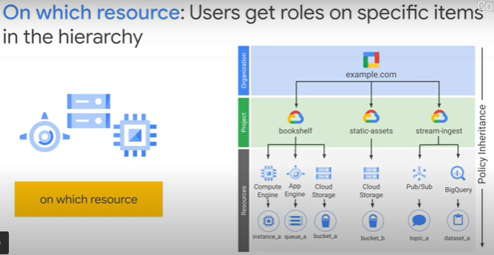

* + when you give a user group or service account a role on a specific element of the resource, hierarchy the resulting policy applies to the element you chose as well as the elements below that in the hierarchy
* [Service accounts](https://www.cloudskillsboost.google/course_sessions/743467/video/108510) 1 minute

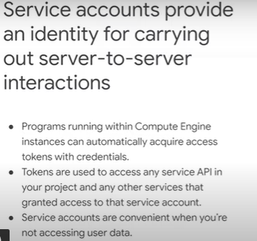

* + a service account is an account that belongs to your application instead of an individual end user
  + this provides an identity for carrying out server-to-server interactions in a project without supplying user credentials
  + for example if your application interacts with cloud storage, it must first authenticate to the cloud storage apis, so you can enable service accounts and grant read write access, then program the application to obtain credentials from the service account, your application authenticates seamlessly to the api without embedding any secret keys or credentials in your instance image or application code
* [Lab Intro: Identity and Access Management](https://www.cloudskillsboost.google/course_sessions/743467/video/108511) 1 minute
* [Identity and Access Management](https://www.cloudskillsboost.google/course_sessions/743467/labs/108512) 30 minutes
  + Overview
  + Google Cloud's Identity and Access Management (IAM) service lets you create and manage permissions for Google Cloud resources. Cloud IAM unifies access control for Google Cloud services into a single system and provides a consistent set of operations.
  + In this lab, you will learn how to use Identity and Access Management (IAM) to grant limited access to employees and external advisors. In addition, you will create a service account for a proof of concept virtual machine, assign it the appropriate permissions, and start a new virtual machine with it.
  + Objectives
    - Use Cloud IAM to manage access control
    - Grant access to employees and external users
    - Create a service account and assign it to a virtual machine
  + Task 1: Grant access to users
    - In the Cloud Console, on the Navigation menu (Navigation menu), click IAM & admin.
    - Click Filter table and select Type > User.
    - In the action bar, click Add. Type "@qwiklabs.net" and choose any user from the list.
      * Because the lab env belongs to the qwiklabs.net domain, choose a demo user from our directory.
    - Click Select a role.
      * The available roles—Browser, Editor, Owner, and Viewer—are known as primitive roles in Google Cloud. Primitive roles set project-level permissions and, unless otherwise specified, control access and management to all Google Cloud services in your Project.
      * The following table pulls definitions from the Google Cloud roles documentation, which gives a brief overview of the Browser, Viewer, Editor, and Owner role permissions:
      * Role Name Permissions
      * roles/viewer Permissions for read-only actions that do not affect state, such as viewing (but not modifying) existing resources or data.
      * roles/editor All viewer permissions, plus permissions for actions that modify state, such as changing existing resources.
      * roles/owner All editor permissions and permissions for the following actions: 1. Manage roles and permissions for a Project and all resources within the Project. 2. Set up billing for a Project.
      * roles/browser Read access to browse the hierarchy for a Project, including the Folder, Organization, and Cloud IAM policy. This role does not include permission to view resources in the Project.
    - Click Type to filer, type Compute, select Compute Admin, and click Save.
      * You granted a new user permissions to manage Compute Engine VMs in your project. The user will not have access to anything else. This follows a security best practice called Least Privilege, which recommends granting the minimal permission possible to any given user or machine to limit the attack surface or potential for accidents.
  + Task 2: Grant access to an external advisor
    - Imagine that your company hired an external advisor. Instead of creating a user for the advisor in your domain's directory, you can use their Gmail Google account.
    - click IAM & admin -> click Add -> Type a Gmail Google account address -> select Editor Role and click Save.
    - Now the external user can log in and work on your project.
  + Task 3: Create a service account
    - Service accounts are a special type of Google account that grant permissions to VMs instead of end users. SAs are primarily used to ensure safe, managed connections to APIs and GC services.
    - Creating a service account is similar to adding a member to your Google Cloud Project, but the service account belongs to your applications instead of to an individual end user.
    - On the IAM page -> click Service accounts.
      * You can see the compute@developer.gserviceaccount.com service account that is created with every project.
      * This account is managed by Google, which means that Google stores both the public and private portion of the key, rotates them regularly, and always holds the private key in escrow, where it is never directly accessible. The service account also has the Project Editor role permissions, which are very broad and do not follow the principle of least privilege.
      * It is a best practice to create a service account for each application and grant it only the permissions necessary to do its job.
      * You will create a service account for a proof-of-concept virtual machine. The application reads images from a Cloud Storage bucket, which is an object-based storage service, and presents it to users.
      * In the action bar, click Create service account.
        + For Service account name, type proof of concept app, and then click Create.
        + Select Storage Object Viewer Role. This role will enable the SA to read objects, such as images, stored in Cloud Storage, which is an object-based storage service.
        + Click Continue. Click Done.
  + Task 4: Create a virtual machine with a custom service account
    - A Compute Engine virtual machine may run as a service account, and that account can be given permissions to access only the resources it needs. This way the service account is the identity of the service, and the service account's permissions control which resources the service can access.
    - Now that you have created a service account for a proof-of-concept application and granted it the appropriate permissions it needs, you can create a virtual machine with that service account.
    - the Navigation menu -> click Compute Engine. -> Click Create.
      * For Name, Type poc-app
      * For Service Account, select proof of concept app.
      * Click Create.
    - Any application that runs on this VM will have only read access to storage buckets in this Project, and any actions performed by this machine will be logged as the 'proof of concept app' SA.
* [Lab Solution: Identity and Access Management](https://www.cloudskillsboost.google/course_sessions/743467/video/108513) 5 minutes
* [Quiz: IAM permissions](https://www.cloudskillsboost.google/course_sessions/743467/quizzes/108514)
  + True or False: If a Google Cloud IAM policy gives you Owner permissions at the project level, your access to a resource in the project may be restricted by a more restrictive policy on that resource. False
    - Policies are a union of the parent and the resource. If a parent policy is less restrictive, it overrides a more restrictive resource policy.
* [Quiz: Service accounts](https://www.cloudskillsboost.google/course_sessions/743467/quizzes/108515)
  + Service accounts are used to provide which of the following?
    - A way to allow users to act with service account permissions
    - A way to restrict the actions that a resource (such as a VM) can perform
    - Key generation and rotation when used with App Engine and Compute Engine
    - Authentication between Google Cloud services
    - All of the other options
* [Cloud Identity](https://www.cloudskillsboost.google/course_sessions/743467/video/108516) 2 minutes

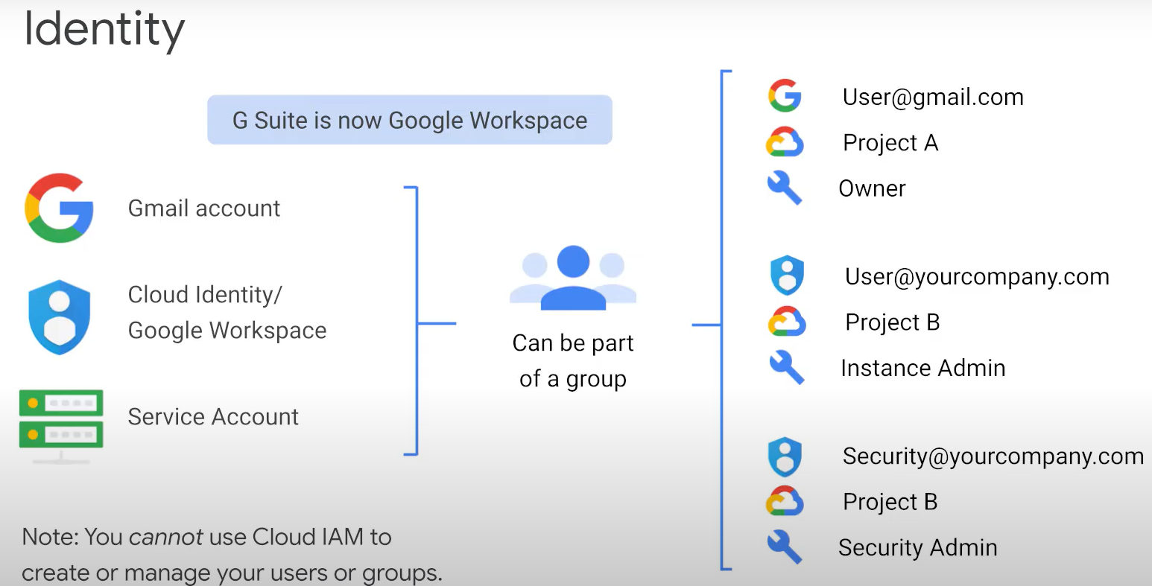

* + many new gcp customers logging into the gcp console with a google gmail account
  + It’s easy to get started with but its disadvantages is that your team's identities are not centrally managed
  + for example if someone leaves your org there is no centralized way to remove their access to your cloud resource immediately
  + GCP customers who are also g suite customers, can define gcp permissions in terms of g suite users and group, this way when someone leaves your organization an administrator can immediately disable their account and remove them from any associated groups using the google admin console
  + Gcp customers who are not g suite customers can get these same capabilities through cloud identity
  + cloud identity lets you manage users and groups using the google admin console but you do not pay for g suite's collaboration products such as gmail docs drives and calendar
  + cloud identity is available in a free and a premium edition, adds capabilities for mobile device management and other advanced features
  + a SA is a special kind of an account that belongs to an application or VM instance not a perso
  + applications use service accounts to make authorized api calls
  + you can create as many service accounts
  + a google group is a named collection of accounts and service accounts
    - every group has a unique email address that is associated with the group
    - google groups are convenient way to apply roles and permissions to a collection of users
  + it is important to note that you cannot use cloud iam to create or manage your users or groups instead you use cloud identity or g suite

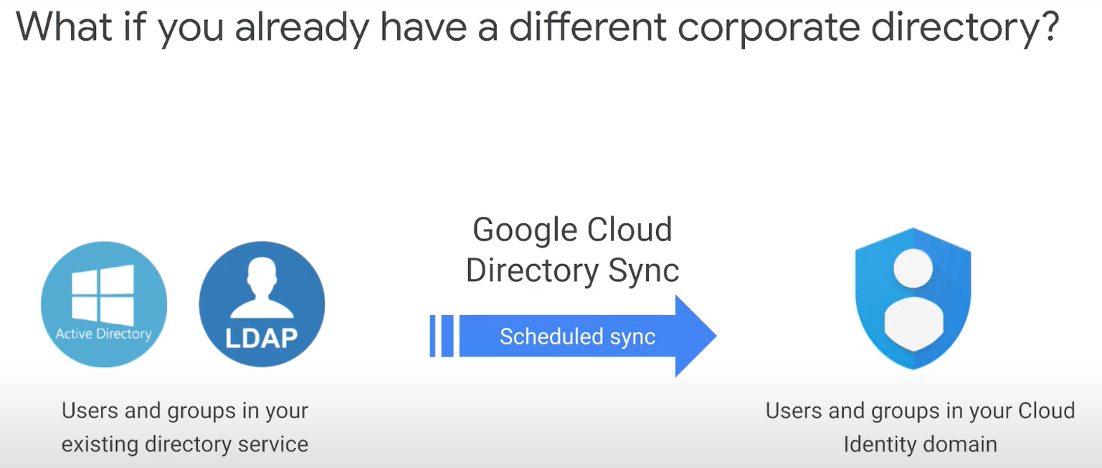

* + using google cloud directory sync also known as gcds
  + your administrators can enable the capability to leverage gcp resources using the same username and passwords
  + your company already uses for popular directory services platforms like microsoft AD or ldap
* [Interacting with Google Cloud](https://www.cloudskillsboost.google/course_sessions/743467/video/108517) 2 minutes

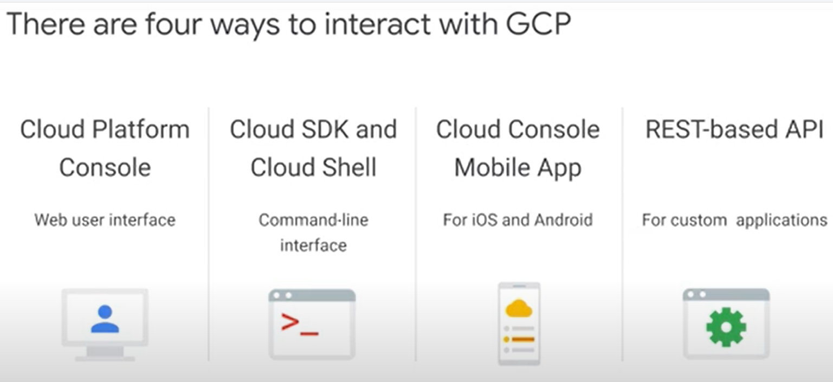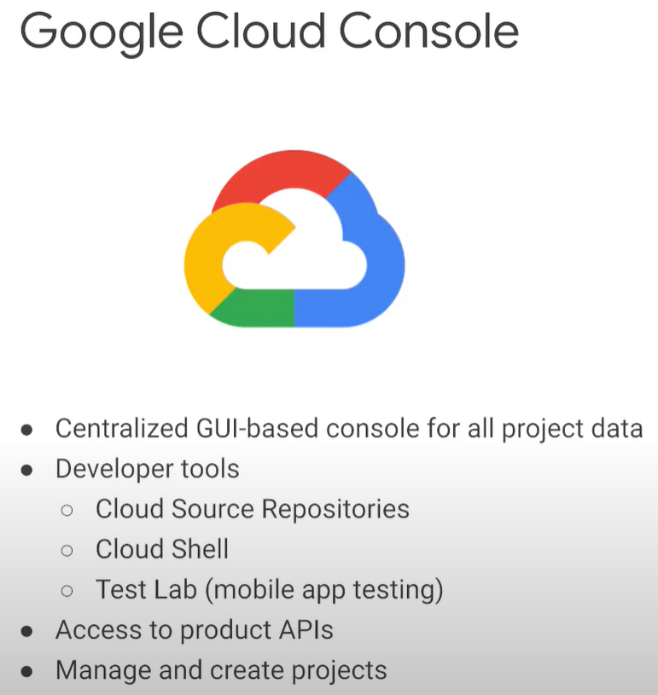

* cloud console is google cloud's web based GUI which helps you deploy scale and diagnose production issues
  + easily find your resources, check their health, have full management control over them and set budgets to control how much you spend on them, search to quickly find resources and connect to instances via ssh in the browser

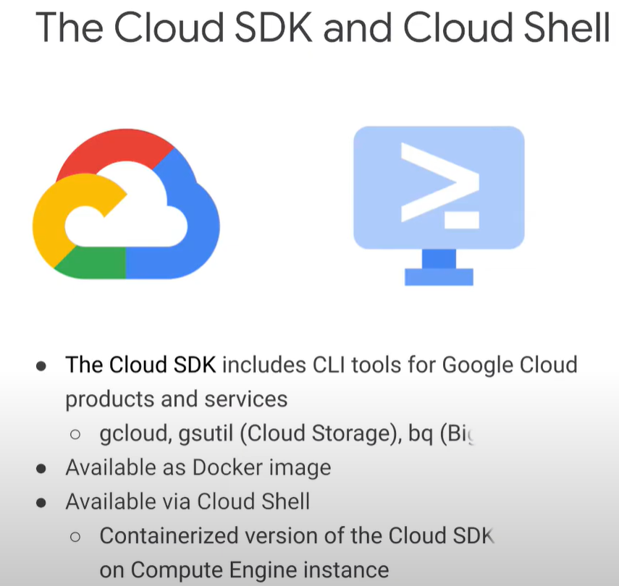

* + the google cloud sdk is a set of tools that you can use to manage resources and application hosted on google cloud platform these include the gcloud tool which provides the main CLI for google cloud platform products and services as well as gsutil and bq
  + google cloud shell provides you with the command line access to your cloud resources directly from the browser

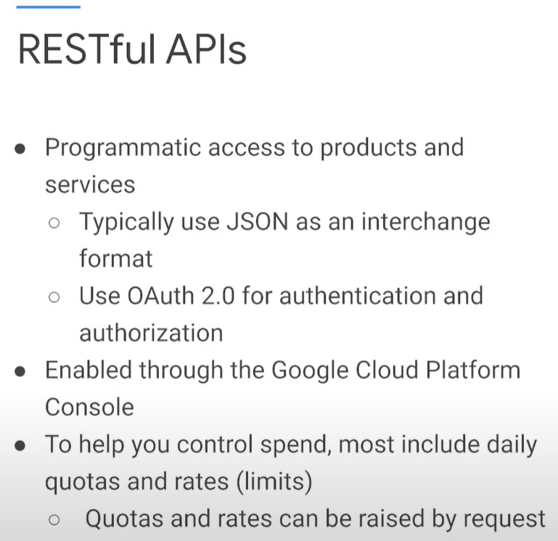

* + the services that make up gcp offers API which allow you to programmatically control your cloud environment through code
  + cloud apis provide functionality similar to cloud sdk and the cloud console and allow you to automate your workflow by using your favorite language

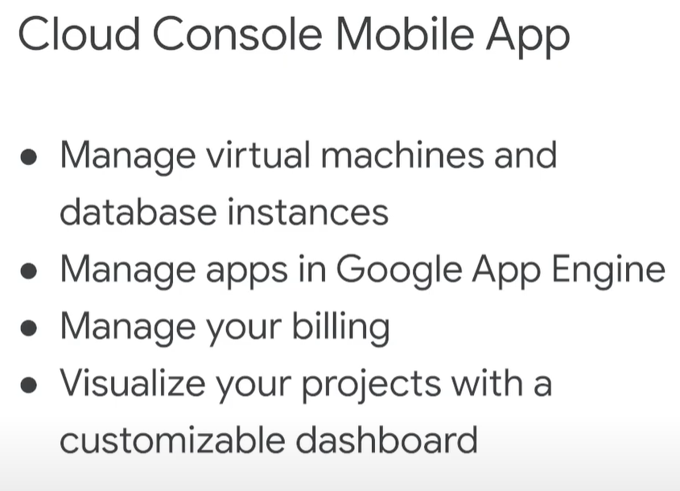

* + the cloud console mobile app gives you a convenient way to discover understand and respond to production issues, monitor and make changes to google cloud platform resources from your ios or android device, manage gcp resources such as projects billing, app engine apps and compute engine virtual machines. receive and respond to alerts helping you quickly address production affecting issues
* [Lab Intro: Getting Started with Cloud Shell and gcloud Command Line Interface](https://www.cloudskillsboost.google/course_sessions/743467/video/108518) 1 minute
* [Getting Started with Cloud Shell & gcloud Command Line Interface](https://www.cloudskillsboost.google/course_sessions/743467/labs/108519) 30 minutes
  + Overview
  + The gcloud CLI is a tool that provides the primary CLI to GC Platform. You can use this tool to perform many common platform tasks either from the CL or within scripts and other automation frameworks.
  + Cloud Shell is a free Debian-based VM that includes the latest Cloud SDK, including the gcloud CLI, popular runtimes, and git, all which allow you to start working quickly. Cloud Shell also has a persistent 5-GB home directory.
  + In this hands-on lab, you will learn how to connect to computing resources hosted on the Google Cloud Platform via Cloud Shell with the gcloud command-line tool.
  + Task 1. Create a virtual machine with 'gcloud' on Cloud Shell
    - In the Google Cloud Platform menu, click Activate Cloud Shell (Cloud Shell).
    - In Cloud Shell, run the following command:
      * gcloud compute instances create myvm --machine-type n1-standard-2
      * Type Y and press Enter at the location prompt.
      * Here is a breakdown of the command so you understand what is happening:
        + gcloud compute enables you to easily manage your Compute Engine resources.
        + instances create creates a new instance.
        + The name of the vm is myvm.
        + The --machine-type flag specifies the machine type as n1-standard-2, which provides 2 vCPU and 7.5GB of RAM.
    - After the machine starts, the CLI will show you its name, location, and IP addresses.
    - In addition, you can run the same gcloud commands from your own workstation instead of using Cloud Shell. In order to do that, you will need to download the Cloud SDK..
  + Task 2. Get information on commands
    - The gcloud CLI comes with built-in documentation that you can access at any time. Useful information like optional flags and expected arguments can be accessed whenever you need it.
    - To view the gcloud compute instance create manual, run: gcloud compute instances create --help
      * Press ENTER or the space bar to scroll through the content. Press Q to exit.
      * The --help flag provides a verbose output for commands. If you want a short summary, use the -h flag.
    - Run the following command in Cloud Shell: gcloud compute instances create -h
  + Task 3. Interactive Mode
    - Gcloud interactive mode features auto prompting for commands and flags and displays inline help snippets in the lower section as the command is typed.
    - Static information, like command and sub-command names, flag names, and enumerated flag values, is auto-completed using dropdown menus.
    - To start interactive mode, run: gcloud beta interactive
      * When using the interactive mode, press TAB to complete file path and resource arguments. If a dropdown menu appears, press TAB to move through the list, and press the space bar to select your choice.
    - Type the following command using interactive mode: gcloud compute instances describe myvm
    - The gcloud interactive mode can help you work quickly as you learn to use the command line interface.
  + Task 4. Use Cloud Shell for testing
    - The contents of your Cloud Shell Home directory persist across Google Cloud Projects between all Cloud Shell sessions, even after the Cloud Shell virtual machine terminates and is restarted. You can use the built-in Git to clone your code and familiar tools to edit it. You can even run any web application that listens to HTTP requests and view them via the Web Preview.
    - Clone a sample app to Cloud Shell: gsutil cp gs://cloud-training/Migrating2gcp/index.js .
    - Run the sample application in your Cloud Shell environment: node index.js
    - To view your running application, click Web Preview (Web Preview).
      * A 'Hello from your Cloud Shell!' message should appear in a new window.
* [Lab Solution: Getting Started with Cloud Shell and gcloud Command Line Interface](https://www.cloudskillsboost.google/course_sessions/743467/video/108520) 7 minutes
* [Quotas](https://www.cloudskillsboost.google/course_sessions/743467/video/108521) 2 minutes

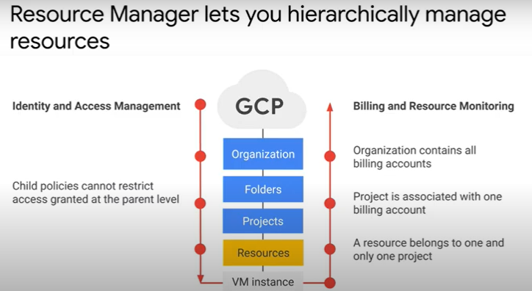

* + iam policies are inherited top to bottom, billing is accumulated from the bottom up
  + as you can see on the resource consumption is measured in quantities like rate of use or time
  + a project accumulates the consumption of all its resources, each project is associated with one billing account which means that an organization node contains all billing accounts

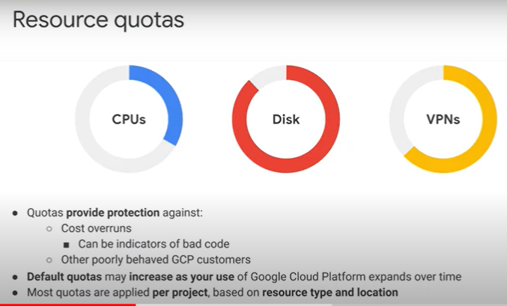

* + cloud resources have near unlimited capacity and since you pay for what you consume
  + quotas protect you from unintentional expenditure,
  + that's the reason all resources in gcp are subject to project quotas or limits where their purpose is to encourage you to make capacity planning, a priority by setting upper limits for resources which can be consumed within your project
  + a good example is decreasing a quota on the amount of vcpus from the default of 24 to 6 for a proof of concept or test project, therefore controlling the monthly bill as a result
  + if your project exceeds particular quota while using a service the platform will return an error given these quotas
  + if you expect a notable upcoming increase in usage you can proactively request quotas adjustments from the quotas page in the gcp console, this page will also display your current quotas

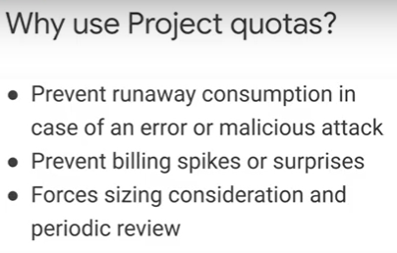

* + project quotas prevent runaway consumption in case of an error or a malicious attack
  + for example imagine you accidentally created a hundred instead of 10 compute engine instances using the gcloud command line having quotas in place can protect you from this scenario
  + quotas also prevent billing spikes or surprises
  + quotas are related to billing
  + finally quotas for sizing consideration and periodic review
    - for example do you really need 96 core instance or can you go with a smaller and cheaper
  + it is also important to mention that quotas are the maximum amount of resources you can create for that specific resource as long as these resources are available quotas, do not guarantee that the resources will be available at all times
    - for example if a region is out of local ssds you cannot create local ssds in that region even if you still had quota for local ssds
* [Pricing calculator and budget](https://www.cloudskillsboost.google/course_sessions/743467/video/108522) 2 minutes

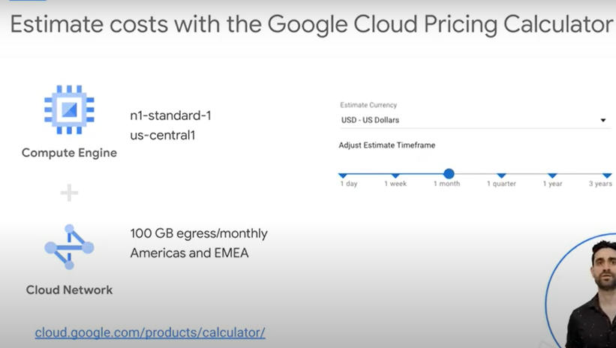

* + each gcp service has its own pricing model
  + using the gcp pricing calculator to estimate the cost of a collection of resources
  + the pricing calculator is a web-based tool that allows you to specify expected consumption of certain services and resources, you will receive an estimated cost of the utilization of these resources as the output from the PC
    - for example you can specify an n1 standard 1vm instance in the us central 1 along with 100 gigabyte of egress traffic to america's anemia, the pricing calculator then returns the total estimated cost
  + you can adjust the currency and time frame to meet your needs

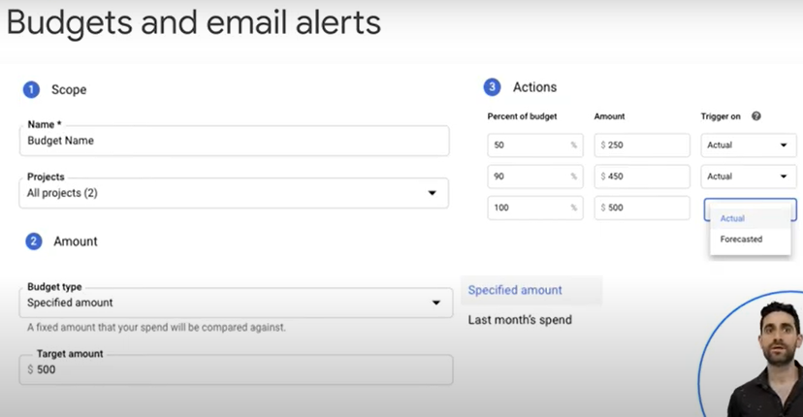

* + setting a budget lets you track how your spend is growing towards that amount
  + this screenshot shows you budget creation interface
  + set a budget name and specify which project this budget applies to
  + set the budget at a specific amount or match it to the previous month's spend
  + determine your budget percentage alert, these alerts send email to billing admins
  + after spend exceeds a percentage of the budget or a specified amount in our case it would send an email when spending reaches 50 90 and 100 of the budget amount

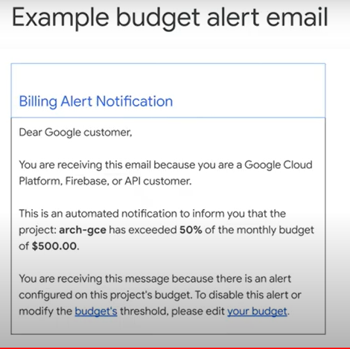

* [Labels](https://www.cloudskillsboost.google/course_sessions/743467/video/108523) 1 minute

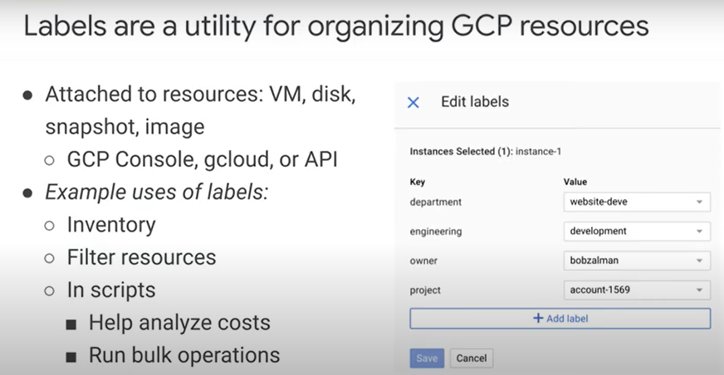

* + labels are a utility for organizing gcp resources
  + labels are key value pairs that you can attach to your resources like vms disks snapshots and images
  + you can create and manage labels using the gcp console, cloud or the resource manager api
  + each resource up to 64 labels
  + using this label you can search and list all your production resources for inventory purposes
  + labels can also be used in scripts to help analyze cost or run bulk operations on multiple resources the screenshot on the right shows an example of four labels that are created
  + some examples of what to use labels for

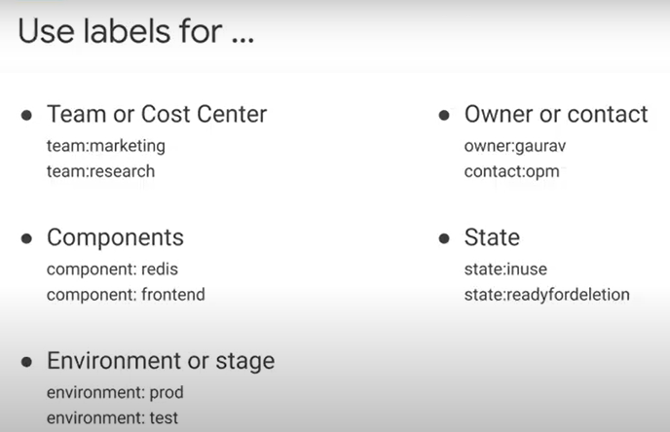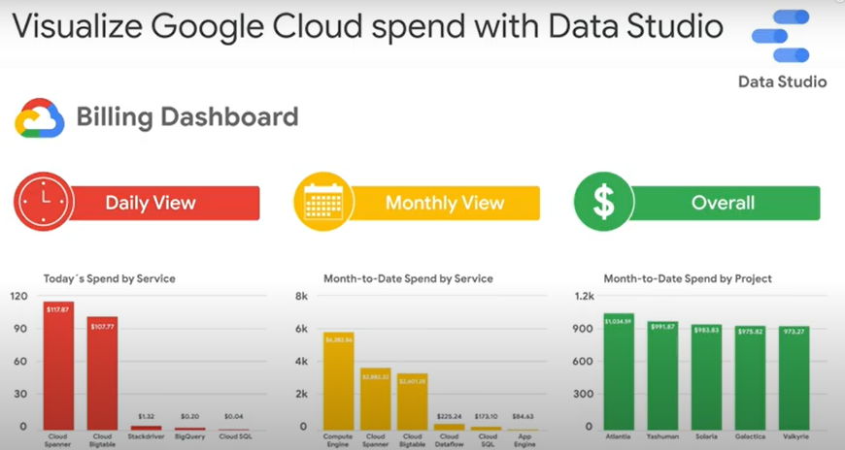

* + data studio turns your data into informative dashboards and reports that are easy to read easy o share and fully customizable
  + for example you can slice and dice your billing reports using your labels
* [Lab Intro: Understanding and Analyzing your Costs with Google Cloud](https://www.cloudskillsboost.google/course_sessions/743467/video/108524) 1 minute
* [Understanding and Analyzing your Costs with Google Cloud 4](https://www.cloudskillsboost.google/course_sessions/743467/labs/108525)5 minutes
  + Overview
    - Google Cloud cost management tools provide greater visibility, accountability, control, and intelligence so that you can scale your business in the cloud with confidence. Tailored to meet the needs of organizations of all sizes, these tools help reduce complexity and increase the predictability of your cloud costs.
    - Cloud Billing Reports is a cost management tool that provides built-in reporting within the Cloud Console. In this lab, you familiarize yourself with Billing reports and understand how to answer fundamental cost management questions, such as:
      * How much am I spending?
      * What are my cost trends?
      * What are my cost drivers?
  + **What you'll do**
    - View Billing reports in the Cloud Console using a sample billing account.
    - View your current and forecasted Cloud costs at project, product, and SKU level.
    - Analyze costs using report filters to identify cost drivers and trends. Examples of report filters include **Projects**, **Products**, **SKUs**, **Locations**, and **Credits**.
  + Open the sample billing account
    - Click [this link](https://console.cloud.google.com/billing/01150A-B8F62B-47D999/reports?organizationId=433637338589) to open the Cloud Console and see a Billing report for a sample billing account.
    - You are now in the Cloud Console in the Billing Reports Overview lab, looking at a Billing report.
    - To access Google Cloud Billing in your own environment, you'll need one of the Cloud Billing roles outlined [here](https://cloud.google.com/billing/docs/how-to/billing-access" \t "_blank).Notice that you use the left panel to navigate Billing views:
    -  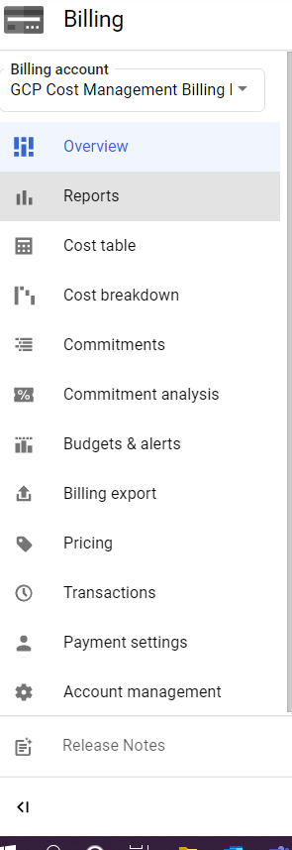
  + How much am I spending?
  + **The chart**
    - In Billing, if necessary, click **Reports** in the left panel to view Billing reports for your sample account. This page includes a chart that plots usage costs for all projects linked to a billing account.
    - By default, the chart shows current and forecasted costs by project for the current calendar month.
    - In the top left, you see actual costs to date for the current month and how they compare to the costs over the same number of days in the preceding month.

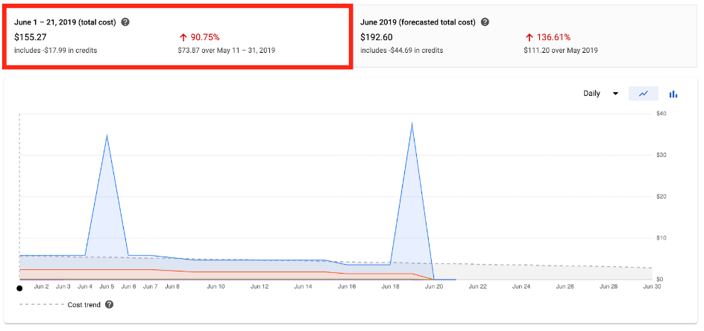

* + - In the top right, you see the total forecasted cost for the current month and a comparison to the previous month.

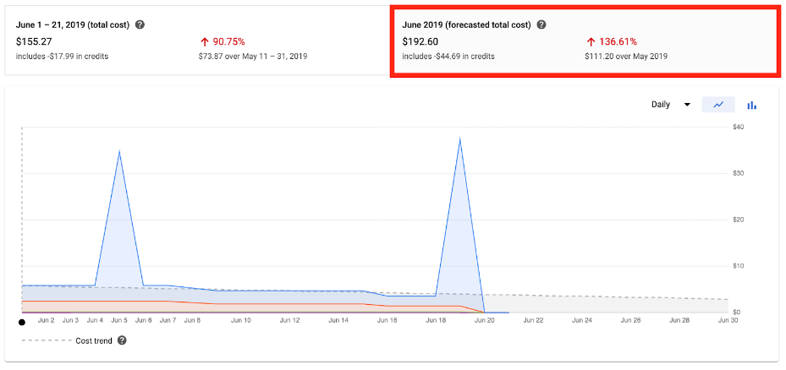

* + - Each color in the chart corresponds to a different project. To visualize your daily costs grouped by project, hover over a specific day on one of the colors in the chart to compare the cost for that project to the total cost for the day.

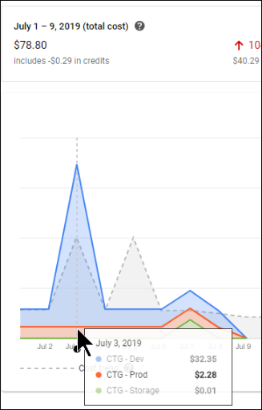

* + - The cost trend line (the dotted line) is visible when your selected time period includes a date in the future.

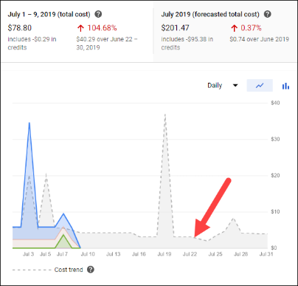

* + - The cost trend line indicates how much you're forecasted to spend in that time period.
    - It also reflects both the long-term trend and any consistent monthly cycles. See [Viewing your forecasted costs](https://cloud.google.com/billing/docs/how-to/reports#cost-forecast) for more information.
    - Below the chart is a summary of the costs by project in the selected time period.
    - 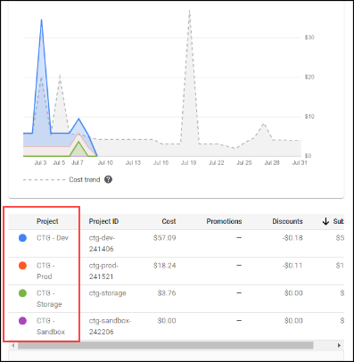
  + **Filters and grouping**
    - Customize your view using the drop-downs for filtering and grouping.

#### View your charges by invoice and without taxes or adjustments

* + - Click **Show filters** in the upper right.

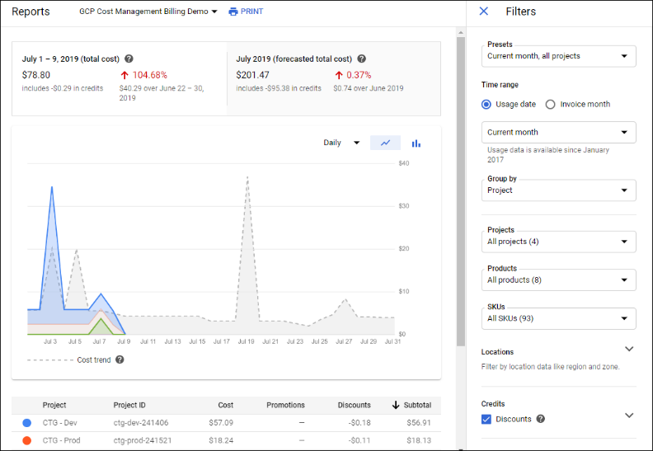

* + - In the **Time range** section, select **Invoice month**, and set your **From** and **To** month range.
    - Under **Invoice level charges**, clear **Tax**.
    - View the chart. Notice that the **Reports** page updates to match the invoice month and tax option you selected. The table below the chart displays the cost breakdown based on your filter selections.
    - 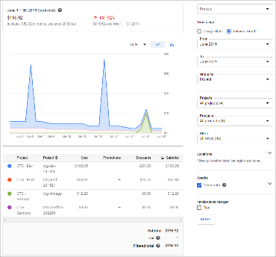
  + What are my cost trends?
    - To determine your cost trends, filter the view and see how your costs have changed. In this section you filter by: **Time range**, **Location**, **Credits**
  + **View your cost trend over a specified time period**
    - * Back in the **Filters** panel, in the **Time range** section, select **Usage date**, and then change the time period to **Last 30 days**.
      * The chart now shows the last 30 days of usage. As before, the top of the graph shows your costs compared to the previous time period so you can easily compare how your costs trend over time.

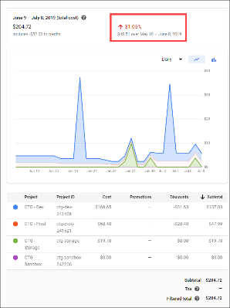

* + - * To see more information about your costs, use additional filters such as **Location** or **Credits**.
  + **View your cost trend by location**
    - Expand the **Locations** section to filter costs to a specific **Geography**, **Multi-region** or **Region**.
    - Click on an individual region or multi-region area to include data from only those locations in your current view.
    - The **Geography** and **Region** options you clicked turn blue, and the chart shows only data from those filters.
    - **Optional:** Select different **Geography** or **Region & multi-region** options and view the result in the chart.
    - Clear the **Geography** or **Region & multi-region** options previously selected, and collapse the **Locations** section.
  + **View your cost trend by credits**
    - See your costs without discounts applied, such as [sustained use discounts](https://cloud.google.com/compute/docs/sustained-use-discounts).
    - Expand the **Credits** section.
    - Clear **Sustained use discounts**.
    - In this lab, because the **Sustained use discount**is the only available discount, the **Discounts** option is automatically cleared when you clear **Sustained use discount.**
    - Note how the chart is more flat when the automatically applied discounts are no longer reflected.
    - Optional: Toggle to select/clear **Sustained use discount**, and view how the chart changes.
    - Select **Sustained use discount** and collapse the **Credits** section.
  + What are my cost drivers?
    - With Billing reports, you can visualize and investigate any unexpected changes in cost.
  + **Find the unexpected cost increase**
    - Because your **Report** view is a working project, your chart looks different from the chart in this section and has different spikes. Follow along to learn how to find the cause of an unexpected cost increase, and then use what you learned to determine the cause of an unexpected cost increase in your chart.
    - In the chart below, notice an unexpected cost increase of mysterious origins:

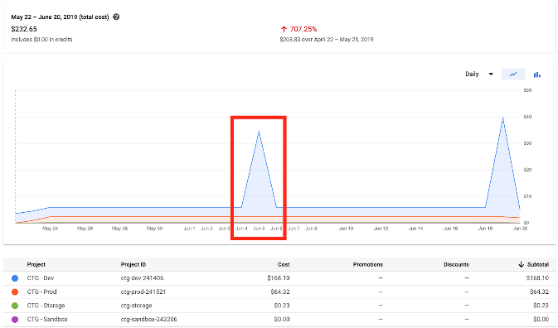

* + - * What's causing the large increase in cost on this date? Hover over the spike in the chart to identify the project.

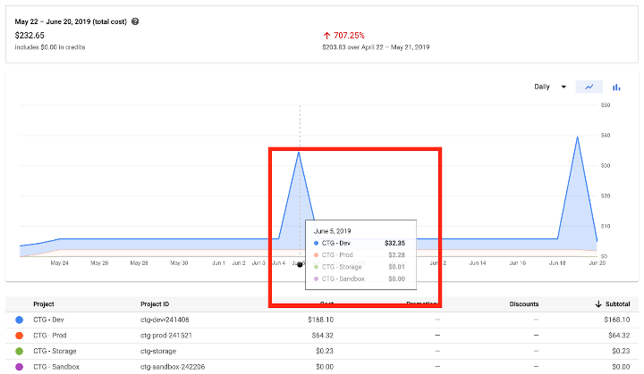

* + - * In this case the project causing the large cost increase is CTG-Dev.
      * Filter to see costs from the CTG-Dev project and group these costs by Product:
      * In the **Projects** dropdown, select **CTG - Dev**.
      * In the **Group by** dropdown, select **Product**.
    - Now that the costs are grouped by product, hover over the spike in the chart to see which product has caused the increase in cost.

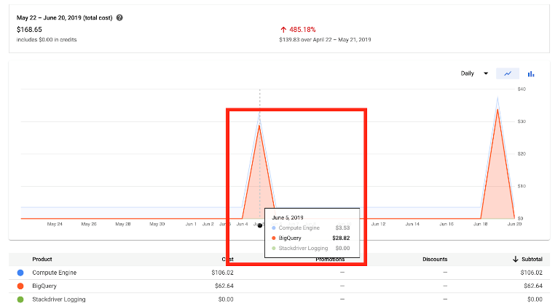

* + - In this case, it looks like BigQuery caused the increase in cost.
    - As a next step, group by SKU to get more detailed information.
    - Back in **Filters**, select **SKU** from the **Group by** dropdown.
    - Close **Filters**, and then hover over the spike in the chart to see which SKU has caused the increase in cost.

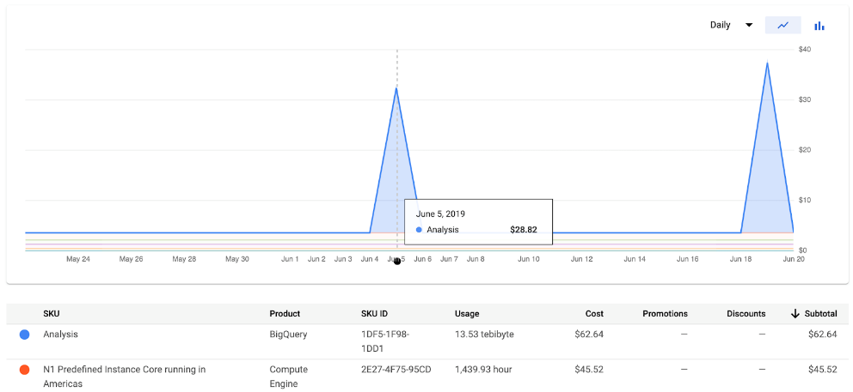

* + - In this case, the BigQuery Analysis SKU was the highest cost on this day. This SKU is charged when executing queries using BigQuery.
    - Now that you know how, find a spike in your chart and determine what caused the unexpected cost increase.
    - How can I see a summary of my costs?
    - Billing reports shows current cost trends and forecasted costs. The cost breakdown report shows what you would have spent at the on-demand price for your Google Cloud usage, and how your final invoice amount was affected by any credits, adjustments, and taxes.
    - To view the cost breakdown report for your sample billing account, click **Cost breakdown** in the left panel.
    - View your total costs for a specific invoice month and see how credits and taxes affected the final amount invoiced for that month. For example, [sustained use discounts](https://cloud.google.com/compute/docs/sustained-use-discounts) automatically apply to Compute Engine resources that run a significant portion of the billing month, helping save you money. The chart below shows the total cost of usage minus the credits applied for sustained use discounts.

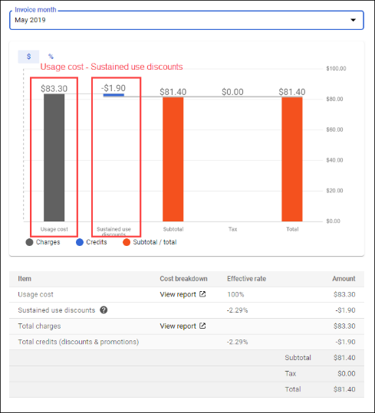

* [Lab Solution: Understanding and Analyzing your Costs with Google Cloud](https://www.cloudskillsboost.google/course_sessions/743467/video/108526) 8 minutes
* Review 1 minute

## **4.0 Virtual Machines and Networks in the Cloud**

* In this module, you will learn how to create a Virtual Private Cloud, your network hosted on Google Cloud’s infrastructure. You will also learn how to control access to your network with firewall rules and how to create subnets. You will then learn how to create and manage Virtual Machines in Compute Engine, choose the right configuration, and understand Compute Engine’s pricing model. Lastly, you will learn how to create a connection between your source environment and your Virtual Private Cloud.
* Module Overview 1 minute
* [Regions and Zones](https://www.cloudskillsboost.google/course_sessions/743467/video/108529) 3 minutes

|  |  |
| --- | --- |
|  |  |
|  |  |

* + regions are independent geographical area that consist of zones
  + region is usually referred to by a continent
  + most regions have three or more zones to ensure redundancy
  + a regional resource like an external ip address is available to all the zones in a region and benefits from a higher degree of resiliency
  + a zone should be considered a single failure domain within a region
  + google designs zones to be independent of each other a zone has power cooling networking and control planes that are isolated from one another
* [Virtual Private Cloud](https://www.cloudskillsboost.google/course_sessions/743467/video/108530) 2 minutes

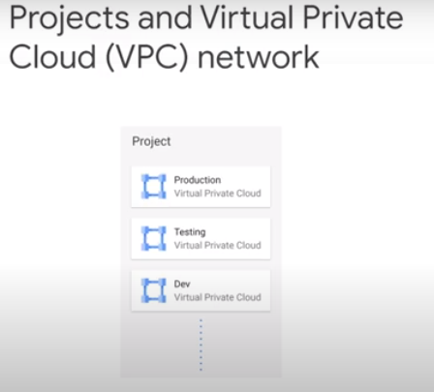

* + each project comes with a default virtual private cloud or vpc which is a global network
  + you can use more than one vpc in each project

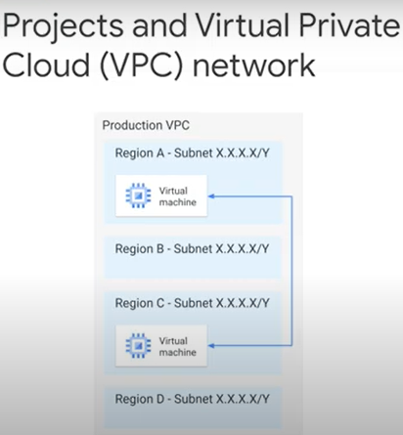

* + the default vpc is a global network spending all available regions across the world
  + inside a network you can segregate your resources with regional subnetworks which have ip ranges associated with them
  + you can have resources in different zones on the same subnet which makes management and fault tolerance a lot easier

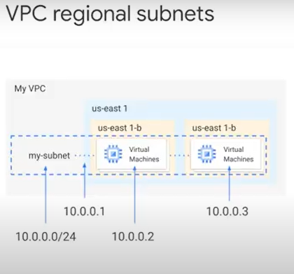

* + in this example the vpc has a subnet in the usd1 region, the iep range spans across all zones in the region so both virtual machines you see on the screen are part of the same subnet
* [Virtual Private Cloud types](https://www.cloudskillsboost.google/course_sessions/743467/video/108531) 2 minutes

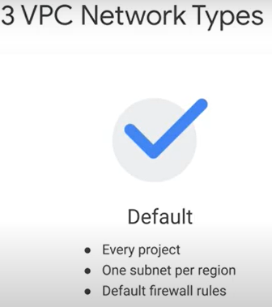 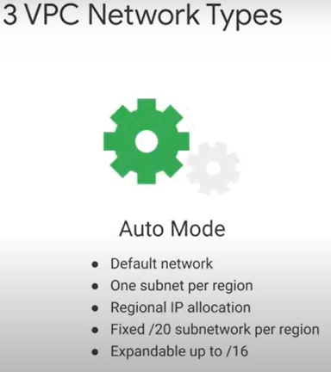 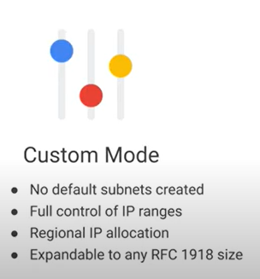

* + every project is provisioned with a default vpc network that comes with a preset of subnets and firewall rules
  + a subnet is allocated for each region with a non-overlapping ip range and firewall rules that allows ingress traffic for icmp, rdp and ssh traffic from anywhere, as well as an ingress traffic from within the default network for all protocols and ports
  + we recommend using the default vpc for prototyping and testing purposes
  + in an automotive network one subnet from each region is automatically created
  + the default network is actually an auto mode network
  + an auto mode network, can manually add and modify these automatically created subnets
  + a custom mode network does not automatically create subnets
  + this type of network provides you with complete control over the subnets and the ip ranges
  + this network is recommended for production because it assumes no implicit trust and gives you maximum control over its layout
  + it is also recommended network if you want to interconnect your vpc network with other networks because you have control over the ip address layout
  + you can convert an auto mode network to a custom mode network
  + but the custom mode networks cannot be changed to an automode networks
* [Demo: Expand a Subnet](https://youtu.be/8o77N1fYFJA) 2 minutes
* [Firewall rules](https://youtu.be/5WO5hpuw93k) 1 minute

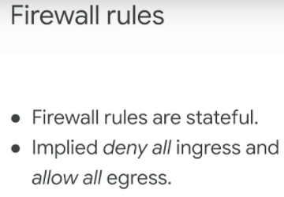 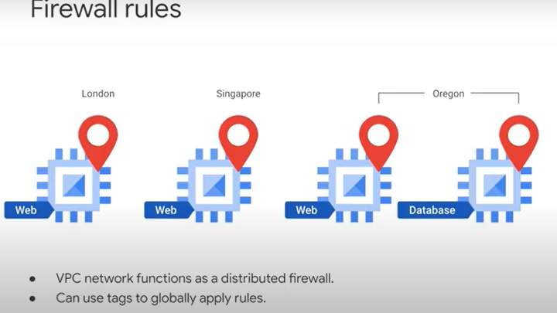

* + for example, tag(web) all your web servers and write a firewall rule saying that traffic on ports 80 and 443 is allowed into all vms with the web tag, no matter what their ip address is or where they are located
  + gcp firewall rules are stateful that means that firewall rules allow bi-directional communication once a session is established

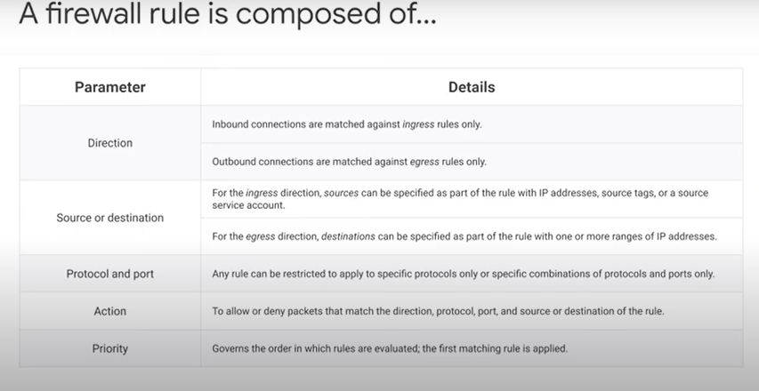

* [Lab Intro: VPC Networking](https://youtu.be/LQghynhUJDQ) 1 minute
* [VPC Networking](https://www.cloudskillsboost.google/course_sessions/743467/labs/108535) 45 minutes
  + Overview
  + Google Cloud Virtual Private Cloud (VPC) provides networking functionality to Compute Engine VM instances, Kubernetes Engine containers, and the App Engine flexible environment. In other words, without a VPC network, you cannot create VM instances, containers, or App Engine applications. Therefore, each Google Cloud project has a **default** network to get you started.
  + You can think of a VPC network as similar to a physical network, except that it is virtualized within Google Cloud. A VPC network is a global resource that consists of a list of regional virtual subnetworks (subnets) in data centers, all connected by a global wide area network (WAN). VPC networks are logically isolated from each other in Google Cloud.
  + In this lab, you create an auto mode VPC network with firewall rules and two VM instances. Then, you convert the auto mode network to a custom mode network and create other custom mode networks as shown in the network diagram below. You also test connectivity across networks.
  + 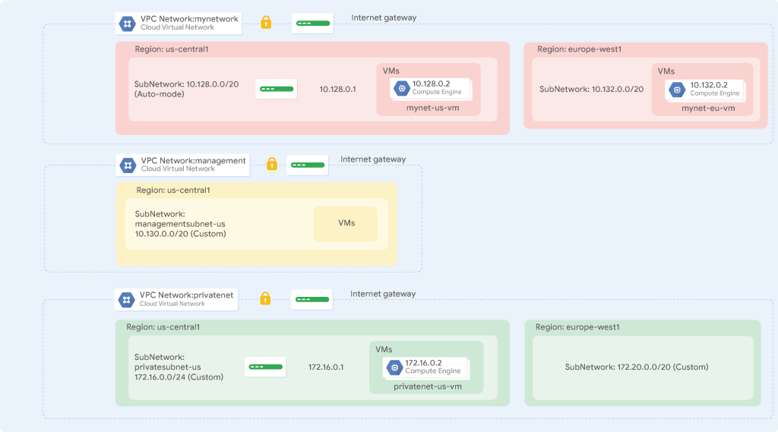
  + **Objectives**
  + In this lab, you learn how to perform the following tasks:
    - Explore the default VPC network
    - Create an auto mode network with firewall rules
    - Convert an auto mode network to a custom mode network
    - Create custom mode VPC networks with firewall rules
    - Create VM instances using Compute Engine
    - Explore the connectivity for VM instances across VPC networks
  + Task 1. Explore the default network
    - Each Google Cloud project has a **default** network with subnets, routes, and firewall rules.

### **View the subnets,** the **Navigation menu**, click **VPC network** > **VPC networks**

* + - * The **default** network has a subnet in each [Google Cloud region](https://cloud.google.com/compute/docs/regions-zones/#available).
      * Notice the **default** network with its subnets. Each subnet is associated with a GC region and a private RFC 1918 CIDR block for its internal **IP addresses range** and a **gateway**.
    - **View the routes,** In the left pane, click **Routes**.
      * Routes tell VM instances and the VPC network how to send traffic from an instance to a destination, either inside the network or outside GC. Each VPC network comes with some default routes to route traffic among its subnets and send traffic from eligible instances to the internet.
      * Notice that there is a route for each subnet and one for the **Default internet gateway** (0.0.0.0/0). These routes are managed for you, but you can create custom static routes to direct some packets to specific destinations. For example, you can create a route that sends all outbound traffic to an instance configured as a NAT gateway.
    - **View the firewall rules,** In the left pane, click **Firewall**.
      * Each VPC network implements a distributed virtual firewall that you can configure. Firewall rules allow you to control which packets are allowed to travel to which destinations. Every VPC network has two implied firewall rules that block all incoming connections and allow all outgoing connections.
      * Notice that there are 4 **Ingress** firewall rules for the **default** network:
        + default-allow-icmp, default-allow-rdp, default-allow-ssh, default-allow-internal
      * These firewall rules allow **ICMP**, **RDP**, and **SSH** ingress traffic from anywhere (0.0.0.0/0) and all **TCP**, **UDP**, and **ICMP** traffic within the network (10.128.0.0/9). The **Targets**, **Filters**, **Protocols/ports**, and **Action** columns explain these rules.
    - **Delete the Firewall rules**
      * Left pane, click **Firewall**. Select all default network firewall rules. Click **Delete & Delete** .
    - **Delete the default network**
      * click **VPC networks**. Select the **default** network. Click **Delete VPC network & Delete**.
      * Wait for the network to be deleted before continuing.
      * click **Routes**. Notice that there are no routes.
      * click **Firewall**. Notice that there are no firewall rules.
      * **Note:**Without a VPC network, there are no routes!
      * Without a VPC network, you cannot create VM instances, containers, or App Engine applications. True
    - **Try to create a VM instance,** Verify that you cannot create a VM instance without a VPC network.
      * the **Navigation menu > Compute Engine > VM instances ->** **Create Instance** > **Create**.
      * Notice the error.
      * Click **Management, security, disks, networking, sole tenancy**.
      * Click **Networking**. Notice the **No local network available** error under **Network interfaces**. Click **Cancel**.
      * **Note:**As expected, you cannot create a VM instance without a VPC network!
  + Task 2. Create an auto mode network
    - You have been tasked to create an auto mode network with two VM instances. Auto mode networks are easy to set up and use because they automatically create subnets in each region. However, you don't have complete control over the subnets created in your VPC network, including regions and IP address ranges used.
    - Feel free to explore more [considerations for choosing an auto mode network](https://cloud.google.com/vpc/docs/vpc#auto-mode-considerations), but for now, assume that you are using the auto mode network for prototyping purposes.
    - **Create an auto mode VPC network with firewall rules**
      * On the **Navigation menu** (), click **VPC network** > **VPC networks** > **Create VPC network**.
        + For **Name**, type **mynetwork** For **Subnet creation mode**, click **Automatic**.

Auto mode networks create subnets in each region automatically.

* + - * + For **Firewall rules**, select all available rules. Click Create

These are the same standard firewall rules that the default network had. The **deny-all-ingress** and **allow-all-egress** rules are also displayed, but you cannot select or disable them because they are implied. These two rules have a lower **Priority** (higher integers indicate lower priorities) so that the allow ICMP, internal, RDP, and SSH rules are considered first.

* + - * When the new network is ready, notice that a subnet was created for each region.
      * **Note:**If you ever delete the default network, you can quickly re-create it by creating an auto mode network as you just did.
* Create a VM instance in the us-central1 region. Selecting a region and zone determines the subnet and assigns the internal IP address from the subnet's IP address range.
  + On the **Navigation menu** (), click **Compute Engine** > **VM instances** > **Create Instance > Create**.
    - Specify the following, and leave the remaining settings as their defaults:

|  |  |
| --- | --- |
| **Property** | **Value (type value or select option as specified)** |
| Name | mynet-us-vm |
| Region | us-central1 |
| Zone | us-central1-c |
| Series | N1 |
| Machine type | n1-standard-1 (1 vCPU, 3.75 GB memory) |
| Boot disk | Debian GNU/Linux 10 (buster) |

* + Verify that the **Internal IP** for the new instance was assigned from the IP address range for the subnet in **us-central1** (10.128.0.0/20).
    - The **Internal IP** should be 10.128.0.2 because 10.128.0.1 is reserved for the gateway, and you have not configured any other instances in that subnet.
* Create a VM instance in the europe-west1 region.
  + Click **Create instance**. Click **Create**
  + Specify the following, and leave the remaining settings as their defaults:

|  |  |
| --- | --- |
| **Property** | **Value (type value or select option as specified)** |
| Name | mynet-eu-vm |
| Region | europe-west1 |
| Zone | europe-west1-c |
| Series | N1 |
| Machine type | n1-standard-1 (1 vCPU, 3.75 GB memory) |
| Boot disk | Debian GNU/Linux 10 (buster) |

* + Verify that the **Internal IP** for the new instance was assigned from the IP address range for the subnet in **europe-west1** (10.132.0.0/20).
    - The **Internal IP** should be 10.132.0.2 because 10.132.0.1 is reserved for the gateway, and you have not configured any other instances in that subnet.
  + **Note:**The **External IP addresses** for both VM instances are ephemeral. If an instance is stopped, any ephemeral external IP addresses assigned to the instance are released back into the general Compute Engine pool and become available for use by other projects.
    - When a stopped instance is started again, a new ephemeral external IP address is assigned to the instance. Alternatively, you can reserve a static external IP address, which assigns the address to your project indefinitely until you explicitly release it.

### **Verify connectivity for the VM instances**

* + - The firewall rules that you created with **mynetwork** allow ingress SSH and ICMP traffic from within **mynetwork** (internal IP) and outside that network (external IP).
    - On the **Navigation menu**, click **Compute Engine > VM instances**.
      * Note the external and internal IP addresses for **mynet-eu-vm**.
    - For **mynet-us-vm**, click **SSH** to launch a terminal and connect.
      * **Note:**You can SSH because of the **allow-ssh** firewall rule, which allows incoming traffic from anywhere (0.0.0.0/0) for **tcp:22**. The SSH connection works seamlessly because Compute Engine generates an SSH key for you and stores it in one of the following locations:
        + By default, Compute Engine adds the generated key to project or instance metadata.
        + If your account is configured to use OS Login, Compute Engine stores the generated key with your user account.
      * Alternatively, you can control access to Linux instances by creating SSH keys and editing public SSH key metadata.
    - To test connectivity to **mynet-eu-vm**'s internal IP, run the following command, replacing **mynet-eu-vm**'s internal IP: ping -c 3 <Enter internal IP here>
      * You can ping **mynet-eu-vm**'s internal IP because of the **allow-internal** firewall rule.
    - To test connectivity to **mynet-eu-vm**'s external IP, run the following command, replacing **mynet-eu-vm**'s external IP: ping -c 3 <Enter external IP here>
    - Which firewall rule allows the ping to mynet-eu-vm's external IP address?
      * Checkmynetwork-allow-icmp
      * mynetwork-allow-internal
      * mynetwork-allow-rdp
      * mynetwork-allow-ssh
      * **Note:**You can SSH to **mynet-us-vm** and ping **mynet-eu-vm**'s internal and external IP addresses as expected. Alternatively, you can SSH to **mynet-eu-vm** and ping **mynet-us-vm**'s internal and external IP addresses, which also works.

### **Convert the network to a custom mode network**

* + - * + The auto mode network worked great so far, but you have been asked to convert it to a custom mode network so that new subnets aren't automatically created as new regions become available. This could result in overlap with IP addresses used by manually created subnets or static routes, or could interfere with your overall network planning.
        + On the **Navigation menu** (), click **VPC network > VPC networks**.
        + Click **mynetwork** to open the network details. Click **Edit**.
        + Select **Custom** for the **Subnet creation mode**. Click **Save**.
        + Return to the **VPC networks** page.

Wait for the **Mode** of **mynetwork** to change to **Custom**.

* + - * + You can click **Refresh** while you wait.
        + **Note:**Converting an auto mode network to a custom mode network is an easy task, and it provides you with more flexibility. We recommend that you use custom mode networks in production.
  + Task 3. Create custom mode networks
    - You have been tasked to create two additional custom networks, **managementnet** and **privatenet**, along with firewall rules to allow **SSH**, **ICMP**, and **RDP** ingress traffic and VM instances as shown in this diagram (with the exception of vm-appliance):



* + - Note that the IP CIDR ranges of these networks do not overlap. This allows you to set up mechanisms such as VPC peering between the networks. If you specify IP CIDR ranges that are different from your on-premises network, you could even configure hybrid connectivity using VPN or Cloud Interconnect.
  + Create the **managementnet** network using the Cloud Console.
    - In the Cloud Console, on the **Navigation menu** (), click **VPC network > VPC networks**.
    - Click **Create VPC Network**. For **Name**, type **managementnet**
    - For **Subnet creation mode**, click **Custom**.
    - Specify the following, and leave the remaining settings as their defaults:

|  |  |
| --- | --- |
| **Property** | **Value (type value or select option as specified)** |
| Name | managementsubnet-us |
| Region | us-central1 |
| IP address range | 10.130.0.0/20 |

* + - Click **Done**. Click **Equivalent Command line**.
      * These commands illustrate that networks and subnets can be created using the gcloud command line. You will create the **privatenet** network using these commands with similar parameters.
    - Click **Close**. Click **Create**.
    - Create the **privatenet** network using the gcloud command line.
      * In the Cloud Console, click **Activate Cloud Shell** ().
      * To create the **privatenet** network, run the following command:
        + gcloud compute networks create privatenet --subnet-mode=custom
      * To create the **privatesubnet-us** subnet, run the following command:
        + gcloud compute networks subnets create privatesubnet-us --network=privatenet --region=us-central1 --range=172.16.0.0/24
      * To create the **privatesubnet-eu** subnet, run the following command:
        + gcloud compute networks subnets create privatesubnet-eu --network=privatenet --region=europe-west1 --range=172.20.0.0/20
      * To list the available VPC networks, run the following command:
        + gcloud compute networks list
        + The output should look like this (**do not copy; this is example output**):
  + NAME SUBNET\_MODE BGP\_ROUTING\_MODE IPV4\_RANGE GATEWAY\_IPV4
  + managementnet CUSTOM REGIONAL
  + mynetwork CUSTOM REGIONAL
  + privatenet CUSTOM REGIONAL
    - * To list the available VPC subnets (sorted by VPC network), run the following command:
        + gcloud compute networks subnets list --sort-by=NETWORK
      * The output should look like this (**do not copy; this is example output**):
* NAME REGION NETWORK RANGE
* managementsubnet-us us-central1 managementnet 10.130.0.0/20
* mynetwork us-central1 mynetwork 10.128.0.0/20
* mynetwork europe-west1 mynetwork 10.132.0.0/20
* mynetwork us-west1 mynetwork 10.138.0.0/20
* mynetwork asia-east1 mynetwork 10.140.0.0/20
* mynetwork us-east1 mynetwork 10.142.0.0/20
* mynetwork asia-northeast1 mynetwork 10.146.0.0/20
* mynetwork asia-southeast1 mynetwork 10.148.0.0/20
* mynetwork us-east4 mynetwork 10.150.0.0/20
* mynetwork australia-southeast1 mynetwork 10.152.0.0/20
* mynetwork europe-west2 mynetwork 10.154.0.0/20
* mynetwork europe-west3 mynetwork 10.156.0.0/20
* mynetwork southamerica-east1 mynetwork 10.158.0.0/20
* mynetwork asia-south1 mynetwork 10.160.0.0/20
* mynetwork northamerica-northeast1 mynetwork 10.162.0.0/20
* mynetwork europe-west4 mynetwork 10.164.0.0/20
* mynetwork europe-north1 mynetwork 10.166.0.0/20
* mynetwork us-west2 mynetwork 10.168.0.0/20
* mynetwork asia-east2 mynetwork 10.170.0.0/20
* mynetwork europe-west6 mynetwork 10.172.0.0/20
* mynetwork asia-northeast2 mynetwork 10.174.0.0/20
* mynetwork asia-northeast3 mynetwork 10.178.0.0/20
* mynetwork us-west3 mynetwork 10.180.0.0/20
* mynetwork us-west4 mynetwork 10.182.0.0/20
* mynetwork asia-southeast2 mynetwork 10.184.0.0/20
* mynetwork europe-central2 mynetwork 10.186.0.0/20
* privatesubnet-eu europe-west1 privatenet 172.20.0.0/20
* privatesubnet-us us-central1 privatenet 172.16.0.0/24
  + - * **Note:**The **managementnet** and **privatenet** networks only have the subnets that you created because they are custom mode networks. **mynetwork** is also a custom mode network, but it started out as an auto mode network, resulting in subnets in each region.
    - In the Cloud Console, on the **Navigation menu**, click **VPC network > VPC networks**.
    - Verify that the same networks and subnets are listed in the Cloud Console.
  + **Create the firewall rules for managementnet**
    - Create firewall rules to allow **SSH**, **ICMP**, and **RDP** ingress traffic to VM instances on the **managementnet** network.
    - In the Cloud Console, on the **Navigation menu** (), click **VPC network > Firewall**.
    - Click **Create Firewall Rule**.
    - Specify the following, and leave the remaining settings as their defaults:

|  |  |
| --- | --- |
| **Property** | **Value (type value or select option as specified)** |
| Name | managementnet-allow-icmp-ssh-rdp |
| Network | managementnet |
| Targets | All instances in the network |
| Source filter | IPv4 Ranges |
| Source IPv4 ranges | 0.0.0.0/0 |
| Protocols and ports | Specified protocols and ports |

* + - * **Note:**Make sure to include the **/0** in the **Source IPv4 ranges** to specify all networks.
    - Select **tcp** and specify ports **22** and **3389**.
    - Select **Other protocols** and specify **icmp** protocol.
    - Click **Equivalent Command line**.
      * These commands illustrate that firewall rules can also be created using the gcloud command line. You will create the **privatenet**'s firewall rules using these commands with similar parameters.
    - Click **Close**. Click **Create**.
    - Create the firewall rules for **privatenet** network using the gcloud command line.
      * Return to **Cloud Shell**. If necessary, click **Activate Cloud Shell** ().
      * To create the **privatenet-allow-icmp-ssh-rdp** firewall rule, run the following command:
        + gcloud compute firewall-rules create privatenet-allow-icmp-ssh-rdp --direction=INGRESS --priority=1000 --network=privatenet --action=ALLOW --rules=icmp,tcp:22,tcp:3389 --source-ranges=0.0.0.0/0
        + The output should look like this (**do not copy; this is example output**):
* NAME NETWORK DIRECTION PRIORITY ALLOW DENY
* privatenet-allow-icmp-ssh-rdp privatenet INGRESS 1000 icmp,tcp:22,tcp:3389
  + - * To list all the firewall rules (sorted by VPC network), run the following command:
        + gcloud compute firewall-rules list --sort-by=NETWORK
        + The output should look like this (**do not copy; this is example output**):
* NAME NETWORK DIRECTION PRIORITY ALLOW
* managementnet-allow-icmp-ssh-rdp managementnet INGRESS 1000 icmp,tcp:22,tcp:3389
* mynetwork-allow-icmp mynetwork INGRESS 1000 icmp
* mynetwork-allow-internal mynetwork INGRESS 65534 all
* mynetwork-allow-rdp mynetwork INGRESS 1000 tcp:3389
* mynetwork-allow-ssh mynetwork INGRESS 1000 tcp:22
* privatenet-allow-icmp-ssh-rdp privatenet INGRESS 1000 icmp,tcp:22,tcp:3389
  + - * The firewall rules for **mynetwork** network have been created for you. You can define multiple protocols and ports in one firewall rule (**privatenet** and **managementnet**) or spread them across multiple rules (**default** and **mynetwork**).
      * he **Navigation menu** > **VPC network > Firewall**. Verify that the same firewall rules are listed in the Cloud Console.
  + Next, create two VM instances:
    - **managementnet-us-vm** in **managementsubnet-us**
    - **privatenet-us-vm** in **privatesubnet-us**
  + **Create the managementnet-us-vm instance**
    - Create the **managementnet-us-vm** instance using the Cloud Console.
    - the **Navigation menu** (), click **Compute Engine > VM instances** > Click **Create instance**.
    - Specify the following, and leave the remaining settings as their defaults:

|  |  |
| --- | --- |
| **Property** | **Value (type value or select option as specified)** |
| Name | managementnet-us-vm |
| Region | us-central1 |
| Zone | us-central1-c |
| Series | N1 |
| Machine type | f1-micro (1 vCPU, 614 MB memory) |
| Boot disk | Debian GNU/Linux 10 (buster) |

* + - Click **Management, security, disks, networking, sole tenancy**. Click **Networking**.
    - For **Network interfaces**, click the dropdown arrow to edit.
    - Specify the following, and leave the remaining settings as their defaults:

|  |  |
| --- | --- |
| **Property** | **Value (type value or select option as specified)** |
| Network | Managementnet |
| Subnetwork | managementsubnet-us |

* + - * **Note:**The subnets available for selection are restricted to those in the selected region (us-central1).
    - Click **Done**. Click **command line**.
      * This illustrates that VM instances can also be created using the gcloud command line. You will create the **privatenet-us-vm** instance using these commands with similar parameters.
    - Click **Close**. Click **Create**.
    - Create the **privatenet-us-vm** instance using the gcloud command line.
      * Return to **Cloud Shell**. If necessary, click **Activate Cloud Shell** ().
      * To create the **privatenet-us-vm** instance, run the following command:
        + gcloud compute instances create privatenet-us-vm --zone=us-central1-c --machine-type=f1-micro --subnet=privatesubnet-us --image-family=debian-10 --image-project=debian-cloud --boot-disk-size=10GB --boot-disk-type=pd-standard --boot-disk-device-name=privatenet-us-vm
        + The output should look like this (**do not copy; this is example output**):
* NAME ZONE MACHINE\_TYPE PREEMPTIBLE INTERNAL\_IP EXTERNAL\_IP STATUS
* privatenet-us-vm us-central1-c f1-micro 172.16.0.2 34.66.197.202 RUNNING
  + - * To list all the VM instances (sorted by zone), run the following command:
        + gcloud compute instances list --sort-by=ZONE
        + The output should look like this (**do not copy; this is example output**):
* NAME ZONE MACHINE\_TYPE PREEMPTIBLE INTERNAL\_IP EXTERNAL\_IP STATUS
* mynet-eu-vm europe-west1-c n1-standard-1 10.132.0.2 34.76.115.41 RUNNING
* managementnet-us-vm us-central1-c f1-micro 10.130.0.2 35.239.68.123 RUNNING
* mynet-us-vm us-central1-c n1-standard-1 10.128.0.2 35.202.101.52 RUNNING
* privatenet-us-vm us-central1-c f1-micro 172.16.0.2 34.66.197.202 RUNNING
  + - * the **Navigation menu** > **Compute Engine > VM instances**. Verify that the VM instances are listed in the Cloud Console. For **Columns**, select **Zone**.
        + There are three instances in **us-central1-c** and one instance in **europe-west1-c**. However, these instances are spread across three VPC networks (**managementnet**, **mynetwork**, and **privatenet**), with no instance in the same zone and network as another. In the next task, you explore the effect this has on internal connectivity.
      * **Note:**You can explore more networking information on each VM instance by clicking the **nic0** link in the **Internal IP** column. The resulting network interface details page shows the subnet along with the IP CIDR range, the firewall rules and routes that apply to the instance, and other network analysis.
  + Task 4. Explore the connectivity across networks
    - Explore the connectivity between the VM instances. Specifically, determine the effect of having VM instances in the same zone versus having instances in the same VPC network.
    - Ping the external IP addresses of the VM instances to determine whether you can reach the instances from the public internet.
      * In the Cloud Console, on the **Navigation menu**, click **Compute Engine > VM instances**. Note the external IP addresses for **mynet-eu-vm**, **managementnet-us-vm**, and **privatenet-us-vm**.
      * For **mynet-us-vm**, click **SSH** to launch a terminal and connect.
      * To test connectivity to **mynet-eu-vm**'s external IP, run the following command, replacing **mynet-eu-vm**'s external IP:
        + ping -c 3 <Enter mynet-eu-vm's external IP here>
    - To test connectivity to **managementnet-us-vm**'s external IP, run the following command, replacing **managementnet-us-vm**'s external IP:
      * ping -c 3 <Enter managementnet-us-vm's external IP here>
    - To test connectivity to **privatenet-us-vm**'s external IP, run the following command, replacing **privatenet-us-vm**'s external IP:
      * ping -c 3 <Enter privatenet-us-vm's external IP here>
    - **Note:**You can ping the external IP address of all VM instances, even though they are in either a different zone or VPC network. This confirms that public access to those instances is only controlled by the **ICMP** firewall rules that you established earlier.
    - **Ping the internal IP addresses**
      * Ping the internal IP addresses of the VM instances to determine whether you can reach the instances from within a VPC network.
      * Which instances should you be able to ping from mynet-us-vm using internal IP addresses?
        + privatenet-us-vm
        + checkmynet-eu-vm
        + managementnet-us-vm
      * In the Cloud Console, on the **Navigation menu**, click **Compute Engine > VM instances**. Note the internal IP addresses for **mynet-eu-vm**, **managementnet-us-vm**, and **privatenet-us-vm**.
      * Return to the **SSH** terminal for **mynet-us-vm**.
      * To test connectivity to **mynet-eu-vm**'s internal IP, run the following command, replacing **mynet-eu-vm**'s internal IP:
        + ping -c 3 <Enter mynet-eu-vm's internal IP here>
      * **Note:**You can ping the internal IP address of **mynet-eu-vm** because it is on the same VPC network as the source of the ping (**mynet-us-vm**), even though both VM instances are in separate zones, regions, and continents!
      * To test connectivity to **managementnet-us-vm**'s internal IP, run the following command, replacing **managementnet-us-vm**'s internal IP:
        + ping -c 3 <Enter managementnet-us-vm's internal IP here>
      * **Note:**This should not work, as indicated by a 100% packet loss!
      * To test connectivity to **privatenet-us-vm**'s internal IP, run the following command, replacing **privatenet-us-vm**'s internal IP:
        + ping -c 3 <Enter privatenet-us-vm's internal IP here>
      * **Note:**This should not work either, as indicated by a 100% packet loss! You cannot ping the internal IP address of **managementnet-us-vm** and **privatenet-us-vm** because they are in separate VPC networks from the source of the ping (**mynet-us-vm**), even though they are all in the same zone, **us-central1-c**.
* [Lab Review: VPC Networking](https://youtu.be/bDtnEUoHgXg) 1 minute
* [Compute Engine Virtual Machines](https://youtu.be/XQ2ABMV9ZkU) 1 minute

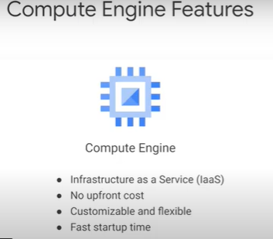

* + google's compute engine provides infrastructure as a service, that means that GC platform manages the physical servers and services , providing with familiar VMs without the need to maintain the infrastructure
  + you only pay for what you provision with no upfront cost
  + you choose how much memory , cpu , the type of disk, configure networking interfaces, os

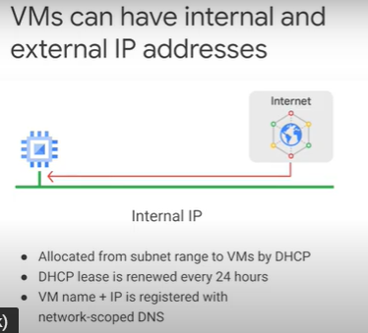

* + in gcp each virtual machine can have 2 ip addresses, internal & external ip address which is optional
* [Demo: Internal and external IP](https://youtu.be/bi-TKWWnO7c) 2 minutes
* [Machine types](https://youtu.be/bsYz-pxhYgs) 3 minutes

|  |  |
| --- | --- |
| Chart, line chart  Description automatically generated  suitable for tasks that has a balance between cpu and memory needs | Chart, line chart  Description automatically generated  ideal for tasks that require more memory relative to vcpu  for example, if your application saves a lot of data in memory for faster access |
| Chart, line chart  Description automatically generated  perfectly suited for in-memory databases and analytics such as subhana and business warehousing workloads, genomic analysis and sql analysis services |  |
|  | Table  Description automatically generated  It provide one vcpu that is allowed to run for a portion of the time on a single hardware hyper-threaded on the host cpu running your instance  It can be more cost effective for running small non-resource intensive applications than other machine types |
|  | independently specify the number of vcpus and the amount of memory for your instance custom machine types |

* [Compute Engine pricing](https://youtu.be/vTaXNLL9Y1w) 2 minutes

|  |  |
| --- | --- |
|  |  |
|  |  |

* [Persistent Disks and Network Interfaces](https://youtu.be/yheFNwezEE4) 5 minutes

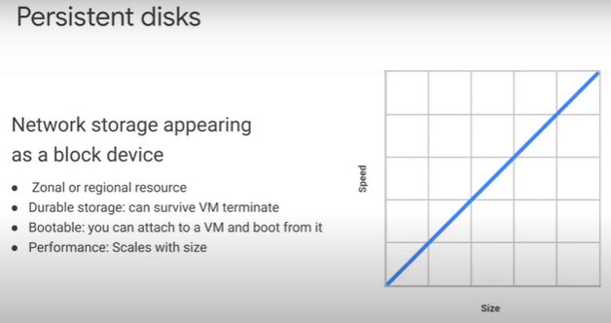

* + persistent disks resembles iscsi disks in on-premise
  + persistent disks are networked attached block storage
  + the first persistent disks (can more) that a VM attaches to is the boot disk which is where the os exists

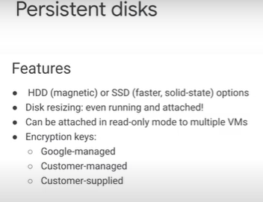

* + hdd is great for long tail files or general bulk data that does not need fast performance
  + ssd is designed for random reads and writes and provides better performance for databases
  + another feature of persistent disks Is that you can dynamically resize them even while they're running and attached to their vm

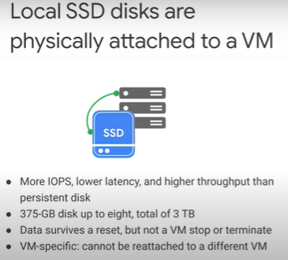

* + Compute engine provides physically attached ssds called local ssds

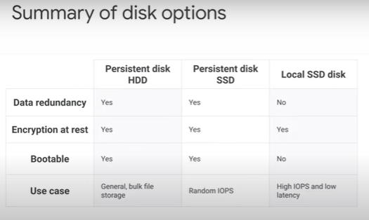

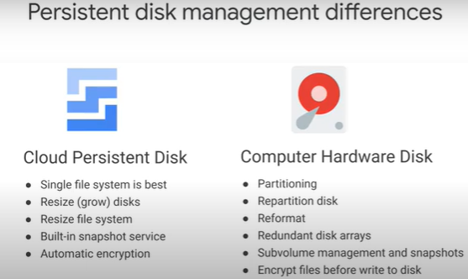 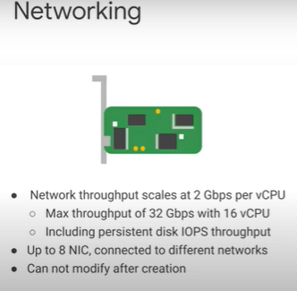

* + each compute engine VM comes with a virtual network interface controller or v-nic
* [Lab Intro: Creating Virtual Machines](https://youtu.be/DiH1TcHuX3s) 1 minute
* [Creating Virtual Machines](https://www.cloudskillsboost.google/course_sessions/743467/labs/108543) 30 minutes
  + Overview: explore the VM instance options and create several VMs with different characteristics.
  + Objectives explore the available options for VMs and see the differences between locations.
  + In this lab, you learn how to perform the following tasks:
    - Create several standard VMs. Create advanced VMs
  + Task 1: Create a utility virtual machine
  + Create a VM
    - the Navigation menu , click Compute Engine > VM instances > Click Create.
      * For Name, type a name for your instance.
      * For Region and Zone select us-central1 and us-central1-c respectively.
      * For Machine configuration, select Series as N1.
      * For Machine type, examine the options.
        + Notice that the menu lists the number of vCPUs, the amount of memory, and a symbolic name such as n1-standard-1. The symbolic name is the parameter you would use to select the machine type if you were creating a VM using the gcloud command. Notice to the right of the zone and machine type that there is a per-month estimated cost.
      * Click Details to the right of the Machine type list to see the breakdown of estimated costs.
      * For Machine type, click n1-standard-4 (4 vCPUs, 15 GB memory). How did the cost change?
      * For Machine type, click n1-standard-1 (1 vCPUs, 3.75 GB memory).
      * For Boot disk, click Change.
      * Click Version and select Debian GNU/Linux 10 (buster). Click Select.
      * Click Management, security, disks, networking, sole tenancy. Click Networking.
      * For Network interfaces, click the Edit icon (Edit). Select None for External IP. Click Done.
      * Leave the remaining settings as their defaults, and click Create. Wait until the new VM is created.
      * External IP addresses that don’t fall under the Free Tier will incur a small cost.
  + Explore the VM details
    - On the VM instances page, click on the name of your VM.
    - Locate CPU platform and note the value. Click Edit.
      * Notice that you can't change the machine type, the CPU platform, or the zone.
      * You can add network tags and allow specific network traffic from the internet through firewalls.
      * Some properties of a VM are integral to the VM, are established when the VM is created, and cannot be changed. Other properties can be edited. You can add additional disks and you can also determine whether the boot disk is deleted when the instance is deleted. Normally the boot disk defaults to being deleted automatically when the instance is deleted. But sometimes you will want to override this behavior. This feature is very important because you cannot create an image from a boot disk when it is attached to a running instance. So you would need to disable Delete boot disk when instance is deleted to enable creating a system image from the boot disk.
    - Examine Availability policies. Click Cancel.
      * You can't convert a non-preemptible instance into a preemptible one. This choice must be made at VM creation. A preemptible instance can be interrupted at any time and is available at a lower cost.
      * If a VM is stopped for any reason, (for example an outage or a hardware failure) the automatic restart feature will start it back up. Is this the behavior you want? Are your applications idempotent (written to handle a second startup properly)?
      * During host maintenance, the VM is set for live migration. However, you can have the VM terminated instead of migrated.
      * If you make changes, they can sometimes take several minutes to be implemented, especially if they involve networking changes like adding firewalls or changing the external IP.
  + Explore the VM logs
    - On the VM instance details page for your VM, click Cloud Logging.
      * Notice that you have now navigated to the Cloud Logging page.
      * This is a structured log view. At the top you can filter by using the pull-down menus, and there is a search box for searching based on labels or text.
    - Click the small triangle to the left of one of the lines to see the kind of information it contains.
    - On the far right, click View Options > Expand All.
  + Task 2: Create a Windows virtual machine
  + Create a VM
    - On the Navigation menu, click Compute Engine > VM instances. Click Create instance.
    - Specify the following, and leave the remaining settings as their defaults:
      * Property Value (type value or select option as specified)
      * Name Type a name for your VM
      * Region europe-west2
      * Zone europe-west2-a
      * Series N1
      * Machine type n1-standard-2(2 vCPUs, 7.5 GB memory)
      * Boot disk Change
      * Public Images > Operating system Windows Server
      * Version Windows Server 2016 Datacenter Core
      * Boot disk type SSD persistent disk
      * Size (GB) 100
    - Click Select. For Firewall, enable Allow HTTP traffic and Allow HTTPS traffic. Click Create.
      * When the VM is running, notice that the connection option in the far right column is RDP, not SSH. RDP is the Remote Desktop Protocol. You would need the RDP client installed on your local machine to connect to the Windows desktop.
      * Note: Installing an RDP client on your local machine is outside the scope of this lab and of the class. For this reason, you will not be connecting to the Windows VM during this lab. However, you will step through the usual procedures up to the point of requiring the RDP client.
      * Instructions for connecting to Windows VMs are here:
      * https://cloud.google.com/compute/docs/instances/windows/connecting-to-windows-instance
  + Set the password for the VM
    - Click on the name of your Windows VM to access the VM instance details.
    - You don't have a valid password for this Windows VM: you cannot log in to the Windows VM without a password. Click Set Windows password.
    - Click Set. Copy the provided password, and click CLOSE.
      * You will not connect to the Windows VM during this lab. However, the process would look something like the following (depending on the RDP client you installed). The RDP client shown can be installed for Chrome here:
      * https://chrome.google.com/webstore/detail/chrome-rdp-for-google-clo/mpbbnannobiobpnfblimoapbephgifkm?hl=en-US
      * On the VM instances page, you would click RDP for your Windows VM and connect with the password copied earlier.
  + Task 3: Create a custom virtual machine
  + Create a VM
    - On the Navigation menu, click Compute Engine > VM instances > Click Create instance.
    - Specify the following, and leave the remaining settings as their defaults:
      * Property Value (type value or select option as specified)
      * Name Type a name for your VM
      * Region us-west1
      * Zone us-west1-b
      * Series N1
      * Machine type Custom
      * Cores 6 vCPU
      * Memory 32 GB
      * Boot disk Debian GNU/Linux 10 (buster)
    - Click Create.
  + Connect via SSH to your custom VM
    - For the custom VM you just created, click SSH.
    - To see information about unused and used memory and swap space on your custom VM, run the following command: free
    - To see details about the RAM installed on your VM, run the following cmd: sudo dmidecode -t 17
    - To verify the number of processors, run the following command: nproc
    - To see details about the CPUs installed on your VM, run the following command: lscpu
* [Lab Review: Creating Virtual Machines](https://youtu.be/BNzRWGvs5tg) 1 minute
* [Interconnecting networks](https://youtu.be/-YSYx5gyTwc) 1 minute

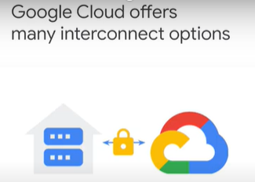

* + before starting a migration to GC platform you need to create a secure connection between your own premises and your vpc
  + this connection will support your migration process and also enhance the interoperability between your existing on-premises workloads and your cloud environment

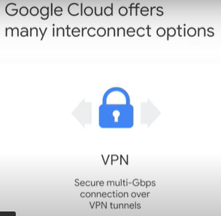

* + many customers start with a VPN connection over the internet using the ipsec protocol
  + the vpn connection is relatively easy to set up and doesn't require a physical connection between your own premises and a google cloud platform's data center

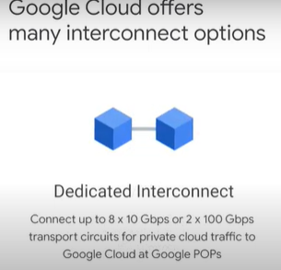

* + on the other hand you might not want to use the internet either because of security concerns or because you need more reliable bandwidth and lower latency
  + google cloud interconnect is a layer 2 private connection to your vpc
  + if your on-premises topology allows it, you can use the dedicated interconnect which connects your own premises to one of our data centers directly

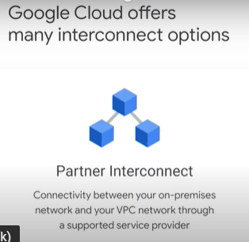

* + It’s useful if your data center is in a physical location that can't reach a dedicated interconnect collocation facility or if your data needs don't warrant an entire 10 gigabit connection
* [Cloud VPN](https://youtu.be/SpoLJoc1Cn0) 4 minutes

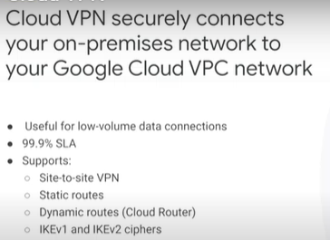

* + cloudvpn securely connects your on-premises network to your gcp vpc network through an ipsec vpn tunnel
  + it does not support client-to-gateway scenarios in other words cloud vpn does not support use cases where client
  + computers need to dial in to a vpn using a client vpn software

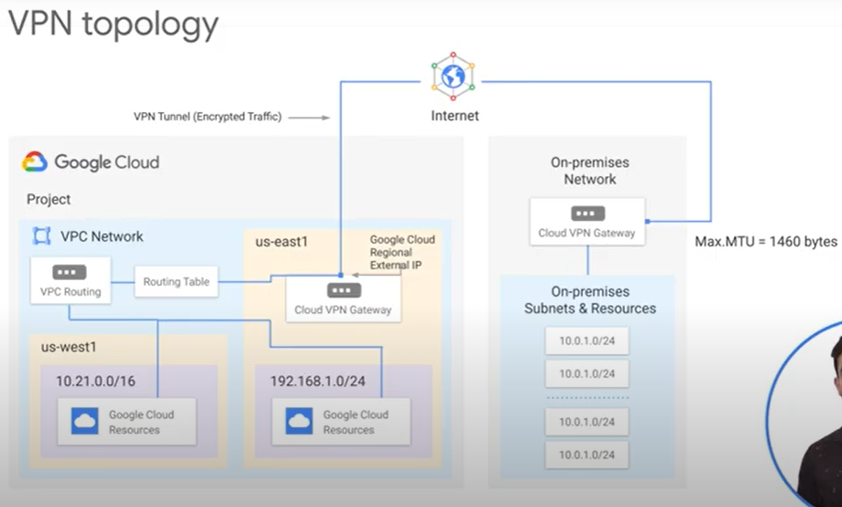

* + let's work through an example of cloud vpn, this diagram shows a simple vpn connection between your vpc and on-premises network
  + your vpc network has subnets in us east1 and us west1 with gcp resources in each of these regions
  + these resources are able to communicate using their internal ip addresses, because routing within the network is automatically configured

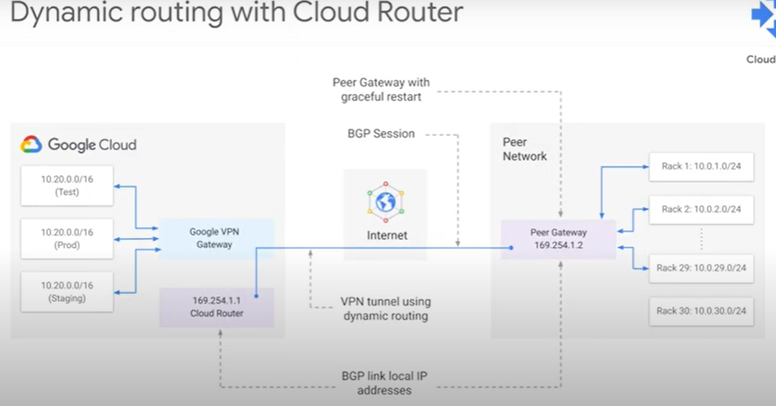

* [Lab Intro: Virtual Private Networks (VPN)](https://youtu.be/QsAEZJVU34I) 1 minute
* [Virtual Private Networks (VPN)](https://www.cloudskillsboost.google/course_sessions/743467/labs/108548) 35 minutes
* [Lab Review: Virtual Private Networks (VPN)](https://youtu.be/lAU2fmte1ow) 1 minute
* Cloud interconnect 4 minutes

|  |  |
| --- | --- |
|  |  |
|  |  |
|  |  |

* Review 1 minute

## 5.0 Migrate for Compute Engine

* In this module, you will learn about Migrate for Compute Engine architecture, how to install it in your source environment, the migration process, and special features like running a test clone. Lastly, you will learn how to use migration waves to migrate a large number of machines at once.
* Module Overview 1 minute
* [Migrate for Compute Engine overview](https://youtu.be/UmrGniF6yNQ) 1 minute
* [Migration technical architecture](https://youtu.be/hDotmw9OnEc) 1 minute
  + 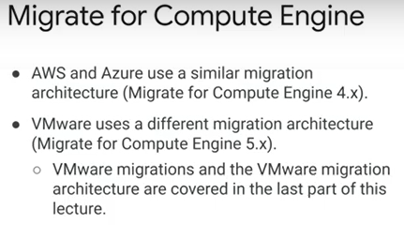
  + migrate from aws or azure use migrate for compute engine 4x
    - 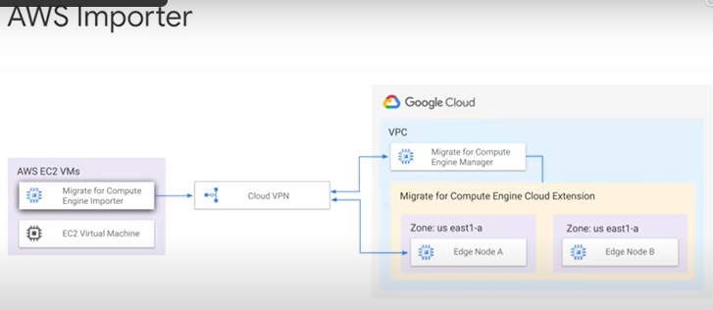
    - From AWS migrate, compute engine importer VM will be installed automatically in your aws cloud environment which provides the same functionality as the back end on premises
    - every time a migration is initiated the manager creates an importer in your aws environment to stream the source VM disk to google cloud platform over secure connection
    - when the migration is completed the importer is deleted
  + the receiving end of the importer from aws or from your on-premises infrastructure is the cloud extension which runs in google cloud
    - 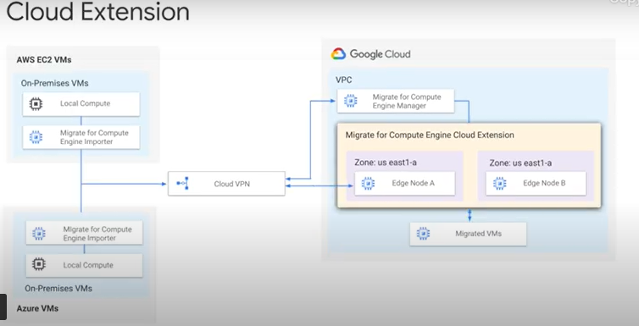
    - cloud extensions works with these components to create a highly optimized data streaming and caching layer for the VMs which are being migrated to the cloud, thus reducing downtime to minutes
    - the cloud extension is composed of a pair of cloud edge nodes for redundancy with one in each zone they serve data to the migrated virtual machine over an iscsi interface
* [Installation Process](https://youtu.be/IzKdrVr9b4w) (Look next topic, migration has been simplified since the installation demos were recorded).
  + 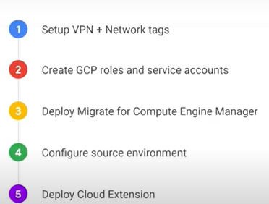
  + migrate for compute engine uses a secure vpn tunnel or cloud interconnect to connect your source environment and require specific networking rules to be set up before migrations can begin
  + after the network is set up you'll need to create google cloud roles and service accounts that migrate for compute engine can use to create the google cloud resources and manage the cloud storage api
  + migrate for compute engine includes a cloud shell script for making these changes simple
  + once your gcp project is configured properly you can deploy the migrate for compute engine manager from the google cloud platform's marketplace in just a few clicks
  + you then deploy the appropriate appliance based on your source environment a backend on vsphere if you are migrating virtual machines from on-premises or an importer if you are migrating from aws
  + and to complete the process you deploy a cloud extension back at the destination environment which is google cloud
* [New workflow to configure the migration manager](https://www.cloudskillsboost.google/course_sessions/743467/documents/108556)
  + https://cloud.google.com/migrate/compute-engine/docs/4.10/how-to/configure-manager/configuring-migration-manager#creating\_and\_configuring\_needed\_sources\_with
* [Demo: Installation on AWS](https://youtu.be/h4yZBDE8Q3A) 5 minutes
* [The migration process](https://youtu.be/iZmh4FfFYxA) 2 minutes - from your on-premises or aws environments to google cloud
  + The migration process which is composed of 3 main phases
  + 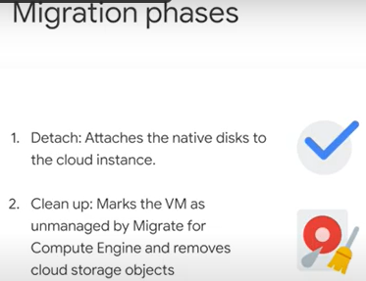
    - 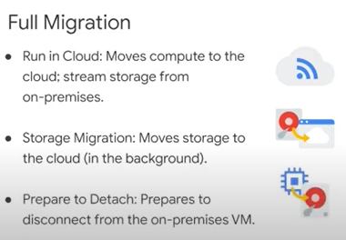
  + the first phase is called full migration migrate for compute engine will execute 3 sub steps
    - run in cloud substep the process starts by turning off the source VM and creating an image
      * if you migrate a windows machine the process will perform relevant adaptations to the cloud environment automatically
      * for linux based operating systems an rpm package or similar must be installed manually in advance
      * when the image is ready for the cloud it will be streamed to the cloud extension and boot within a few minutes
      * migrate for compute engine then streams any data on demand when the migrated VM needs it
    - the storage migration subset proactively migrates the full data to the cloud so that streaming is no longer necessary
    - when storage migration is completed, migrate for compute engine prepares to detach which copies all the data from the previous operations to a native compute engine persistent disk
    - it is important to note that you can manually go through each of these phases but we recommend automatically executing them sequentially by choosing full migration
  + after full migration is completed, all read and writes from the migrated VM still goes through the cloud extension to not interrupt the migrated machine's operation
    - when you are ready to fully detach from the cloud extension which involves brief downtime you can initiate the detach step it moves the remaining data on the cloud extension to the native persistent disk and then shuts down the migrated virtual machine so it can boot natively and securely from its persistent disk, thus becoming fully independent
  + lastly a cleanup will mark the virtual machine as unmanaged by migrate from compute engine and removes migration artifacts
* [Run in the cloud](https://youtu.be/2oFdz9-h1Nk) 1 minute
  + 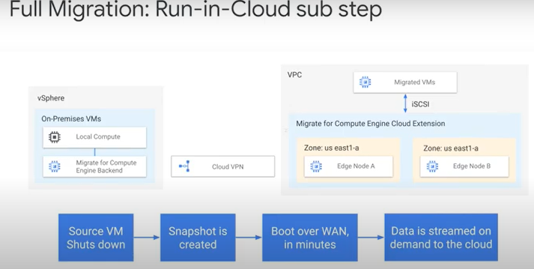
  + 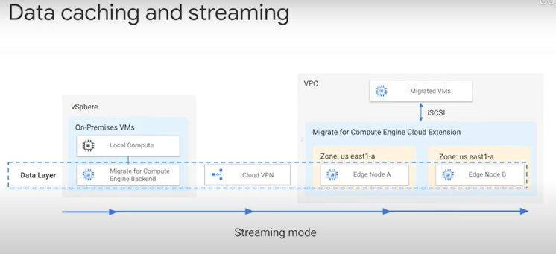
* [AWS Run in the cloud difference](https://youtu.be/9gZ1hPsXx0s) 1 minute
  + 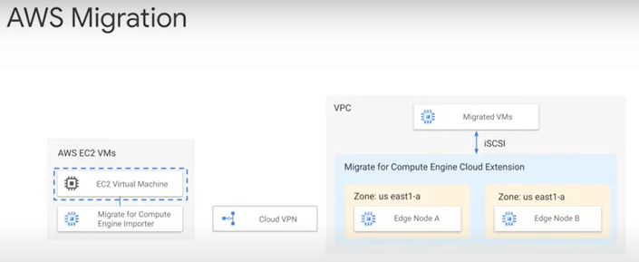
* [Detach](https://youtu.be/OsdvEdDGoIc) 1 minute
  + 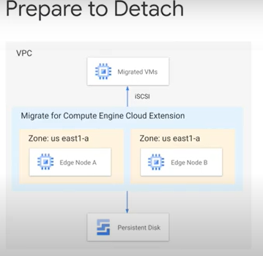
* [Demo: Migrating from AWS to Google Cloud](https://youtu.be/3XMJQjvJhqE) 9 minutes
* [Lab Intro: Migrating to Compute Engine](https://youtu.be/n92w2m3G5Bk) 1 minute
* [Migrating to Compute Engine](https://www.cloudskillsboost.google/course_sessions/743467/labs/108564) 1 hour 30 minutes
  + Overview
    - Migrate for Compute Engine gets enterprise applications running in GC within minutes while data migrates transparently in the background. With Migrate for Compute Engine, enterprises can validate, run, and migrate applications into GC without rewriting them, modifying the image, or changing management processes.
    - In this lab you use Migrate for Compute Engine to migrate a VM instance (EC2) that exists on AWS to Google Cloud. This will be a **"lift and shift"** operation. When you finish, the VM instance that was running on AWS will be running on Google Cloud.
  + Objectives
    - In this lab, you learn how to perform the following tasks:
      * Deploy a Terraform script to provision your environment.
      * Configure the lab AWS EC2 instance for migration.
      * Configure Migration Manager and Service Accounts.
      * Use Migrate for Compute Engine Manager (formerly Velostrata) to configure AWS as a source for migration.
      * Configure Migrate for Compute Engine Cloud Extensions.
      * Generate migration waves for easy migration.
      * Verify that VM migration was completed successfully.
  + In the Google Cloud Console, in the navigation pane, click **Activate Cloud Shell** (image).
    - List the active account name: gcloud auth list
    - List the project ID: gcloud config list project
    - For full documentation of gcloud, see the [gcloud command-line tool overview](https://cloud.google.com/sdk/gcloud" \t "_blank).
  + Task 1: Prepare your working environment
    - In this task you will prepare the working environment for your lab. Migrate for Compute Engine requires a VPN between the GC environment and the environment from which you are sourcing the VM. Creating a VPN between AWS and GC can require many steps, including the exchange of IP addresses, keys, and many other definitions. Instead of requiring you to configure these manually, which introduces the possibility for errors, this lab provides you with a Terraform script.
    - Terraform is an infrastructure as code (IaC) tool used to provision environments. Terraform supports both Google Cloud and AWS and can configure both environments. When you run the Terraform script, it performs the following tasks:
      * Create an AWS EC2 instance.
      * Create a Google Cloud Compute Engine instance.
      * Create an AWS network.
      * Create a custom Virtual Private Cloud (VPC) in Google Cloud.
      * Create the AWS side of the VPN connection.
      * Create the Google Cloud side of the VPN connection.
      * Enable appropriate firewall rules for the Google Cloud VPC network.
    - In Cloud Shell, set your Google Cloud Project ID:
      * gcloud config set project $DEVSHELL\_PROJECT\_ID
    - In Cloud Shell, retrieve the Terraform scripts by copying them and unzipping the files:
      * gsutil cp gs://spls/gsp677/autonetdeploy-multicloudvpn.tar .
      * tar xvf autonetdeploy-multicloudvpn.tar
    - Change into the directory with the scripts: cd autonetdeploy-multicloudvpn
    - In Google Cloud console, click **APIs & Services**> **Credentials**.
      * Under Service Accounts, click **Qwiklabs User Service Account**.
    - 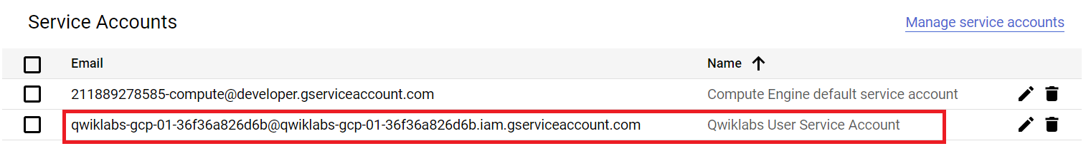
    - Click **Keys**.
    - 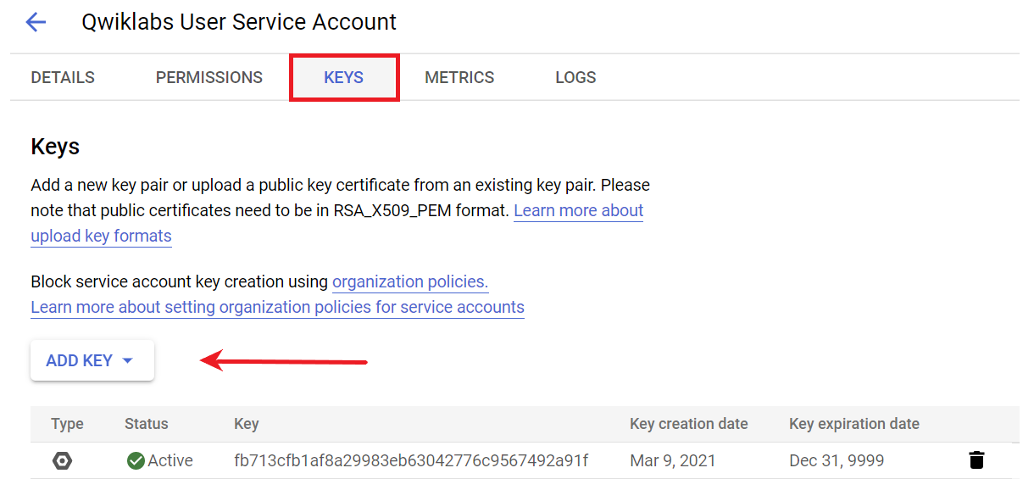
    - Click **Add Key**. Click **Create new key**. Choose the default key type, **JSON**, and click **Create**.
    - 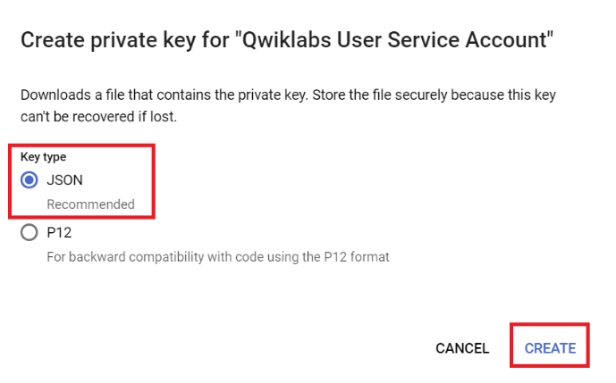
      * This will automatically download a JSON file of the key onto your local machine. Close the Private key window.
    - To move this file from your local machine, click the **vertical three dots** icon in the Cloud Shell ribbon, and then select **Upload File**.
      * 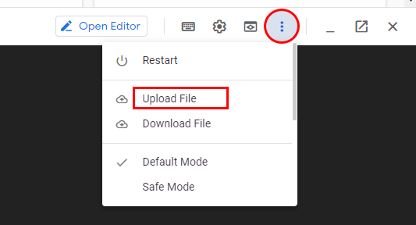
    - Navigate to the JSON file you downloaded, and click **Open**. The file is copied to the home (~) directory.
    - Run the following command, replacing [YOUR-CREDENTIALS]with the name of the JSON file you previously downloaded:
      * ./gcp\_set\_credentials.sh ~/[YOUR-CREDENTIALS].json
    - This script creates the ~/.config/gcloud/credentials\_autonetdeploy.json file. It also creates terraform/terraform.tfvars with a reference to the new credentials.
  + Task 2: Set AWS access credentials and deploy with Terraform
    - In this task you will use the AWS access credentials that were created for the lab environment. These credentials are split into an **AWS Access Key** and an **AWS Secret Key**, which are both displayed in the resources panel for this lab. You will then deploy a Terraform script that will configure an AWS environment and a Google Cloud environment.
    - To store your **AWS Access Key** in an environment variable, run this command in Cloud Shell, replacing [YOUR\_ACCESS\_KEY] with the **AWS Access Key** from the resources panel : export AWS\_ACCESS\_KEY=[YOUR\_ACCESS\_KEY]
    - 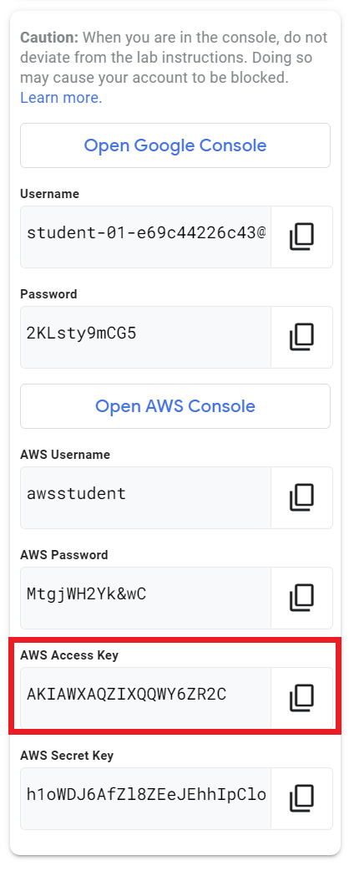
    - To store your **AWS Secret Key** in an environment variable, run this command, replacing [YOUR\_SECRET\_KEY] with the **AWS Secret Key** from the resources panel:
      * export AWS\_SECRET\_KEY=[YOUR\_SECRET\_KEY]
    - To set your credentials, run the following:
      * ./aws\_set\_credentials.sh $AWS\_ACCESS\_KEY $AWS\_SECRET\_KEY
    - To update the project value in your configuration files for Deployment Manager and Terraform, run the following script: ./gcp\_set\_project.sh

### **Generate key pairs**

* + - * Generate a new key pair with your current account:
        + ssh-keygen -t rsa -f ~/.ssh/vm-ssh-key -C $(whoami)
      * In this lab you will use an empty passphrase. When asked for a passphrase, press ENTER twice to leave it blank.
      * To restrict access to your private key, run the cmd: chmod 400 ~/.ssh/vm-ssh-key

### **Import the key to Google Cloud**

* + - * In Cloud Shell, register your public key with Google Cloud:
        + gcloud compute config-ssh --ssh-key-file=~/.ssh/vm-ssh-key
        + **Note** You can ignore the warning about host aliases.

### **Download the key** Get the filepath to your public key:

* + - * readlink -f ~/.ssh/vm-ssh-key.pub
      * Copy the file path from the output.
      * Download the public key file from Cloud Shell by clicking the **three vertical dots** icon in the Cloud Shell ribbon, and then click **Download File**.
      * 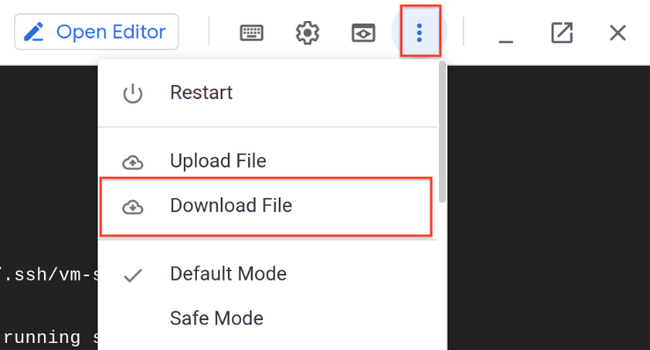
      * Paste in the file path to the key copied from the readlink command.
      * Click **Download**. This will download the key file to your local machine.

### **Import the key to AWS**

* + - * In the resources panel for this lab, click **Open AWS Console**.
      * This opens the AWS Console sign-in page.
      * On the sign-in page, enter your **AWS Username** value for the **IAM user name** and enter your **AWS Password** value for the **Password**. Both of these are listed in the resources panel. Click **Sign In**.
      * In the AWS Console, ensure that you are signed in to the **N. Virginia** region. If you are not, use the dropdown menu to select it.
      * 
      * In the AWS Console, click **Services > EC2**. In the **Resources** panel, click **Key pairs**.
      * Click **Actions > Import Key Pair**. Name the key pair **vm-ssh-key**.
      * Click **Browse**, and navigate to the location of the downloaded key pair file.
      * Select **vm-ssh-key.pub**, and click **Open**.
        + The key pair will be added to your Import Settings page.
      * Click **Import key pair**.
    - **Deploy with Terraform**
      * In Cloud Shell, install the Terraform providers for this deployment:
        + pushd ./terraform && terraform init && popd > /dev/null
      * Verify your credentials:
        + pushd ./terraform && terraform plan && popd > /dev/null
      * If you don't see red error text, your authentication is working properly.
      * Navigate to the terraform directory: pushd terraform
      * Validate the syntax of your configuration files: terraform validate
        + This validation check is simpler than those performed as part of the plan and apply commands in subsequent steps. The validate command does not authenticate with any providers.
      * Create your deployment: terraform apply -auto-approve
        + **Note** This will take about 10 minutes to complete.
      * When the script has completed, you will have both an AWS environment and a Google Cloud environment configured. This is the VM instance that you will migrate to Google Cloud in the tasks that follow.
  + Task 3: Configure AWS EC2 instance for migration
    - In this task you will customize the EC2 instance so that you can easily see that, after migration, it is the same VM on Google Cloud that was on AWS.
    - On the AWS tab, in the navigation menu, click **Instances** to find the EC2 running instance.
    - Select the instance and record the Public IP address.
      * You will use your public key and ssh to connect to your AWS instance.
    - In Cloud Shell, run the following, replacing [AWS\_INSTANCE\_EXTERNAL\_IP] with your instance's public IP address:
      * ssh -i ~/.ssh/vm-ssh-key ubuntu@[AWS\_INSTANCE\_EXTERNAL\_IP]
      * When a message asks you to confirm the authenticity of the host, type yes.
    - After you are logged in, run the following commands:
      * sudo bash -c "apt-get update"
      * sudo bash -c "apt-get install apache2 -y"
      * echo "Hello World" > MyText.txt
      * When the Linux image runs on Google Cloud, it expects to find kernel drivers for the Migrate for Compute Engine mapped disks. These must be downloaded and installed before the migration up to Google Cloud. The driver installation must be performed on the EC2 machine.
    - To download the installation package, run the following command:
      * wget https://storage.googleapis.com/velostrata-release/4.5/4.5.1/velostrata-prep-0.9-3.deb
      * sudo dpkg -i velostrata-prep-0.9-3.deb
      * sudo apt-get update && sudo apt-get install -f -y
      * You have now completed the setup of the EC2 instance.
    - Type exit to log out of the AWS VM instance.
  + Task 4: Set up Migration Service Accounts
    - In this task you create the service accounts that you will assign to Migrate for Compute Engine.
    - In Cloud Shell, return to the home directory.
    - To create the service accounts that you will assign to Migrate for Compute Engine, run the following command:
      * cd ~/autonetdeploy-multicloudvpn/
      * sh migrate\_sa\_roles.sh
  + Task 5: Set up Migration Manager
    - In this task you will install a special version of Migrate for Compute Engine that consumes fewer resources and runs faster. Normally you would use the Cloud Console to install Migrate for Compute Engine from the marketplace, but because this lab runs in a QwikLabs environment, a script has been provided that will create a Compute Engine instance.
    - To create the instance using the script provided in the lab, run the following command:
      * bash create\_instance.sh
      * **Note** You can ignore the warning about disk size.
      * This will take a few minutes to complete.
    - Record the **External IP** located in the details of the velo-mgr vm. You will use it in the next task.
  + Task 6: Configure AWS as a source
    - In this task you will configure AWS as a source for migrating VMs to Compute Engine using Migrate for Compute Engine. You perform these tasks with the Migrate for Compute Engine Manager.
    - In Cloud Shell, run this command until you successfully get a response replacing [VELO-EXTERNAL-IP] with your velo-mgr vm's External IP:
      * curl -k https://[VELO-EXTERNAL-IP]
      * The Velostrata Manager can take up to 2 minutes to launch before you can connect to it.
    - Copy the velo-mgr External IP address and copy it into a new tab in your browser.
    - In **Sign in**, specify the following information:

|  |  |
| --- | --- |
| **Property** | **Value** |
| Username | **apiuser** |
| Password | **velo1234** |

* + - On the initial setup screen, click **Yes** for both Stackdriver Logging and Stackdriver Metrics. Click **OK**.
      * Now you provide source information about the AWS VM to Migrate for Compute Engine.
    - In **System Operations**, Click the **Source Cloud** icon. Click the **Cloud Credentials** tab. Click **Create**.
    - In **Create New Credentials**, specify the following information:

|  |  |
| --- | --- |
| **Property** | **Value** |
| Cloud Provider | **AWS** |
| Credentials Name | **A name of your choosing (eg. aws-credentials)** |
| Region | **US East (N. Virginia)** |
| Access Key | The AWS access key (listed in the resources panel) |
| Secret Key | The AWS secret key (listed in the resources panel) |

* + - Click **Ok** to complete. Click the **Cloud Details** tab. Click **Create**.
    - In **Create New Cloud Details**, specify the following information:

|  |  |
| --- | --- |
| **Property** | **Value** |
| Cloud Provider | **AWS** |
| Name | **AWS** |
| Credentials | Select the credentials created previously from dropdown menu |
| Region | **US East (N. Virginia)** |
| VPC | **aws-vpc vpc-xxx** |
| Security Group | **default** |
| Worker subnet for availability zone | **172.16.0.0/24 subnet-xxx** |

* + - Click **Ok**. Click **Home**.
  + Task 7: Set up Cloud Extensions
    - In this task you will set up Migrate for Compute Engine Cloud Extensions. A Cloud Extension is a conduit for VM storage between two hosting environments, such as between an on-premises data center and Google Cloud, between AWS and Google Cloud, or between Azure and Google Cloud.
    - Click the **Target Cloud** icon.
    - On the **Cloud Extensions** tab, click **Create**.
    - In **Create New Cloud Extension** in **Network Settings**, specify the following information and leave all other settings as default:

|  |  |
| --- | --- |
| **Property** | **Value** |
| Project | Select your **qwiklabs-gcp-xxx** |
| Region | **us-central1** |
| VPC | **gcp-network** |
| Default Destination Project for Workloads | **qwiklabs-gcp-xxx** |
| Default Service Account for Workloads | **migration-cloud-extension** |

* + - To expand the **Cloud Extension** section, click the **+** icon.
    - In **Cloud Extension**, specify the following information:

|  |  |
| --- | --- |
| **Property** | **Value** |
| Cloud Extension Name | **ext1** |
| Service Account for Edge Nodes | **migration-cloud-extension** |
| Cloud Extension Size | **Small** |

* + - To expand the **Zones** section, click the **+** icon. In **Zones**, specify the following information:

|  |  |
| --- | --- |
| **Property** | **Value** |
| Node A Zone | **us-central1-a** |
| Node B Zone | **us-central1-b** |
| Node A Subnet | **10.240.0.0/24** |
| Node B Subnet | **10.240.0.0/24** |
| Default Workload Subnet | **10.240.0.0/24** |

* + - Click **Ok**.
      * **Note** **ext1** should now be in the *Creating* state. Wait until it's in an *Active* state before continuing to the next task. This will take up to 4 minutes.
  + Task 8: Generating migration waves
    - In this task you will use a Migrate for Compute Engine feature called a wave that batches VMs for migration. Waves are made up of runbooks and jobs, which makes migration more manageable.
    - Click **Home**.
      * 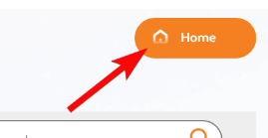
    - Click **Migration Waves**.
      * 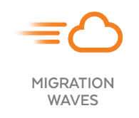
    - Click **Generate Runbook**, and provide the following information:
      * 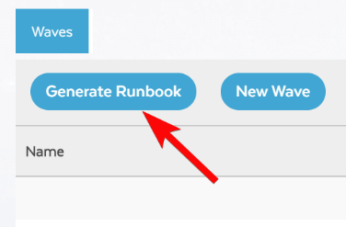

|  |  |
| --- | --- |
| **Property** | **Value** |
| Source | **AWS** |
| Source Cloud Details | **AWS** |
| Filter by Source Tags | **Name= Name, Value= \*** |
| Target Cloud Extension | **ext1** |
| Target Network | **checked** |

* + - * 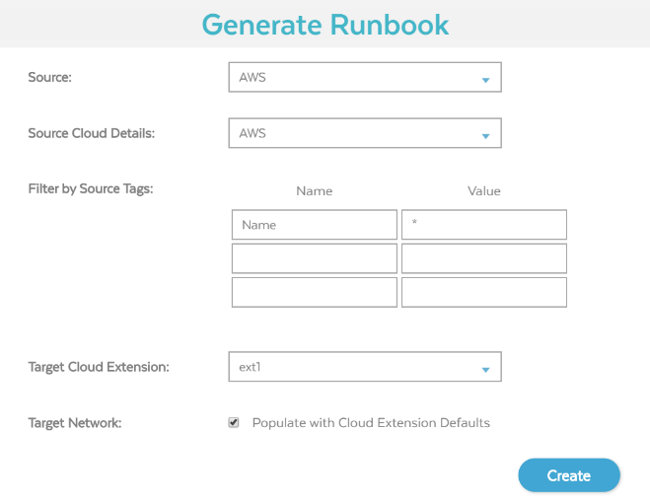
    - Click **Create**. A .csv file will be downloaded. You will edit this file to configure the migration settings.
    - Open [Google Sheets](https://docs.google.com/spreadsheets/u/0/?tgif=d) in a new tab. On the **Google Sheets** page, click **Blank** to start a new spreadsheet.
    - Click **File > Import**. On the **Upload** tab, drag your **Velostrata Runbook.csv** file into the window.
    - In the **Import file** box, select **Comma** as the Separator type and leave all other settings as their defaults. Click **Import data**.
    - **Edit the runbook**
      * Change the RunGroup column value from -1 to 1, and set the TargetInstanceType column to be n1-standard-1.
      * Save the file back to your local file system: **File > Download > Comma-separated values (.csv, current sheet)**.
    - **Create a new wave**
      * Return to your Migrate for Compute Engine Manager (Velostrata Migration) tab, click **New Wave**, and specify the following information:

|  |  |
| --- | --- |
| **Property** | **Value** |
| Wave Name | **wave1** |
| Runbook CSV | **Your edited CSV file** |

* + - * + **Note** Be sure to select the CSV file that contains the edited changes and \*not\* the original one that was generated (assuming that you now have two files).
      * Click **Save**.
    - **Validate the wave**
      * Click on the **wave1** line to select it.
      * For **Action**, select **Validate**.
      * in the **Run Validation** dialog, Click **Yes**.
        + The status will change to Validating, and then to Passed.
      * Ensure that wave1 line is still selected, and for **Action**,select **New Job**.
      * In the **New Job** dialog, select **Full Migration**, and click **Start**.
        + The status will now change to Full Migration (Running).
      * The migration is now progressing. Wait for the corresponding Compute Engine to become available.
      * The migration proceeds in two major phases:
        + The first is the start up of the Compute Engine by bringing in enough of the original VM to start.
        + From there, the remainder of the VM disk will be streamed in the background.
      * Click **Monitor**.
        + 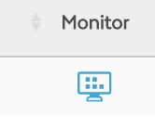
        + A record line for the VM being migrated should be displayed. This should take up to 10 minutes.
      * Look at the AWS instance. The machine you're migrating should have an **Instance State** of stopped.
        + Refresh the browser session to see the most up-to-date information.
      * In the Google Cloud Console, on the **Compute Engine** page, click **Refresh** until the aws-vm-us-east-1 machine from AWS appears.
      * Monitor the **Migration Status** in the Velostrata Migration Waves dashboard until it changes from empty or Moving To Target Cloud to one of these:
        + Cache on demand
        + Migrating
        + Preparing to Detach
      * When this status changes, the VM is available on Google Cloud and is ready to be used. When the VM has been 100% migrated, the status will change to Fully Migrated.
      * **Note** You don't need to wait for this status; you can continue to the next section.
  + Task 9: Test the new Google Cloud machine
    - In this task you will verify that the VM has been migrated successfully.
    - In the Google Cloud Console, on the **Navigation menu**, click **Compute Engine > VM Instances**.
    - The **aws-vm-us-east-1** VM should be listed. You will need to assign it a Public IP address to enable SSH connection.
    - Click on the machine name to open the VM instance details page. Click **Edit**.
    - For **Network interfaces**, click **Edit**.
    - 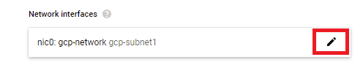
    - Under **External IP**, select **Ephemeral**, and then click **Done**. Click **Save**.
    - Click **VM instances** again, and the Public IP address has been assigned.
    - In Cloud Shell, run this command, replacing **PUBLIC IP** with the public IP address of your migrated VM: ssh -i ~/.ssh/vm-ssh-key ubuntu@[PUBLIC\_IP]
    - Type yes.
    - You will be logged in to the migrated VM running on Google Cloud.
    - To see the **MyText.txt** file that was created earlier on the AWS EC2 instance, run this command: ls
* [Lab Solution: Migrating to Compute Engine](https://youtu.be/jsVqHzIR9Ow) 15 minutes
* [Test clone](https://youtu.be/6HMPWNGaoqA) 2 minutes
  + 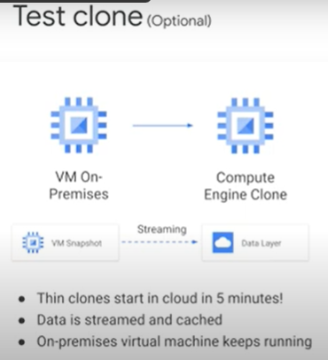
  + other features that migrate for compute engine supports like test clones and offline migration
  + testing your applications in the cloud before you officially migrate them is an important way to save time and mitigate migration risk it gives enterprises the opportunity to easily see how applications perform in the cloud and to make the appropriate adjustments before going live
  + creating a test clone is completely optional but we recommend testing VMs before putting them in production
  + unlike the migration process test clones leave the on-premises vms running and create an identical clone of that machine from a snapshot of the source VM , the image begins to transfer to the source environment
  + there are a few points to be aware of
    - first each virtual machine can have a maximum of one test clone at a time
    - second windows VMs are automatically configured to run in the cloud but linux-based VMss need to have an rpm package or similar manually installed
    - 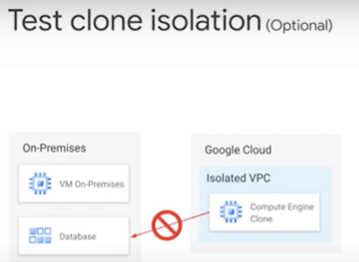
  + in addition the test clone virtual machine is created in write isolation storage mode that means that changes in the cloud-based clone storage are not written back to on-premises storage
  + it is important to
  + remember that test clones are exact copies of your source workload including any credentials data and state which is currently being used on the virtual machine and remember both of them are running at the same time
  + after testing your workload with the test clone you should delete it deleting the test clone removes it from google cloud,
  + note that deleting the test clone has no impact on your live system or data
* [systemOffline migration](https://youtu.be/O6sIsF7k1mo) 1 minute
  + 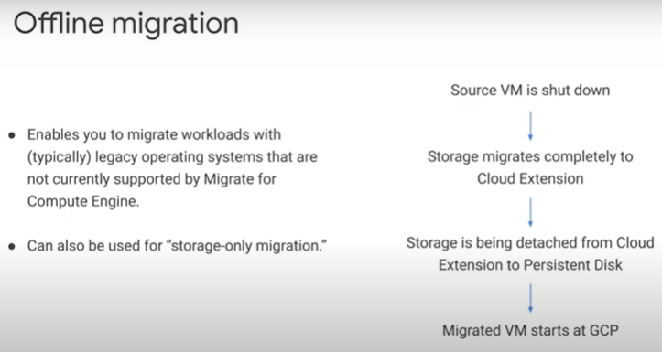
  + with offline migration migrate for compute engine enables you to migrate workloads running on vmware's vsphere with OS that are not currently supported by migrate for compute engine streaming technology
  + these are typically legacy OS systems
  + during the offline migration process all storage migrates to the cloud before the virtual machine starts on compute engine
  + the source virtual machine will first be shut down and then storage will be migrated completely detached and cleaned up before the virtual machine starts in google cloud
  + since data cannot be streamed the downtime is measurably longer and depends on the connection and amount of data that needs to be transferred
    - 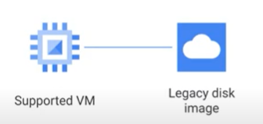
  + offline migration can also be used for storage-only migration
  + legacy virtual machines can be migrated to the cloud with offline migration even when unsupported in compute engine
  + administrators can then reattach a data disk to a newer and supported cloud instance to retrieve data from it
* [Wave migration](https://youtu.be/2V36nMKtUV8) 2 minutes
  + 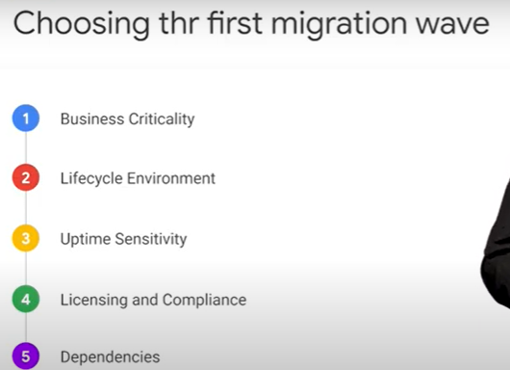
* Wave Objects 1 minute
  + 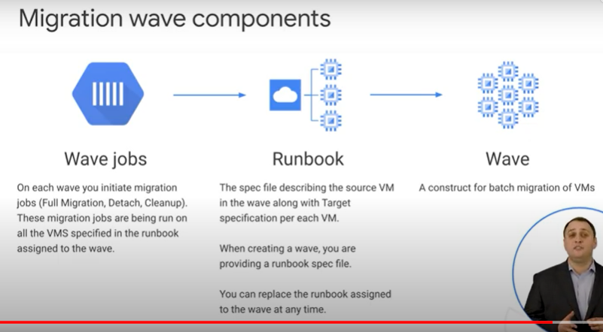a wave is a high-level construct that represents a migration batch
  + when you migrate a large number of machines you will do it in batches which makes sense in terms of interdependency and other technical requirements
  + a run book is a csv file that specifies the virtual machines to be included in a wave and the configuration of the target virtual machines
  + it describes the source VMs, defines properties for the target VMs and networks and also contains other metadata
  + a job is the migration operation that migrate for compute engine performs on the list of VMs in the run book
  + migration operations include creating test clones, full migration and detaching the exact same operations you've learned about previously in this module
* [Demo: Migration waves](https://youtu.be/IVuTIPT84Co) 10 minutes
  + Which of the following three steps are part of the Full Migration phase?
    - Run in Cloud
      * It moves compute resources to the cloud and streams storage from on-premises.
    - Storage Migration
      * This step moves storage to the cloud (in the background).
    - Prepare to Detach
      * This step prepares the disconnect from the on-premises VM.
  + What’s the purpose of migration waves?
    - Group multiple virtual machines together and move them in sprints to the Cloud.
* [Introduction to Migrate for Compute Engine 5](https://youtu.be/4szvnnjiZqA) 3 minutes
* learn how to migrate from vmware using migrate for CE 5. It’s is a bit different than what you learned earlier
* 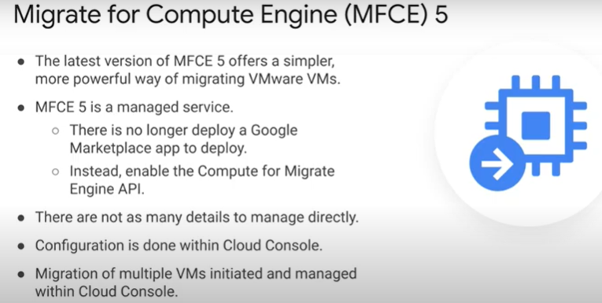 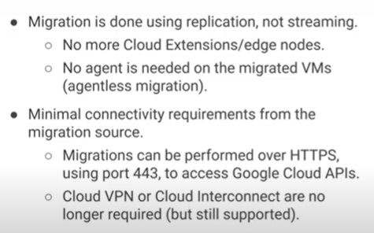
* 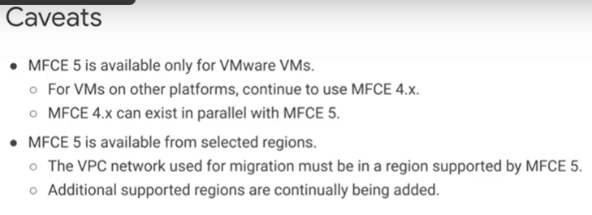
* 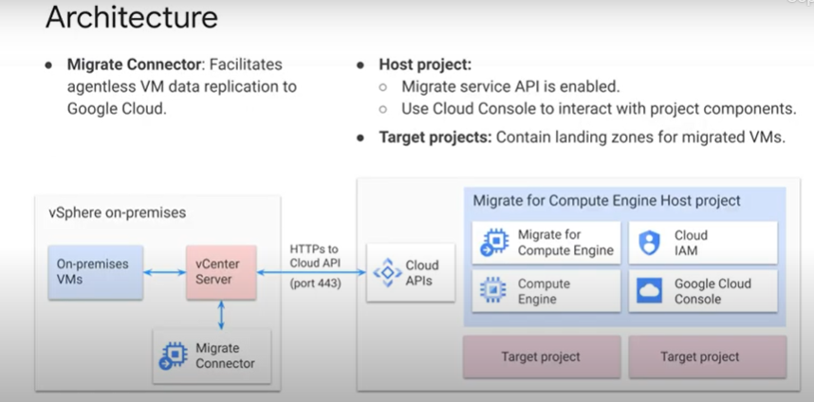
* [Using Migrate for Compute Engine 5](https://youtu.be/XNSopPiJFY8) 3 minutes
* 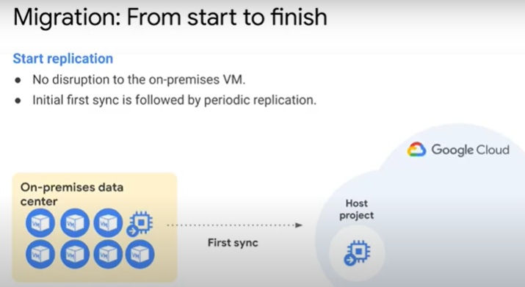 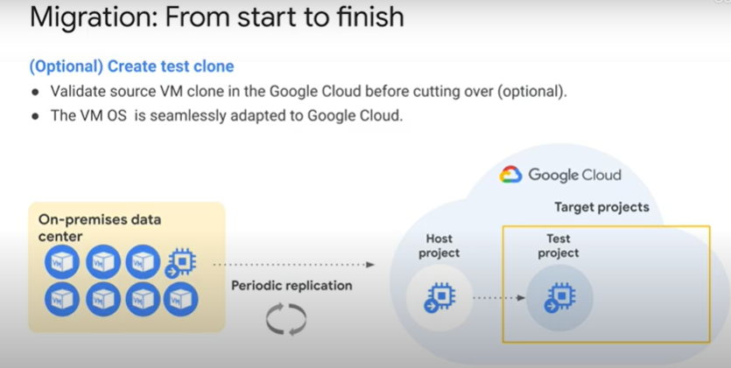
* 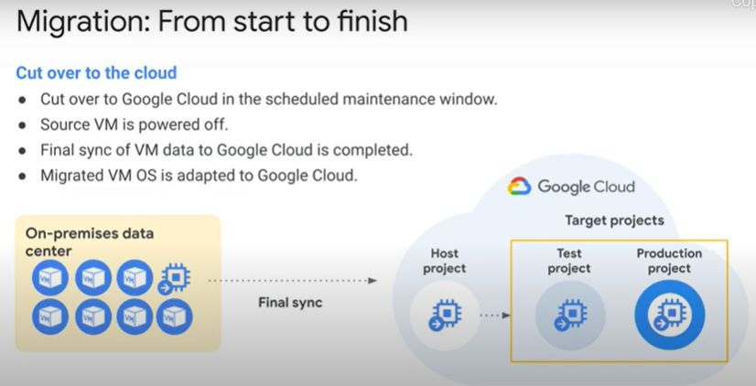 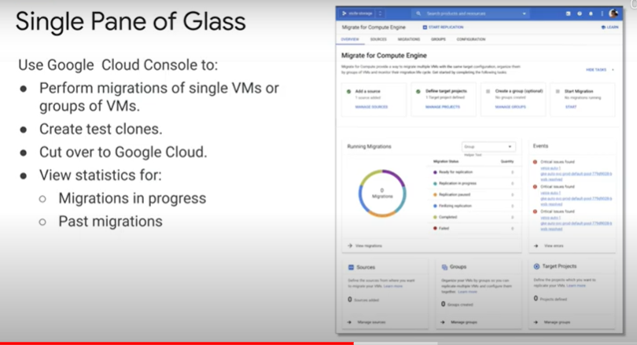
* 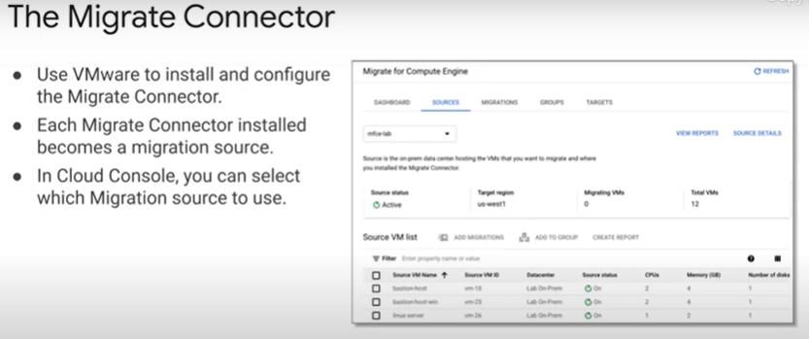 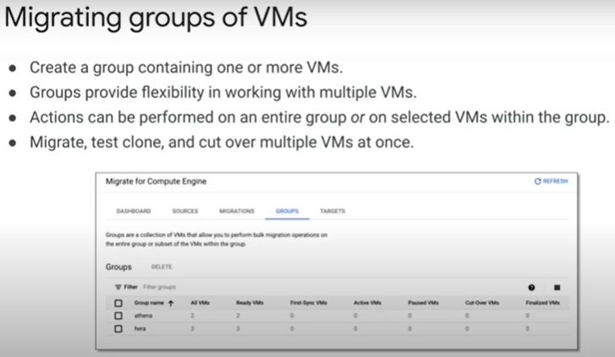
* [Demo: Installing Migrate for Compute Engine on vSphere](https://youtu.be/wBavYeBneUY) 12 minutes
* [Demo: Migrating from vSphere to Google Cloud](https://youtu.be/O_74BXnQxq8) 13 minutes
* Review 1 minute

## 6.0 Governance

* In this module, you will learn how to create and manage user identities in the cloud using Cloud Identity. You will also learn how to sync your current users and groups from your on-premises environment to the cloud using an automation tool. In addition, you will learn best practices on how to structure your resource hierarchy as your cloud footprint grows in size. You will then learn how to centrally manage a single network across multiple projects, known as Shared VPC. Lastly, you will learn how to manage an identity provider across environments.
* Module Overview 1 minute
* [Cloud Identity Overview](https://youtu.be/OfXOVsC0i0E) 1 minute
  + 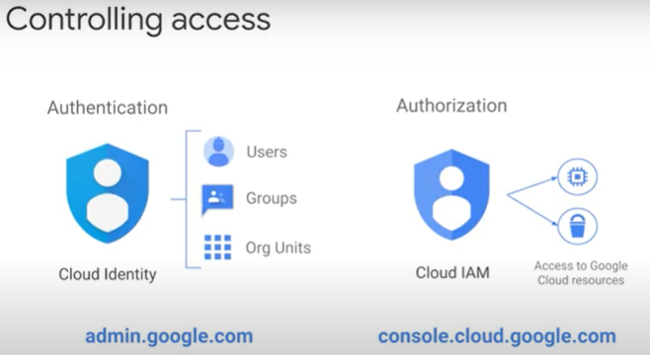
* [Demo: Cloud Identity setup](https://youtu.be/fgWSi8AFLcw) 3 minutes
* [User lifecycle management](https://youtu.be/zGSrg2w3ig0) 3 minutes
  + 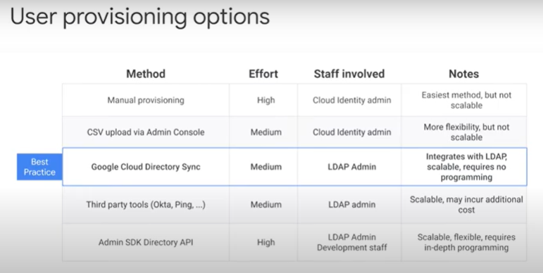 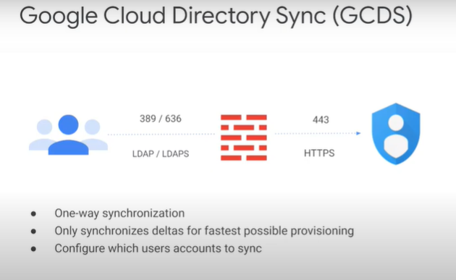
  + 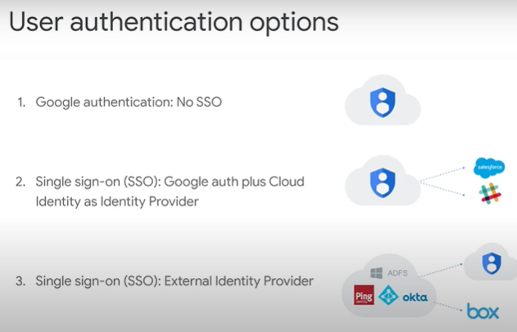 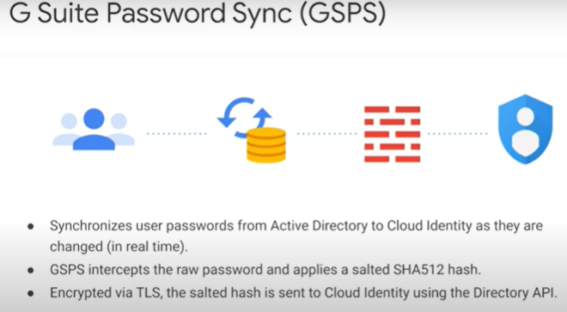
* [Resource hierarchy](https://youtu.be/bM3fDVdtikc) 2 minutes
  + 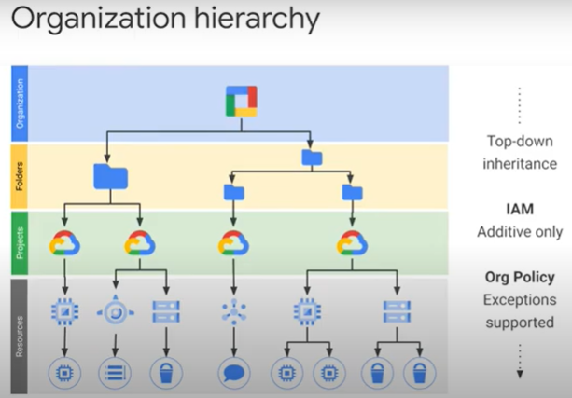 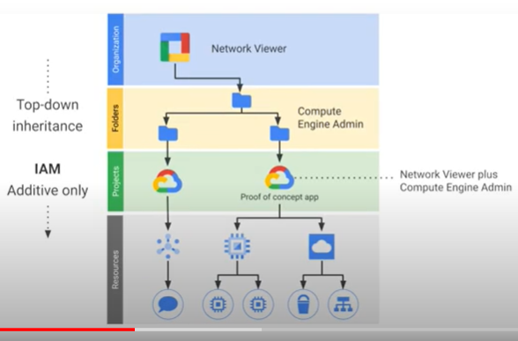
  + 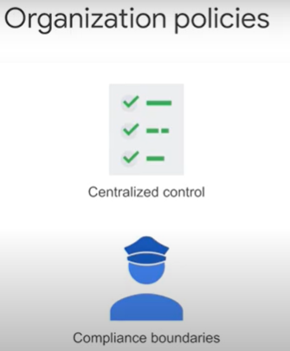 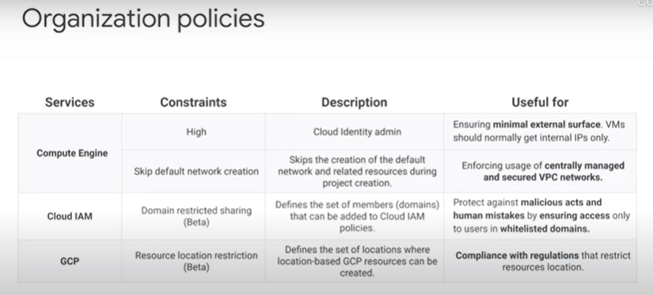
* [Resource hierarchy examples](https://youtu.be/sn9JMF0vDK4) 1 minute
  + 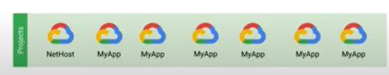 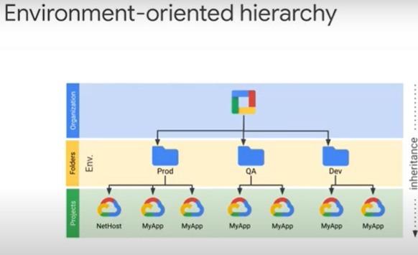
  + 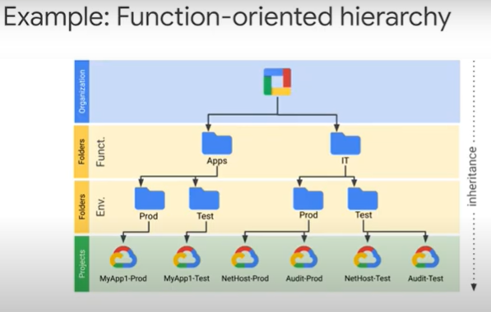 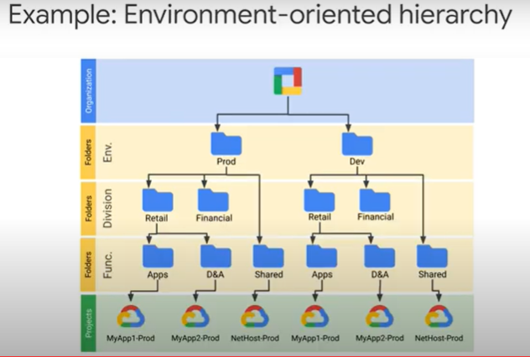
* [IAM Roles](https://youtu.be/YpPe4IhZsXw) 2 minutes
* 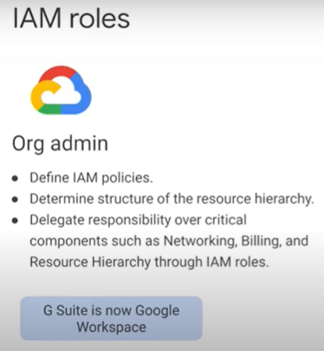 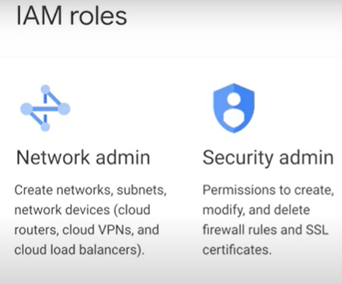 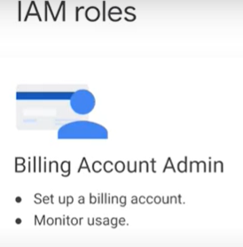
* [Shared VPC](https://youtu.be/nREoIq6Tzbo) 5 minutes
* 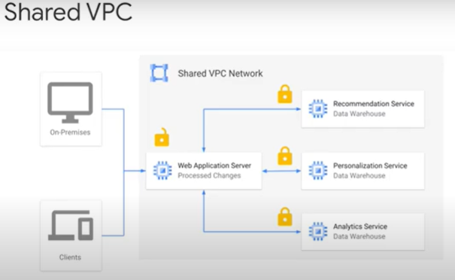 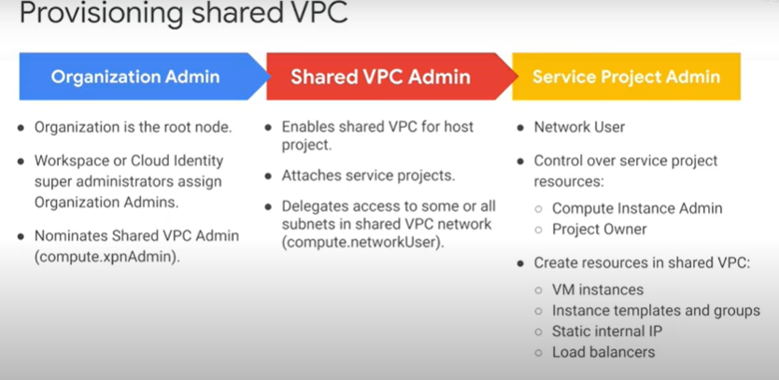 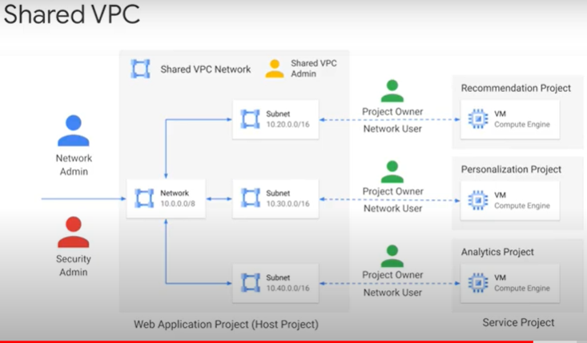
* [Demo: Shared VPC](https://youtu.be/Jf8ANl29ZB0) 4 minutes
* [Active Directory in the Cloud](https://youtu.be/V7Nm5X-4-pU) 4 minutes
* 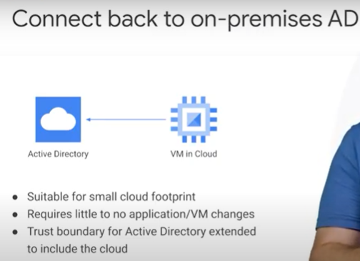 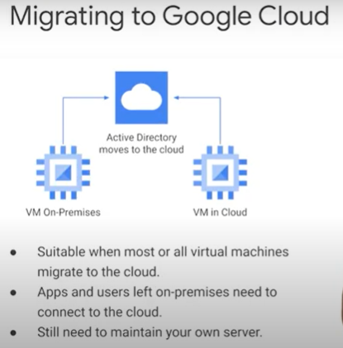 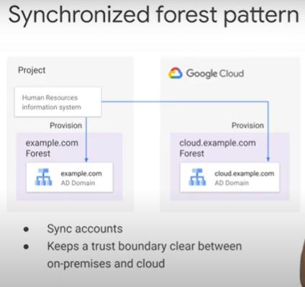
* 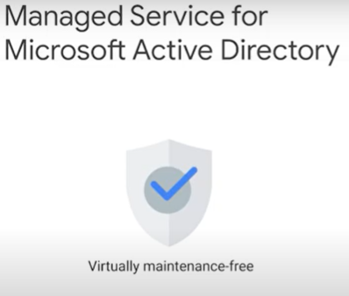 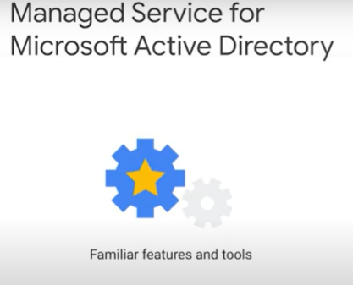 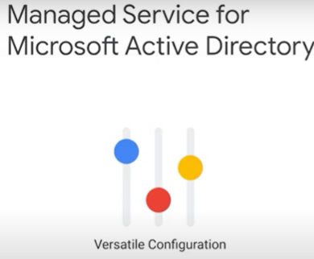
* [Demo: Active Directory](https://youtu.be/qZoZDhYr7PM) 4 minutes
* Module Quiz
  + Sort the following steps for provisioning Shared VPC in Google Cloud:
    - 1. A Shared VPC Admin enables shared VPC for the host project.
    - 2. An Organization Admin nominates a Shared VPC Admin.
    - 3. A Shared VPC Admin delegates access to some or all subnets of a shared VPC network by granting the Network User role.
    - 4. A Network User creates resources in their Service Project.
    - 2->1->3->4
      * First, an Organization Admin nominates a Shared VPC Admin. The Shared VPC Admin then enables shared VPC for the host project and delegates access to some or all subnets of the shared VPC network by granting the Network User role. Finally, the Network User creates resources in his/her Service Project.
  + Where do you control the authentication of user identities? admin.google.com
* Review 1 minute

## 7.0 Logging, monitoring and next steps

* In this module, how to use Cloud Monitoring & Logging capabilities to enhance your observability of your cloud environment. how to use managed instance groups, which are automated groups of VMs that can scale up & down based on metrics. how to use our global load balancer to frontend the group of VMs, Cloud Support tiers.
* Module Overview 1 minute
* [The monitoring pyramid](https://youtu.be/J8HUtBxKCz8) 1 minute
* 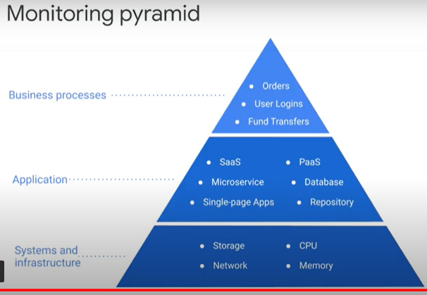
* [Google Cloud's operations suite](https://youtu.be/BQrpWJhGg3Q) 3 minutes
* 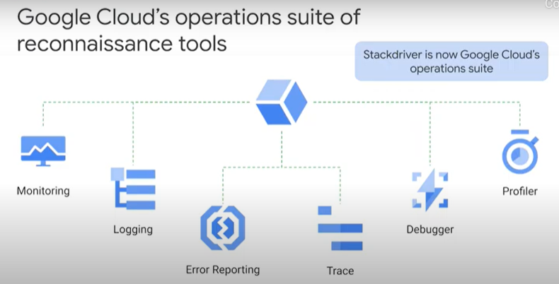 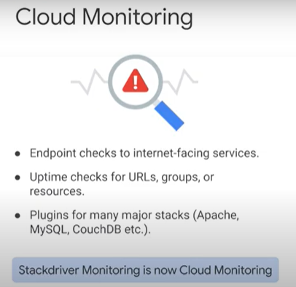
* 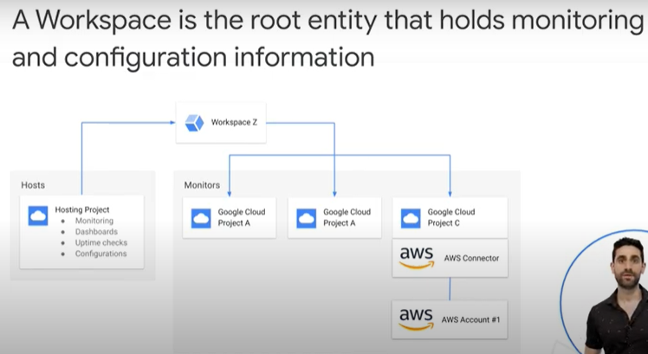 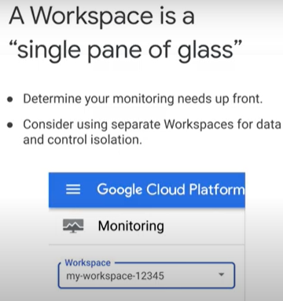
* [Cloud Monitoring metrics](https://youtu.be/5Qtr0dxCm8E) 1 minute
* 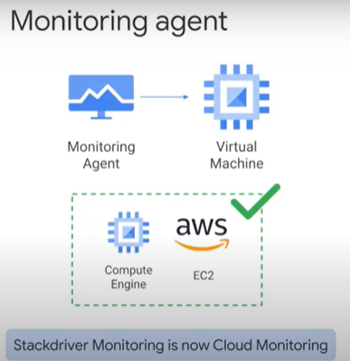 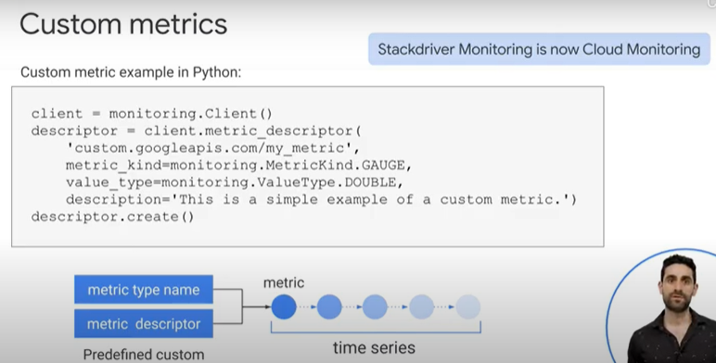
* 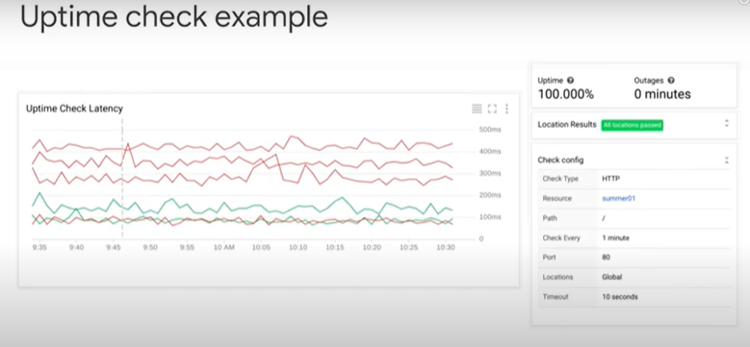
* [Lab Intro: Resource Monitoring](https://youtu.be/4ff5Z0AB0TQ) 1 minute
* Resource Monitoring 34 minutes
  + In this lab, you learn how to use Cloud Monitoring to gain insight into applications that run on GC.
  + Objectives, In this lab, you learn how to perform the following tasks:
    - Explore Cloud Monitoring
    - Add charts to dashboards
    - Create alerts with multiple conditions
    - Create resource groups
    - Create uptime checks
  + Task 1: Create a Cloud Monitoring workspace
    - Verify resources to monitor
      * Three VM instances have been created for you that you will monitor.
      * In the Cloud Console, on the Navigation menu -> click Compute Engine > VM instances. Notice the nginxstack-1, nginxstack-2 and nginxstack-3 instances.
    - Create a Monitoring workspace
      * You will now setup a Monitoring workspace that's tied to your Qwiklabs GCP Project. The following steps create a new account that has a free trial of Monitoring.
      * In the Google Cloud Platform Console, click on Navigation menu > Monitoring.
      * Wait for your workspace to be provisioned.
      * When the Monitoring dashboard opens, your workspace is ready.
        + 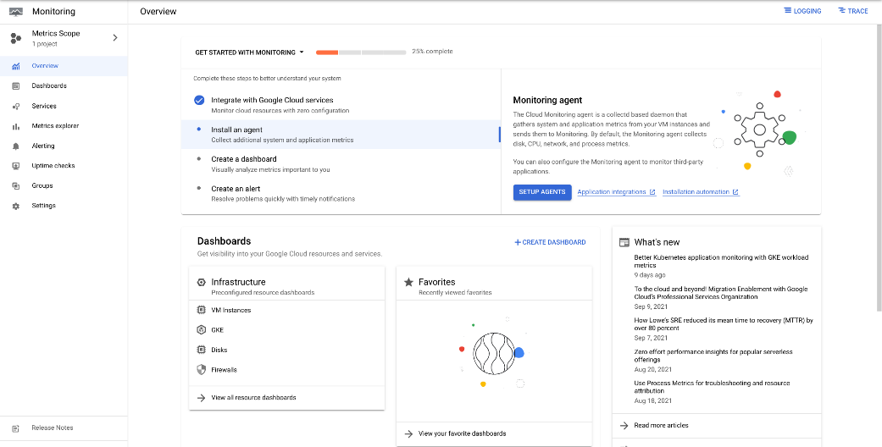
    - Why is monitoring important to Google?
      * It is at the base of site reliability which incorporates aspects of software engineering and applies that to operations whose goals are to create ultra-scalable and highly reliable software systems.
  + Task 2: Custom dashboards
    - Create a dashboard
      * In the left pane, click Dashboards. Click +Create Dashboard. For New Dashboard Name, type My Dashboard.
    - Add a chart
      * From Chart library, Select Line. For Title, give your chart a name.
      * For Resource type, select VM Instance.
      * For Metric, select a metric to chart for the Instance resource, such as CPU utilization or CPU usage. Click + Add Filter and explore the various options.
    - Metrics Explorer
      * It allows you to examine resources and metrics without having to create a chart on a dashboard. Try to recreate the chart you just created using the Metrics Explorer.
      * In the left pane, click Metrics explorer.
      * For Resource type and Metric, select a resource name and metric.
      * Explore the various options and try to recreate the chart you created earlier.
        + Not all metrics are currently available on the Metrics Explorer, so you might not be able to find the exact metric you used on the previous step.
  + Task 3: Alerting policies
    - What is not a recommended best practice for alerts?
      * Report all noise to ensure all data points are presented.
    - Create an alert and add the first condition
      * In the left pane, click Alerting. Click + Create Policy. Click Add Condition.
      * For Find resource type and metric, select VM Instance.
        + If you cannot locate the VM Instance resource type, you might have to refresh the page.
      * Select a metric you are interested in evaluating, such as CPU usage or CPU Utilization.
      * Under Configuration, for Condition, select is above.
      * Specify the threshold value and for how long the metric must cross this set value before the alert is triggered. For example, for THRESHOLD, type 20 and set FOR to 1 minute.
      * Click ADD.
    - Add a second condition
      * Click Add Condition. Repeat the steps above to specify the second condition for this policy. For example, repeat the condition for a different instance. Click ADD.
      * In Policy Triggers, for Trigger when, click All conditions are met. Click Next.
    - Configure notifications and finish the alerting policy
      * Click on dropdown arrow next to Notification Channels, then click on Manage Notification Channels. A Notification channels page will open in new tab.
      * Scroll down the page and click on ADD NEW for Email.
      * Enter your personal email in the Email Address field and a Display name. Click Save.
      * Go back to the previous Create alerting policy tab.
      * Click on Notification Channels again, then click on the Refresh icon to get the display name you mentioned in the previous step. Click Notification Channels again if needed.
      * Now, select your Display name and click OK. Click Next.
      * Enter a name of your choice in Alert name field. Click Save.
  + Task 4: Resource groups
    - In the left pane, click Groups. Click + Create Group.
    - Enter a name for the group. For example: VM instances
    - In the Criteria section, type nginx in the value field below Contains. Click DONE. Click CREATE.
    - Review the dashboard Cloud Monitoring created for your group.
  + Task 5: Uptime monitoring
    - Select all valid targets for Cloud Monitoring uptime alert notifications.
      * Pub/sub. Email. 3rd party service. Webhook. SMS
    - In the Monitoring tab, click on Uptime Checks. Click + Create Uptime Check.
    - Specify the following, and leave the remaining settings as their defaults:
      * Property Value (type value or select option as specified)
      * Title Enter a title then click Next
      * Protocol HTTP
      * Resource Type Instance
      * Applies To Group
      * Group Select your group
      * Check Frequency 1 minute
    - Click on Next to leave the other details to default. Under Alert & Notification, select your Notification Channels from the dropdown.
    - Click Test to verify that your uptime check can connect to the resource.
    - When you see a green check mark everything can connect. Click Create.
    - The uptime check you configured takes a while for it to become active.
  + Task 6: Disable the alert
    - Disable the alert Alerting policies stay active for a while after a project is deleted, just in case it needs to be reinstalled. Since this is a lab, and you will not have access to this project again, remove the alerting policy you created.
    - You should still be in the Alerting section.
    - From you alert's Policy details page, click the Enabled link at the top of the page.
    - You will be asked to confirm that you want to disable the alerting policy - click Disable.
    - The link will now say Disabled.
* [Lab Solution: Resource Monitoring](https://youtu.be/bbd_Egy440A) 15 minutes
  + Overview
  + GC HTTP(S) load balancing is implemented at the edge of Google's network in Google's points of presence (POP) around the world. User traffic directed to an HTTP(S) load balancer enters the POP closest to the user and is then load-balanced over Google's global network to the closest backend that has sufficient available capacity.
  + In this lab, you configure an HTTP load balancer as shown in the diagram below. Then, you stress test the load balancer to demonstrate global load balancing and autoscaling.
  + 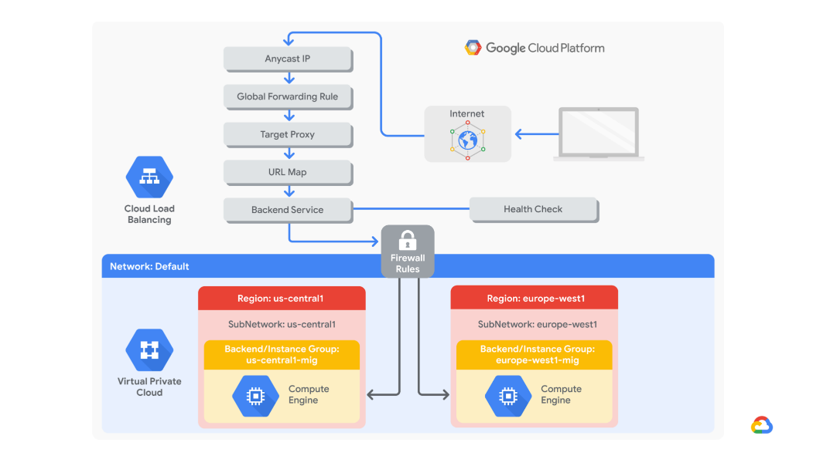
  + Objectives
    - In this lab, you learn how to perform the following tasks:
    - Create a health check firewall rule
    - Create a NAT configuration using Cloud Router
    - Create a custom image for a web server
    - Create an instance template based on the custom image
    - Create two managed instance groups
    - Configure an HTTP load balancer with IPv4 and IPv6
    - Stress test an HTTP load balancer
  + Task 1. Configure a health check firewall rule
    - Health checks determine which instances of a load balancer can receive new connections. For HTTP load balancing, the health check probes to your load-balanced instances come from addresses in the ranges 130.211.0.0/22 and 35.191.0.0/16. Your firewall rules must allow these connections.
    - Create a firewall rule to allow health checks.
      * on the Navigation menu -> VPC network > Firewall.
        + Notice the existing ICMP, internal, RDP, and SSH firewall rules.
        + Each GC project starts with the default network and these firewall rules.
      * Click Create Firewall Rule. Specify the following, and leave the remaining settings as their defaults:
        + Property Value (type value or select option as specified)
        + Name fw-allow-health-checks
        + Network default
        + Targets Specified target tags
        + Target tags allow-health-checks
        + Source filter IPv4 ranges
        + Source IPv4 ranges 130.211.0.0/22 and 35.191.0.0/16
        + Protocols and ports Specified protocols and ports
        + Make sure to include the /22 and /16 in the Source IP ranges.
        + Select tcp and specify port 80. Click Create.
    - Task 2: Create a NAT configuration using Cloud Router
      * The Google Cloud VM backend instances that you setup in Task 3 will not be configured with external IP addresses.
      * Instead, you will setup the Cloud NAT service to allow these VM instances to send outbound traffic only through the Cloud NAT, and receive inbound traffic through the load balancer.
      * Create the Cloud Router instance
        + In the Cloud Console, on the Navigation menu (Navigation menu), click Network services > Cloud NAT.
        + Click Get started. Specify the following, and leave the remaining settings as their defaults:

Property Value (type value or select option as specified)

Gateway name nat-config

Network default

Region us-central1

* + - * + Click Cloud Router, and select Create new router.
        + For Name, type nat-router-us-central1. Click Create.
        + In Create a NAT gateway, click Create.
      * Wait until the NAT Gateway Status changes to Running before moving onto the next task.
    - Task 3: Create a custom image for a web server
      * Create a custom web server image for the backend of the load balancer.
      * Create a VM
        + In the Cloud Console, on the Navigation menu (Navigation menu), click Compute Engine > VM instances.
        + Click Create Instance. Specify the following, and leave the remaining settings as their defaults:

Property Value (type value or select option as specified)

Name webserver

Region us-central1

Zone us-central1-a

Boot disk Debian GNU/Linux 10 (buster)

* + - * + Under Boot disk, click Change > Show Advanced Configuration.
        + For Deletion rule, select Keep boot disk. Click Select.
        + Click Networking, Disks, Security, Management, Sole-tenancy. Click Networking.

For Network tags, type allow-health-checks.

Under Network interfaces , click default.

Under External IP dropdown, select None. Click Done.

* + - * + Click Create.
      * Customize the VM
        + For webserver, click SSH to launch a terminal and connect.
        + If you see the Connection via Cloud Identity-Aware Proxy Failed popup, click Retry.
        + To install Apache2, run the following commands:

sudo apt-get update

sudo apt-get install -y apache2

* + - * + To start the Apache server, run the following command:

sudo service apache2 start

* + - * + To test the default page for the Apache2 server, run the following command:

curl localhost

* + - * + The default page for the Apache2 server should be displayed.
      * Set the Apache service to start at boot
        + The software installation was successful. However, when a new VM is created using this image, the freshly booted VM does not have the Apache web server running. Use the following command to set the Apache service to automatically start on boot. Then test it to make sure it works.
        + In the webserver SSH terminal, set the service to start on boot:

sudo update-rc.d apache2 enable

* + - * + In the Cloud Console, select webserver, and then click More actions moreopti . Click Reset. In the confirmation dialog, click Reset.

Reset will stop and reboot the machine. It keeps the same IPs and the same persistent boot disk, but memory is wiped. Therefore, if the Apache service is available after the reset, the update-rc command was successful.

* + - * + Check the server by connecting via SSH to the VM and entering the following command:

sudo service apache2 status

* + - * + NOTE: If you see the Connection via Cloud Identity-Aware Proxy Failed popup, click Retry.
        + The result should show Started The Apache HTTP Server.
      * Prepare the disk to create a custom image
        + Verify that the boot disk will not be deleted when the instance is deleted.
        + On the VM instances page, click webserver to view the VM instance details.
        + Under Storage > Boot disk, verify that When deleting instance is set to Keep disk.
        + Return to the VM instances page, select webserver, and then click More actions.
        + Click Delete. In the confirmation dialog, click Delete.
        + In the left pane, click Disks and verify that the webserver disk exists.
      * Create the custom image
        + In the left pane, click Images. Click Create image. Specify the following, and leave the remaining settings as their defaults:

Property Value (type value or select option as specified)

Name mywebserver

Source Disk

Source disk webserver

* + - * + Click Create.

You have created a custom image that multiple identical webservers can be started from. At this point, you could delete the webserver disk.

* + - * + The next step is to use that image to define an instance template that can be used in the managed instance groups.
    - Task 4. Configure an instance template and create instance groups
      * A managed instance group uses an instance template to create a group of identical instances. Use these to create the backends of the HTTP load balancer.
      * Configure the instance template
        + An instance template is an API resource that you can use to create VM instances and managed instance groups. Instance templates define the machine type, boot disk image, subnet, labels, and other instance properties.
        + on the Navigation menu , click Compute Engine > Instance templates.
        + Click Create instance template.
        + For Name, type mywebserver-template. For Series, select N1.
        + For Machine type, select f1-micro (1 vCPU).
        + For Boot disk, click Change. Click Custom images > Select a Project.
        + In Select a Project dialog, click Project\_ID. For Image, Select mywebserver.
        + Click Select. Click Networking, Disks, Security, Management, Sole-tenancy.
        + Click Networking.

For Network tags, type allow-health-checks.

Under Network interfaces , click default.

Under External IP dropdown, select None. Click Done.

* + - * + Click Create.
      * Create the managed instance groups
        + Create a managed instance group in us-central1 and one in europe-west1.
        + On the Navigation menu, click Compute Engine > Instance groups.
        + Click Create Instance group. Specify the following, and leave the remaining settings as their defaults:

Property Value (type value or select option as specified)

Name us-central1-mig

Instance template mywebserver-template

Location Multiple zones

Region us-central1

* + - * + Under Autoscaling, enter Minimum number of instances 1 and Maximum number of instances 2.
        + Under Autoscaling metrics, click on the CPU utilization.
        + Under Metric type, select HTTP load balancing utilization.
        + Enter Target HTTP load balancing utilization to 80. Click Done.
        + Click Cool down period and set to 60 seconds.

Managed instance groups offer autoscaling capabilities that allow you to automatically add or remove instances from a managed instance group based on increases or decreases in load. Autoscaling helps your applications gracefully handle increases in traffic and reduces cost when the need for resources is lower. You just define the autoscaling policy, and the autoscaler performs automatic scaling based on the measured load.

* + - * + Under Autohealing for Health check, select Create a health check.
        + Specify the following, and leave the remaining settings as their defaults:

Property Value (select option as specified)

Name http-health-check

Protocol TCP

Port 80

Managed instance group health checks proactively signal to delete and recreate instances that become unhealthy.

* + - * + Click Save.
        + For Initial delay, type 60. This is how long the Instance Group waits after initializing the boot-up of a VM before it tries a health check. You don't want to wait 5 minutes for this during the lab, so you set it to 1 minute.
        + Click Create. Click Confirm in the dialog window.

NOTE: If a warning window will appear stating that There is no backend service attached to the instance group. Ignore this; you will configure the load balancer with a backend service in the next section of the lab.

* + - * + Repeat the same procedure for europe-west1-mig in europe-west1:
        + Click Create Instance group. Specify the following, and leave the remaining settings as their defaults:

Property Value (type value or select option as specified)

Name europe-west1-mig

Instance template mywebserver-template

Location Multiple zones

Region europe-west1

Autoscaling > Minimum number of instances 1

Autoscaling > Maximum number of instances 2

Autoscaling metrics > Metric Type HTTP load balancing utilization

Target HTTP load balancing utilization 80

Cool down period 60

* + - * + For Health check, select http-health-check (TCP). For Initial delay, type 60.
        + Click Create. Click Confirm in the dialog window.
      * Verify the backends Verify that VM instances are being created in both regions.
        + On the Navigation menu, click Compute Engine > VM instances. Notice the instances that start with us-central1-mig and europe-west1-mig. These instances are part of the managed instance groups.
    - Task 5. Configure the HTTP load balancer
      * Configure the HTTP load balancer to balance traffic between the two backends (us-central1-mig in us-central1 and europe-west1-mig in europe-west1) as illustrated in the network diagram:
      * 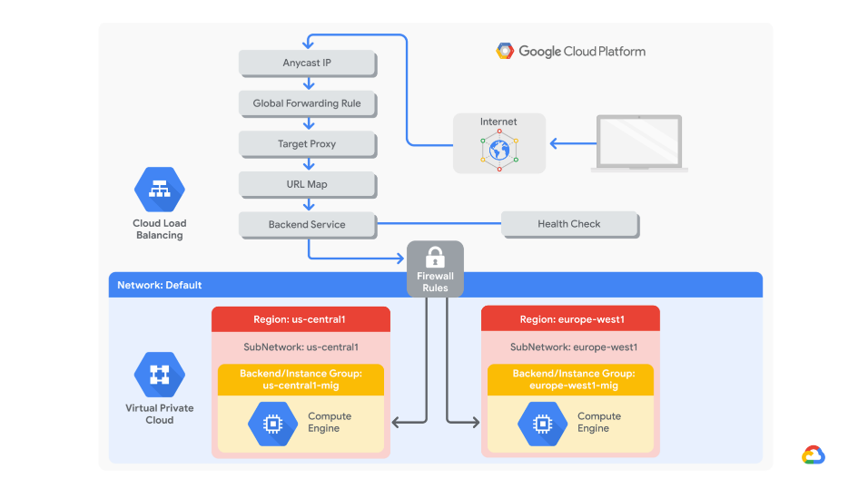
      * Start the configuration
        + On the Navigation menu, click Network Services > Load balancing.
        + Click Create load balancer. Under HTTP(S) Load Balancing, click Start configuration.
        + Under Internet facing or internal only, select From Internet to my VMs or serverless services.
        + Under Advanced traffic management, select Classic HTTP(S) Load Balancer.
        + Click Continue. For Name, type http-lb.
      * Configure the backend
        + Backend services direct incoming traffic to one or more attached backends. Each backend is composed of an instance group and additional serving capacity metadata.
        + Click Backend configuration.
        + Click Backend services & backend buckets > Create a backend service.
        + Specify the following, and leave the remaining settings as their defaults:

Property Value (select option as specified)

Name http-backend

Backend type Instance group

Instance group us-central1-mig

Port numbers 80

Balancing mode Rate

Maximum RPS 50

Capacity 100

This configuration means that the load balancer attempts to keep each instance of us-central1-mig at or below 50 requests per second (RPS).

* + - * + Click Done. Click Add backend.
        + Specify the following, and leave the remaining settings as their defaults:

Property Value (select option as specified)

Instance group europe-west1-mig

Port numbers 80

Balancing mode Utilization

Maximum backend utilization 80

Capacity 100

This configuration means that the load balancer attempts to keep each instance of europe-west1-mig at or below 80% CPU utilization.

* + - * + Click Done. For Health Check, select http-health-check.
        + Click check for the Enable logging checkbox.
        + Specify Sample rate as 1. Click Create. Click OK.
      * Configure the frontend
        + The host and path rules determine how your traffic will be directed. For example, you could direct video traffic to one backend and direct static traffic to another backend. However, you are not configuring the host and path rules in this lab.
        + Click Frontend configuration.
        + Specify the following, and leave the remaining settings as their defaults:

Property Value (type value or select option as specified)

Protocol HTTP

IP version IPv4

IP address Ephemeral

Port 80

* + - * + Click Done. Click Add Frontend IP and port.
        + Specify the following, and leave the remaining settings as their defaults:

Property Value (type value or select option as specified)

Protocol HTTP

IP version IPv6

IP address Ephemeral

Port 80

* + - * + Click Done.

HTTP(S) load balancing supports both IPv4 and IPv6 addresses for client traffic. Client IPv6 requests are terminated at the global load balancing layer and then proxied over IPv4 to your backends.

* + - * Review and create the HTTP load balancer
        + Click Review and finalize.
        + Review the Backend services and Frontend.
        + Click Create. Wait for the load balancer to be created.
        + Click on the name of the load balancer (http-lb).
        + Note the IPv4 and IPv6 addresses of the load balancer for the next task. They will be referred to as [LB\_IP\_v4] and [LB\_IP\_v6], respectively.

The IPv6 address is the one in hexadecimal format.

* + - Task 6. Stress test the HTTP load balancer
      * Now that you have created the HTTP load balancer for your backends, it is time to verify that traffic is forwarded to the backend service.
      * The HTTP load balancer should forward traffic to the region that is closest to you. True
      * Access the HTTP load balancer
        + On the Google Cloud Console title bar, click Activate Cloud Shell (images\_devshell.png).
        + If prompted, click Continue.
        + To check the status of the load balancer, run the following command, replace [LB\_IP\_v4] with the IPv4 address of the load balancer:

LB\_IP=[LB\_IP\_v4]

while [ -z "$RESULT" ] ;

do

echo "Waiting for Load Balancer";

sleep 5;

RESULT=$(curl -m1 -s $LB\_IP | grep Apache);

done

Note: Once the load balancer is ready, the command will exit.

* + - * + Open a new tab in your browser and navigate to http://[LB\_IP\_v4]. Make sure to replace [LB\_IP\_v4] with the IPv4 address of the load balancer.
      * Stress test the HTTP load balancer
        + Create a new VM to simulate a load on the HTTP load balancer. Then determine whether traffic is balanced across both backends when the load is high.
        + In the Cloud Console, on the Navigation menu (Navigation menu), click Compute Engine > VM instances.
        + Click Create instance.
        + Specify the following, and leave the remaining settings as their defaults:

Property Value (type value or select option as specified)

Name stress-test

Region us-west1

Zone us-west1-c

Series N1

Machine type f1-micro (1 vCPU)

Because us-west1 is closer to us-central1 than to europe-west1, traffic should be forwarded only to us-central1-mig (unless the load is too high).

* + - * + For Boot Disk, click Change. Click Custom images > Select a Project.
        + In Select a Project dialog, click Project\_ID. For Image, select mywebserver.
        + Click Select. Click Create. Wait for the stress-test instance to be created.
        + For stress-test, click SSH to launch a terminal and connect.
        + To create an environment variable for your load balancer IP address, run the following command: export LB\_IP=<Enter your [LB\_IP\_v4] here>
        + Verify it with echo: echo $LB\_IP
        + To place a load on the load balancer, run the following command:

ab -n 500000 -c 1000 http://$LB\_IP/

* + - * + In the Cloud Console, on the Navigation menu (Navigation menu), click Network Services > Load balancing. Click http-lb. Click Monitoring.
        + Monitor the Frontend Location (Total inbound traffic) between North America and the two backends for a couple of minutes.

At first, traffic should just be directed to us-central1-mig, but as the RPS increases, traffic is also directed to europe-west1-mig. This demonstrates that by default traffic is forwarded to the closest backend, but if the load is very high, traffic can be distributed across the backends.

* + - * + 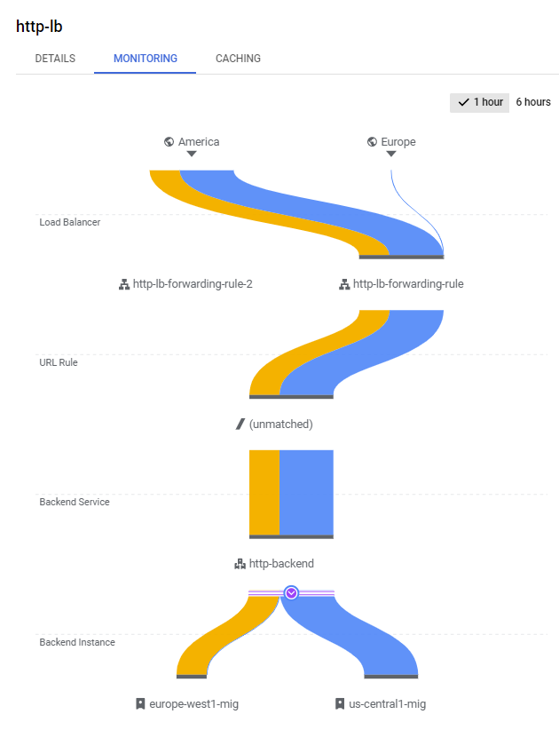
        + In the Cloud Console, on the Navigation menu (Navigation menu), click Compute Engine > Instance groups.
        + Click on us-central1-mig to open the instance group page.
        + Click Monitoring to monitor the number of instances and LB capacity.
        + Repeat the same for the europe-west1-mig instance group.
        + Depending on the load, you might see the backends scale to accommodate the load.
* [Cloud Logging](https://youtu.be/KDfhb8kJQCg) 1 minute
  + 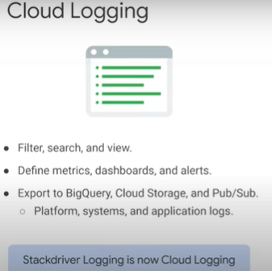
  + stackdriver logging allows you to store, search, analyze, monitor and alert on log data and events from gcp & aws
  + it is a fully managed service that performs at scale and can ingest applications and system log data from
  + thousands of virtual machines
  + logging includes storage for logs a user interface called log viewer and an api to manage logs programmatically
  + 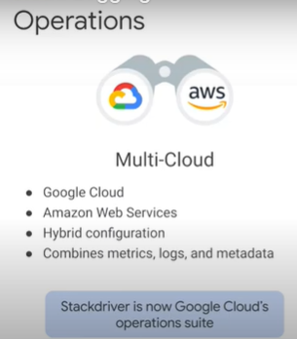
  + whether you're running on gcp, aws, on-premises infrastructure or with hybrid clouds, stackdriver combines metrics logs and metadata from all of your cloud accounts and projects into a single comprehensive view of your environment
  + 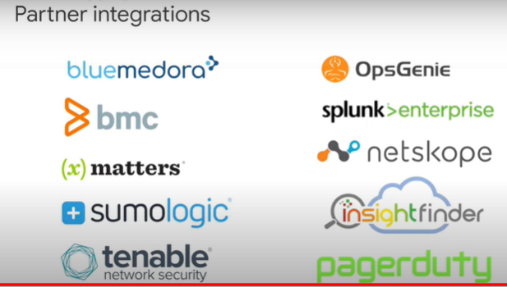
* [Quiz: Google Cloud's operations suite](https://www.cloudskillsboost.google/course_sessions/743467/quizzes/108598)
  + Google Cloud’s operations suite integrates several technologies, including monitoring, logging, error reporting, debugging, and profiling that are commonly implemented in other environments as separate solutions that use separate products. What are some key benefits of integrating these services?
    - Reduces overhead, reduces noise, streamlines use, and fixes problems faster
* [Managed Instance Group](https://youtu.be/h5Gy9wkD1Jo) 1 minute
  + 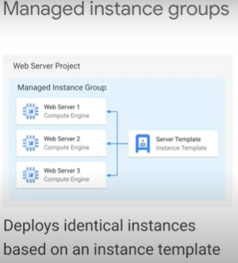
  + a manage instance group is a collection of identical virtual machines that you control as a single entity using an instance template
* [Managed Instance Group features](https://youtu.be/nAHtCqtOmuk) 2 minutes
  + 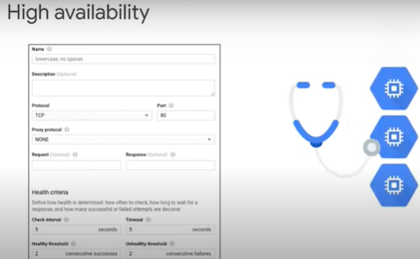 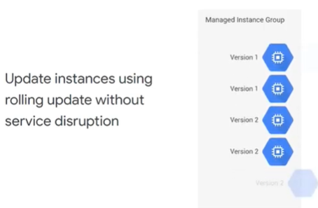
  + 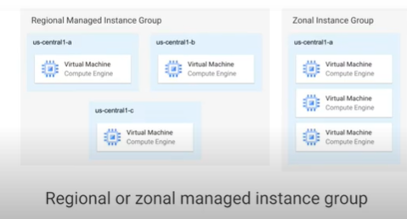
  + 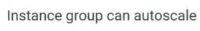 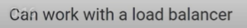
* [Global Load Balancer](https://youtu.be/9LAWajxN-kM) 1 minute
  + 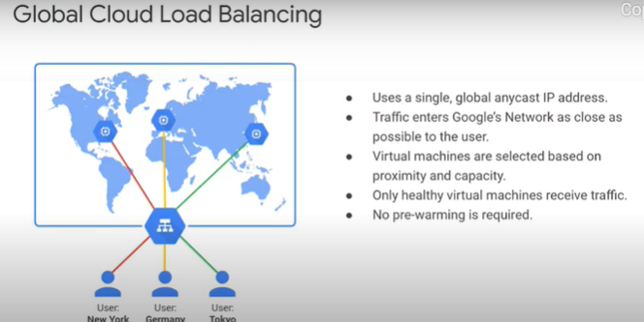
* [Lab Intro: Configuring an HTTP Load Balancer with Autoscaling](https://youtu.be/FjhD11HSI9w) 1 minute
* [Configuring an HTTP Load Balancer with Autoscaling](https://www.cloudskillsboost.google/course_sessions/743467/labs/108603) 1 hour
* [Lab Review: Configuring an HTTP Load Balancer with Autoscaling](https://youtu.be/5wQWQdtAlbk) 1 minute
* [Google Cloud Rapid Assessment and Migration Program (RAMP)](https://www.cloudskillsboost.google/course_sessions/743467/documents/108605)
* [Contacting Support](https://www.cloudskillsboost.google/course_sessions/743467/documents/108606)
* Document

## 8.0 Document

* <https://www.cloudskillsboost.google/course_sessions/743467/documents/108608>
* <https://storage.googleapis.com/cloud-training/Migrating2gcp/v1.2/Module_0_Course_Introduction.pdf>
* <https://storage.googleapis.com/cloud-training/Migrating2gcp/v1.2/Module_1_Introduction_to_Cloud_Migration.pdf>
* <https://storage.googleapis.com/cloud-training/Migrating2gcp/v1.2/Module_2_Assessing_the_Source_Environment.pdf>
* <https://storage.googleapis.com/cloud-training/Migrating2gcp/v1.2/Module_3_Google_Cloud_Fundamentals.pdf>
* <https://storage.googleapis.com/cloud-training/Migrating2gcp/v1.2/Module_4_Virtual_Machines_and_Networks_in_the_Cloud.pdf>
* <https://storage.googleapis.com/cloud-training/Migrating2gcp/v1.2/Module_5_Migrate_for_Compute_Engine.pdf>
* <https://storage.googleapis.com/cloud-training/Migrating2gcp/v1.2/Module_6_Governance.pdf>
* https://storage.googleapis.com/cloud-training/Migrating2gcp/v1.2/Module\_7\_Logging\_monitoring\_and\_Next\_Steps.pdf